
City of Phoenix

Human Services Department
Education Division
Head Start Program

Application for Federal Head Start Refunding Grant

Program Year 39 (2004-2005)

Community Assessments, Goals & Objectives

March 25, 2004

City of Phoenix
Grantee Operated and
Delegate Agency Programs



Table of Contents

Page
Introduction 1
Objectives, Need for Assistance and Geographic Area 1
Overview of Grant Refunding Document 1
Demographic Make-Up of Head Start Eligible Children 2
Other Child Development Programs Serving Head Start Eligible Children 3
Estimated Number of Children With Disabilities 4
Education, Health, Nutrition & Social Service Needs of Head Start Eligible Children 5
Resources Available in the Community 6
Philosophy Statement 6
City-Wide Objectives: 2004-2007 7
Recruitment Area of the Program and the Delegate Agencies 12
Locations of Centers and Home-Based Programs 12
Priorities for Recruitment and Selection 12

City of Phoenix Grantee Operated Programs 13

Alhambra School District 19

Booker T. Washington Child Development Center, Inc. 25

Cartwright School District 32

Deer Valley Unified School District 40

Golden Gate Community Center, Inc. 48

Greater Phoenix Urban League 57

John C. Lincoln Health Network, Lincoln Learning Center 63

Murphy School District 76

Phi Iota’s Omega Foundation, Inc. 84

Roosevelt School District 92

Southminster Presbyterian Church 99

Washington Elementary School District 104

Wilson School District 112

Appendix A. Survey Questionnaires 120
Introduction

Objectives, Need for Assistance and Geographic Area
The City of Phoenix is the sixth-largest city in the U.S., with approximately 1,372,000 residents, and one of the nation’s fastest-growing areas. Arizona’s capital and largest city, Phoenix is a major winter tourist destination and prime retirement location. Tourism is a major source of entry-level, low-wage jobs. Other major employment sectors include retail, information technology, manufacturing and government.

As one of four states bordering Mexico, Arizona—and Phoenix—are prime destinations for immigrants, both legal and undocumented. Approximately 34% of the Phoenix population is Hispanic (Census 2000), and the city’s Hispanic population is growing much faster than the population as a whole. Over half (51%) of children five and younger are Hispanic, and nearly three-fourths (74.6%) of children five and younger from poverty-level families are Hispanic.

The City of Phoenix operates eight Head Start sites (Grantee Operated Programs) with up to 144 children, and contracts 13 Delegate Agencies to operate 67 more sites for up to 3,050 children, for a total of 75 sites to a City-wide funded capacity of 3,194 Head Start children. These programs cover most of the geographical area within the Phoenix city limits.

Phoenix has over 134,000 children 5 and younger, comprising just over 10% of the City’s population. More than 32,000 children 5 and younger, or over 24%, live in families with incomes below the federal poverty line.

More than 68,000 children (over 5% of the population) are 3-to-5 years old, key ages for regular Head Start. Available data do not show how many of these children live in poverty, but if this population is similar to the larger 5-and-younger population of which it is a part, then an estimated 16,363 3-to-5 year-olds (24%) are from poor families. These 16,363 children comprise the potential community need for Head Start services. The City of Phoenix and its 13 delegate agencies host 3,194 Head Start seats, potentially meeting just 19.5%—less than one-fifth—of the overall community need.

Overview of Grant Refunding Document
This Introduction describes the City of Phoenix, summarizes the City’s Head Start Program, discusses City-wide Head Start goals for 2004-07, and overviews the results of the City’s community assessment.

The City of Phoenix conducted a three-pronged community assessment process to support this refunding application: (a) survey questionnaires in English and Spanish (Appendix A) asked about the need for and accessibility of various health and social services; 1,946 completed questionnaires were returned. (b) The City facilitated four focus groups of parents of Head Start students, community leaders, citizens and social services providers. (c) The City conducted structured interviews with selected experts in child care development, social services delivery and education. The Grantee Operated Programs and each of the delegate agencies received the community assessment data that applied to their individual service areas, and used this information in their individual analysis sections that follow.

The Grantee Operated Programs and each Delegate Agency provides an analysis of its specific program’s community assessment. Each section begins with a map of the agency’s service area, followed by an approval sheet for the agency’s community assessments, goals, objectives, and action plan, signed by the Board Chairperson or Executive Director, the Delegate Agency Director and the Policy Committee Chairperson. Each section then presents an analysis of community assessment data. Each cites information from the City-wide survey and focus group activities, and many include additional information obtained locally.

Demographic Make-Up of Head Start Eligible Children
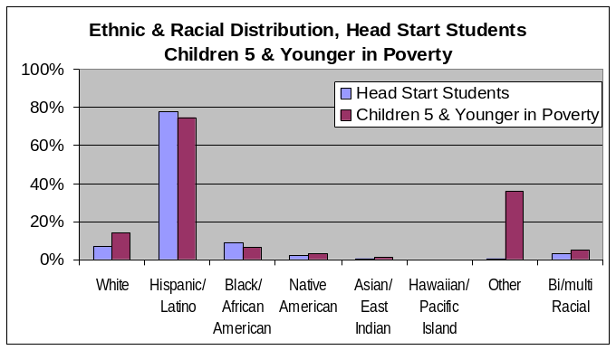
Although people of Hispanic origin make up 34% of the City’s population, over half of children 5 and younger are Hispanic, and nearly half of 3-to-5 year-olds are Hispanic. Of the 32,000 children 5 and younger who live in poverty, nearly 75% are Hispanic, and nearly 78% of Phoenix Head Start students are Hispanic. A largely Hispanic client base adds complications to Phoenix Head Start that many other communities do not face. For example: Virtually all classrooms operate in dual languages, in both Spanish and English, requiring more communication time; 59% of Phoenix Head Start students use Spanish as their primary language. Most Teachers, Assistant Instructors and Bus Monitors must be bilingual, making recruitment of personnel with these special skills more difficult. Communications to parents must be prepared in both English and Spanish, nearly doubling the time to prepare materials. Meal service must accommodate cultural differences, requiring a more diverse supply chain.
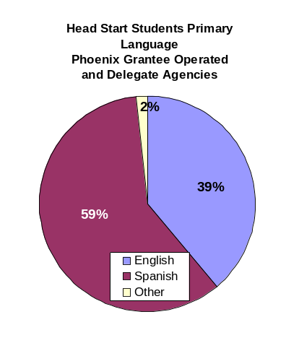
Hispanic Head Start students’ family environments are more challenging than many of their counterparts because many of their parents are undocumented—even if the children are U.S. citizens—facing sanctions against employment and discrimination in other areas; their English language and literacy skills may be lacking; and they fear that using available social and health services may lead to deportation. Helping children of undocumented parents become fully ready-to-learn means that Head Start must offer families a broader range of services, including ESL, GED, health, transportation and employment.

Even if these Head Start students’ families are documented, they face discrimination in housing, employment, banking and other areas, and they may face language or literacy barriers.

Ethnic & Racial Distribution: Population, Children, Poverty and Head Start Students
Phoenix City  Ethnicity/Race |  | Popu  lation | Children  3 to 5 | Children  5 and  Younger | % In  Poverty –  Children  5 and  Younger  (1999)* | % of Children  5 and  Younger  in Poverty  (1999)* | Head  Start  Students†
Hispanic, any race |  | 34.0% | 49.9% | 51.0% | 17.9% | 74.6% | 77.7%
Not Hispanic | White | 55.8% | 38.8% | 37.8% | 3.4% | 14.0% | 7.1%
Not Hispanic | African American | 4.8% | 5.0% | 4.9% | 1.6%* | 6.7%* | 9.1%
Not Hispanic | Native American | 1.6% | 1.7% | 1.8% | 0.7%* | 3.0%* | 1.8%
Not Hispanic | Asian | 1.9% | 1.7% | 1.6% | 0.3%* | 1.2%* | 0.3%
Not Hispanic | Hawaiian/Pac. Isl. | 0.1% | 0.1% | 0.1% | 0.0%* | 0.1%* | 0.2%
Not Hispanic | Other race | 0.1% | 0.2% | 0.2% | 8.6%* | 35.9%* | 0.7%
Not Hispanic | Two or more races | 1.6% | 2.6% | 2.7% | 1.3%* | 5.2%* | 3.1%
Total‡ |  | 100% | 100% | 100% | 24.2%* | * | 100%
* The 1999 Census Bureau poverty data do not separate non-Hispanic populations from non-White races, so some double-counting occurs; consequently, these percentages are somewhat overstated.
† 2003-04 Head Start Demographics report, run date March 23, 2004.
‡ Totals may not add to 100.0% due to rounding.

Other Child Development Programs Serving Head Start Eligible Children
Greater Phoenix has two other programs serving Head Start eligible children: Maricopa County and its delegate agency, CSS/CNA Head Start, and Southwest Human Development.

Maricopa County Head Start serves the East Valley in the communities of Mesa, Tempe, Higley, Guadalupe, Chandler, Gilbert, Scottsdale, Cave Creek, Ahwatukee, Queen Creek, Fountain Hills and Chandler Heights. Its delegate agency, CSS/CNA Head Start, serves the West Valley in the communities of New River, Glendale, Tolleson, Gila Bend, Cashion, Litchfield Park, Wickenburg, Peoria, Avondale, Aguila, Liberty, Luke AFB, El Mirage, Goodyear, Surprise and Buckeye. Maricopa County does not serve within the Phoenix City limits.

Southwest Human Development is a non-profit educational and human services organization providing comprehensive services to young children and their families who face challenges related to health, child abuse and neglect, mental health, poverty and disabilities. It also train and consults to other organizations and individuals. The state's largest community-based organization of its type, Southwest Human Development’s staff of over 400 serves almost 30,000 children and families each year in Maricopa County. to create a positive future for young children.

Southwest Head Start, a program of Southwest Human Development, is a federally funded, comprehensive child and family development program serving low-income children from birth through four years of age and their families. Head Start emphasizes: high-quality early childhood education, child health and nutrition, social services and parent involvement. Southwest Head Start's program includes: child development, disabilities, mental health, health, nutritional and family development services. Southwest Head Start serves parts of the City of Phoenix east side, but its service area does not overlap the City of Phoenix or its delegate agency programs.

Chicanos Por La Causa, Inc., is a community development corporation headquartered in Phoenix. CPLC operates the Arizona Migrant & Seasonal Headstart Program, serving over 550 children of migrant farm worker families in 2001.

Arizona State University Child Development Lab, part of ASU's Department of Family and Human Development, located on the main ASU campus in Tempe, plays an integral role in the university's threefold mission of teaching, research and service: CDL provides carefully supervised training opportunities for child development students; CDL children and families have a unique opportunity to participate voluntarily in research studies; CDL provides a model of high quality education and care for young children, and offers training opportunities and technical assistance for state and local early-childhood professionals. CDL tuition is $535 per month.

Other child development service providers include the Salvation Army Herberger Child Care Center for homeless children, New Creations, and Faces of Crisis Nursery. Nearly 500 day care centers are listed in the City of Phoenix Yellow Pages, located within 25 miles of the city center.

The Directory of Human Services lists over 1,100 human services agencies and 230 self-help support groups throughout Greater Phoenix. Among its listings are: adoption agencies (19 listings); advocacy, children (19); case management, low income (32); day care, child (19); day care, home child (3); day care, ill child (4); day care, latch key/phone friend (5); education, basic (35, including many Grantee Operated and delegate agency programs); education, Head Start (10, including many Grantee Operated and delegate agency programs); education, special age 0-3 (12); education, special age 4-6 (12); foster care, child (12); health, chronically ill child (22). Several agencies are listed multiple times under different categories.

Many families entrust child care and development to extended family members, particularly among families of Hispanic origin, who comprise 78% of Phoenix Head Start students. These families maintain strong bonds across generations, extending to aunts, uncles and cousins.

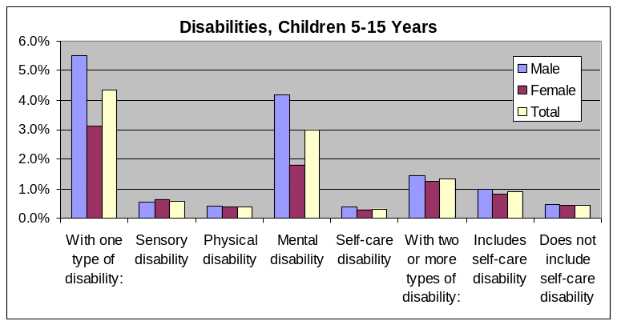
Estimated Number of Children With Disabilities
Census 2000 data regarding disabilities is available only for people 5 years and older. The accompanying chart shows disabilities frequencies for children 5-to-15 years old in Phoenix. The data show that:
- 5.7% of children in this cohort have one or more disabilities;
- The most frequent type of disability is mental (3.0%);
- Males in this cohort are 1.8 times more likely to have a disability—and 2.3 times more likely to have a mental disability —than females.

Education, Health, Nutrition & Social Service Needs of Head Start Eligible Children as Defined by Their Families and Community Institutions
In August-November 2003, the City of Phoenix, Human Services Department, Education Division surveyed parents of Head Start children, community leaders and citizens to identify the education, health, nutrition and social services needs of the community. The survey questionnaires, in both English and Spanish, are presented in Appendix A. Different agencies used different methodologies to distribute the questionnaires, discussed under each section below. In total, 1,946 surveys were received.

Survey Responses – Need for Social Services
Rank | Social Service | Don't  Need  Services | Have  Enough  Services | Need  More  Services | Don't  Know | Item  Response  Rate
1 | Neighborhood Safety | 23% | 9% | 56% | 13% | 78%
2 | ESL | 21% | 8% | 54% | 16% | 82%
3 | Dental Care | 21% | 13% | 53% | 12% | 82%
4 | Medical Care | 23% | 15% | 50% | 12% | 82%
5 | Job Training 1 | 26% | 6% | 48% | 21% | 77%
6 | Housing | 27% | 10% | 47% | 15% | 81%
7 | Job Training | 30% | 6% | 44% | 20% | 80%
8 | Clothing | 25% | 13% | 44% | 19% | 79%
9 | Utility Assistance | 25% | 9% | 44% | 22% | 76%
10 | Public Schools | 26% | 15% | 43% | 16% | 77%
11 | City Services | 27% | 11% | 43% | 19% | 76%
12 | School Dropout | 27% | 6% | 43% | 24% | 75%
13 | Food | 25% | 14% | 43% | 18% | 79%
14 | Child Care | 35% | 11% | 40% | 15% | 80%
15 | After School Care | 34% | 11% | 40% | 16% | 80%
16 | Legal Aid | 29% | 7% | 39% | 25% | 75%
17 | Citizenship | 28% | 7% | 38% | 27% | 76%
18 | Financial Debt | 29% | 6% | 38% | 26% | 73%
19 | Transportation | 33% | 18% | 37% | 13% | 80%
20 | Gang Prevention | 37% | 5% | 35% | 24% | 77%
21 | Substance Abuse | 36% | 6% | 33% | 25% | 75%
22 | Juvenile Crime | 39% | 4% | 32% | 25% | 77%
23 | Domestic Violence | 36% | 6% | 32% | 26% | 75%
24 | Other Crime | 38% | 4% | 30% | 28% | 75%
25 | Pregnancy | 40% | 8% | 29% | 23% | 77%
26 | Child Abuse | 40% | 5% | 29% | 25% | 76%
27 | Mental Health | 36% | 8% | 25% | 32% | 75%

The key questions asked respondents to identify from a list the degree of their need for social services (don’t need, have enough, or need more). The accompanying table—“Need for Social Services”—shows their responses, ranked by the services most in need. As the table shows, the top five priority needs for social services identified by the respondents are:
- Neighborhood Safety
- ESL
- Dental Care
- Medical Care
- Job Training

The first four of these were identified by over half the respondents as “need more.” Job training was also selected by over half the respondents, when analyzing detailed data for the two different job training options that were listed.

Resources Available in the Community
The community needs assessment survey questionnaire also asked respondents to identify from the same list the degree of service accessibility. The accompanying table—“Accessibility of Social Services”—shows their responses, ranked by degree of difficulty to access. As the table shows, the top five most-difficult-to-access social services are:
- Housing
- Dental Care
- Medical Care
- Child Care
- Utility Assistance

Philosophy Statement
It is the practice of City of Phoenix Head Start to enhance the early childhood development of all our children. In order to effectively enhance each child’s growth and development, we:
- Respect and celebrate diversity.
- Engage in a respectful partnership with each child’s family.
- View each child as a capable and competent learner.
- Believe in fostering the development of the whole child.
- Provide children with meaningful active learning experiences, and provide for interaction with other children, adults and open-ended materials in a safe, healthy, and joyful learning environment.
- Ensure all learning experiences are developmentally appropriate and focused on the needs, strengths, interests and abilities of the children.
- Teach skills and concepts while exploring content-rich subjects such as the arts, the sciences, literature and the social sciences.
- Provide a carefully arranged learning environment that has the potential to engage children in learning and is cared for and valued by the children and adults.
- View all adults as life learners and researchers.

Survey Responses – Accessibility of Social Services
Rank | Social Service | Easy to  Access: | Difficult to  Access | Impossible  to Access | Don't  Know | Item  Response  Rate
1 | Housing | 19% | 51% | 9% | 21% | 80%
2 | Dental Care | 32% | 42% | 8% | 18% | 77%
3 | Medical Care | 37% | 40% | 7% | 16% | 78%
4 | Child Care | 27% | 41% | 4% | 29% | 76%
5 | Utility Assistance | 21% | 35% | 7% | 38% | 73%
6 | Job Training | 23% | 35% | 5% | 37% | 75%
7 | Neighborhood Safety | 25% | 35% | 5% | 34% | 73%
8 | After School Care | 30% | 34% | 5% | 31% | 75%
9 | Legal Aid | 17% | 31% | 7% | 45% | 72%
10 | Clothing | 33% | 32% | 5% | 31% | 75%
11 | Job Training 1 | 23% | 30% | 6% | 41% | 72%
12 | Financial Debt | 16% | 28% | 6% | 49% | 68%
13 | ESL | 31% | 29% | 5% | 35% | 75%
14 | City Services | 28% | 27% | 6% | 39% | 71%
15 | Transportation | 47% | 28% | 4% | 21% | 76%
16 | Citizenship | 22% | 26% | 5% | 47% | 72%
17 | Food | 41% | 27% | 4% | 28% | 74%
18 | Public Schools | 35% | 25% | 4% | 35% | 72%
19 | School Dropout | 22% | 23% | 5% | 50% | 71%
20 | Gang Prevention | 19% | 20% | 5% | 56% | 71%
21 | Domestic Violence | 25% | 20% | 5% | 50% | 69%
22 | Pregnancy | 25% | 21% | 3% | 51% | 71%
23 | Juvenile Crime | 20% | 19% | 5% | 56% | 71%
24 | Substance Abuse | 22% | 19% | 4% | 55% | 70%
25 | Mental Health | 23% | 18% | 4% | 56% | 71%
26 | Child Abuse | 24% | 18% | 4% | 54% | 71%
27 | Other Crime | 18% | 17% | 4% | 60% | 70%

City-Wide Objectives: 2004-2007
For the three-year period from July 1, 2004 through June 30, 2007, the City of Phoenix Head Start program has established five program development goals:

- To increase affordable after-school / wraparound opportunities for Head Start children in at least 50% of delegate agencies by 2006.

Families with parents who work full-time have difficulty ensuring affordable quality child care throughout the work day. Although Head Start offers high-quality educational care free for qualified families for a half-day, many families need care for the other half of the day as well. Some families rely on extended family members, such as grandparents, aunts and uncles, etc. These alternatives provide a loving environment, but are not regulated and quality is not assured. Other families pay high rates to private day-care providers. Both options present difficulties in transporting children from Head Start to the afternoon care site.
Currently, all the Grantee Operated Programs, and just 4 of the 13 Phoenix Head Start delegate agencies offer limited full-day child care options. This goal would expand these options so that at least half the agencies offer some full-day child care options. The accompanying map shows the correlation between the current 75 Head Start locations and Census 2000 poverty data. Helping parents emerge from poverty, and transition from public assistance to employment, requires an effective network of day care options for their children; traditional half-day Head Start programs do not solve this issue for the “working poor.”

Survey respondents cited child care as the fourth most-difficult-to-access social service.

- To add six new Community Health Care Partnerships by June 2005 (est. two per region).

Access to health care is a primary issue for many Head Start families, especially if they are undocumented. Effective, preventative health care is necessary for successful communities. If a child becomes ill, a parent must stay home, endangering the family’s entire economic security. A child with marginal health is less able to learn effectively, and will not absorb the full benefit of the Head Start program. Unhealthy children will pass infections to others, creating local epidemics in neighborhoods where resources to fight them are scarce.

In spite of Head Start requirements, few Head Start programs are able to ensure every single child receives an annual medical examination by relying on parents to meet this requirement on their own. To ensure access to medical care, Head Start must partner with community health organizations to bring medical care to Head Start sites and to develop a medical relationship to meet ongoing health care needs. To date, development of these community health care partnerships has been the responsibility of individual delegate agencies. Under this goal, the City of Phoenix will assist in developing partnerships in each of the three Head Start regions (north, central and south). By taking a regional approach, the City and the community health organizations will both benefit from economies of scale.

Survey respondents identified medical care as the fourth-highest priority need, and the third most-difficult-to-access social service. They also ranked dental care the third highest priority, and the second most-difficult-to-access.

- To increase the number of GED and ESL participants by 25% by the end of 2007.

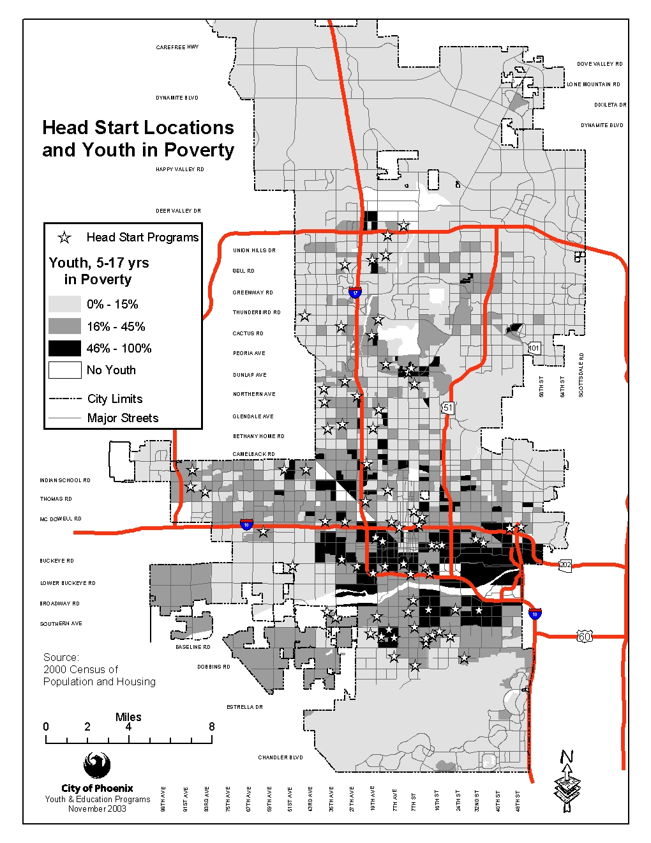
About 34% percent of the Phoenix population is Hispanic (Census 2000), and the Hispanic population is growing much faster than the population as a whole. Reasons include both “natural” population growth, and immigration. Hispanic families in Phoenix are generally younger, giving them a higher likelihood of having children; culturally, Hispanic families tend to have more children than non-Hispanic families. In fact, 51% of all Phoenix children five years old and younger are Hispanic. At less than three hours from the Mexico border, Phoenix is a prime destination for Mexico immigrants seeking entry-level jobs in the Phoenix tourism industry., The Hispanic population has a greater poverty rate than the population as a whole; City-wide nearly 75% of children five and younger from poverty-level families are Hispanic and 78% percent of the Head Start children are Hispanic. Many first-generation immigrants speak English poorly or not at all. Many of these families speak only Spanish in the home, and Spanish becomes the first language for their children; 59% of Phoenix Head Start students use Spanish as their primary language. As a result, every Head Start site has bilingual teachers, who use dual language techniques, using both Spanish and English.
An important factor in preparing Head Start children to succeed in the public school system is to develop their English language skills. Dual language education teaches English, but the new language skills must be used and practiced continually in order to establish fluency prior to grade school entry. One important way to reinforce these language skills is to help the children use their English more at home, which means ensuring their parents have English language skills as well, through English as a Second Language (ESL) programs.

On a more fundamental level, helping families increase their level of economic success will also help their children excel in school. By helping parents obtain a U.S. high school education—obtaining a GED certificate—the parents will be better able to improve their economic security, develop their English skills, help their children with homework, etc.

Several Phoenix Head Start agencies sponsor both GED and ESL classes, typically with a community college or other partner. Achieving this goal will result in an increase in the number of such classes by 25% in the next three years.

Survey respondents identified ESL classes as the second-highest priority social service need.

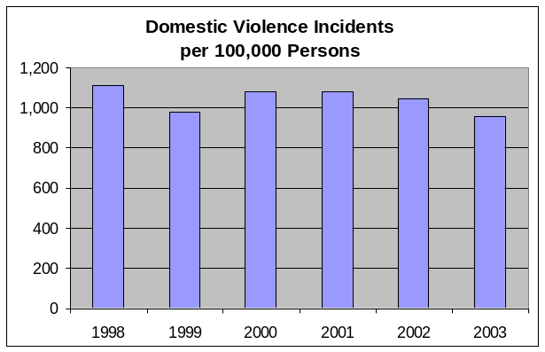
- To increase awareness of domestic violence among Head Start families by 20% by December 31, 2007.

Domestic violence continues to be a significant problem in Phoenix, averaging over 14,000 incidents reported per year since 1996. The rate of domestic violence has stayed at just under 1,000 incidents per 100,000 persons, but they are concentrated in the low-income communities that provide most of the City’s Head Start clients.

Domestic violence is disruptive to effective child development, adding stress and fear—and sometimes injury and ill health—to children’s lives. Studies show victims of domestic violence tend become violent, or pair with violent spouses. Breaking this cycle is an important element in ensuring the long-term educational and economic success of children and their families.

The City’s Head Start program can do little to reduce domestic violence directly, but it can marshal its educational resources to help its client families recognize domestic violence and identify sources of community assistance for victims and perpetrators. By increasing awareness of domestic violence, the City’s Head Start programs will help to break the cycle of violence and restore children to a home environment that will support their educational experience, rather than complicate it.

Survey respondents identified neighborhood safety as the highest-priority social service need.
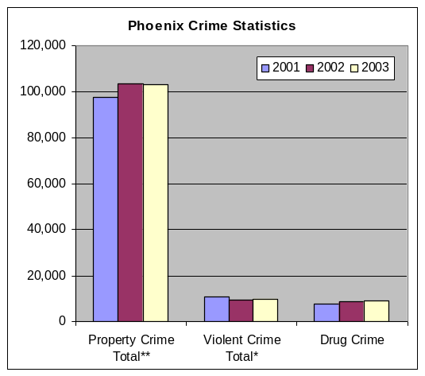
- To increase the number of educational opportunities related to personal and neighborhood safety throughout the Grantee service area by having each region coordinate two events/ trainings per year by 2006.

Crime continues to be a serious problem for many Phoenix families. As the accompanying chart shows, approximately 100,000 property crimes have been reported in each of the last three years, along with nearly 10,000 violent crimes and drug crimes increasing from over 7,800 in 2001 to nearly 9,000 last year.

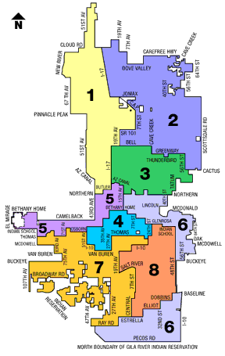
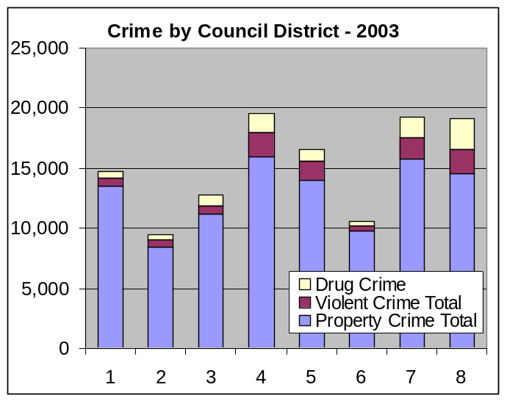
Even more important is the distribution of crimes across the city. The accompanying chart shows the same three categories of crime in the eight City Council districts. As the chart shows, the highest crime areas are districts 4, 7 and 8, followed by district 5. These districts comprise a large area of the City that includes the center city and much of south Phoenix, and encompasses 11 of the 13 delegate agency service areas (except Washington and Deer Valley), and seven of eight Grantee Operated programs (except ASU West).

The chart shows that most of the reported violent crimes and drug crimes are also concentrated in these four districts. The prevalence of urban crime in these areas makes families of Head Start families more sensitive to the negative effects of crime, since they live with it every day. The loss of property and property values reduces the standard of living in these neighborhoods, and the stress of constant worry about personal safety prevents parents and children alike from performing at their best levels.

Survey respondents identified neighborhood safety as the highest-priority social service need.

Recruitment Area of the Program and the Delegate Agencies
The Grantee Operated sites are noted on a map with the section for their community assessment, below. In general, the Grantee Operated sites recruit from their immediate neighborhoods.

Each of the delegate agencies’ recruitment areas is shown on the map that accompanies each agency’s community assessment, below.

Locations of Centers and Home-Based Programs
Nearly 500 child day care centers are listed in the online Yellow Pages within 25 miles of the city center, at Central Ave. and Washington St. Such a radius covers most of the City, except for the far north. They are well-distributed throughout the city.

Priorities for Recruitment and Selection
Phoenix has consistently been the second-fastest growing metropolitan area in the country, behind only Las Vegas, for several years. This rapid growth rate has continued even as the City has surpassed 1.3 million residents, and the metropolitan area has grown past 3.2 million. Pleasant weather most of the year, low housing costs, proximity to Mexico, modern infrastructure and a strong and diversified economy have attracted diverse immigrants from other states and countries.

This growth also means that the City’s Head Start programs have little trouble filling their funded seats. As discussed above, Phoenix has funded Head Start positions for less than one out of five children 3-to-5 years old who live in poverty. Within this growth environment, neighborhoods may change their character, going through periods of decline, with low housing costs attracting poorer residents; but then new investment comes in to take advantage of low land costs, and the neighborhood experiences a rebuilding cycle. As these cycles come and go, various Head Start providers adapt to the changing conditions in their neighborhoods.

Throughout all these cycles, the dominant constant is unrelenting growth. Even during the recession years of 2001 and 2002, the City of Phoenix gained 51,000 residents, or nearly 1,900 new residents per month over 27 months. In this environment, most delegate agencies worry more about the length of their waiting lists than their recruitment activities. Typically, they print up flyers and distribute them through schools, churches and social services agencies, and programs fill up fast.

If the City were to gain significant additional funds, to expand the program by adding multiple additional classrooms, those funds would likely be concentrated in areas of highest need with fewest services. From the map correlating Head Start locations with youth in poverty, the key areas are: the Wilson School District; the Laveen and Pendergast School Districts, which are both served by the Greater Phoenix Urban League Head Start; the Cartwright School District; and the Fowler School District, which is served by Golden Gate Community Center. A more detailed study would have to determine specific funding priorities, but these providers currently serve areas that are most in need.

City of Phoenix Grantee Operated Programs

City of Phoenix Head Start Map Showing Individual Delegate Agencies

Grantee Operated Programs

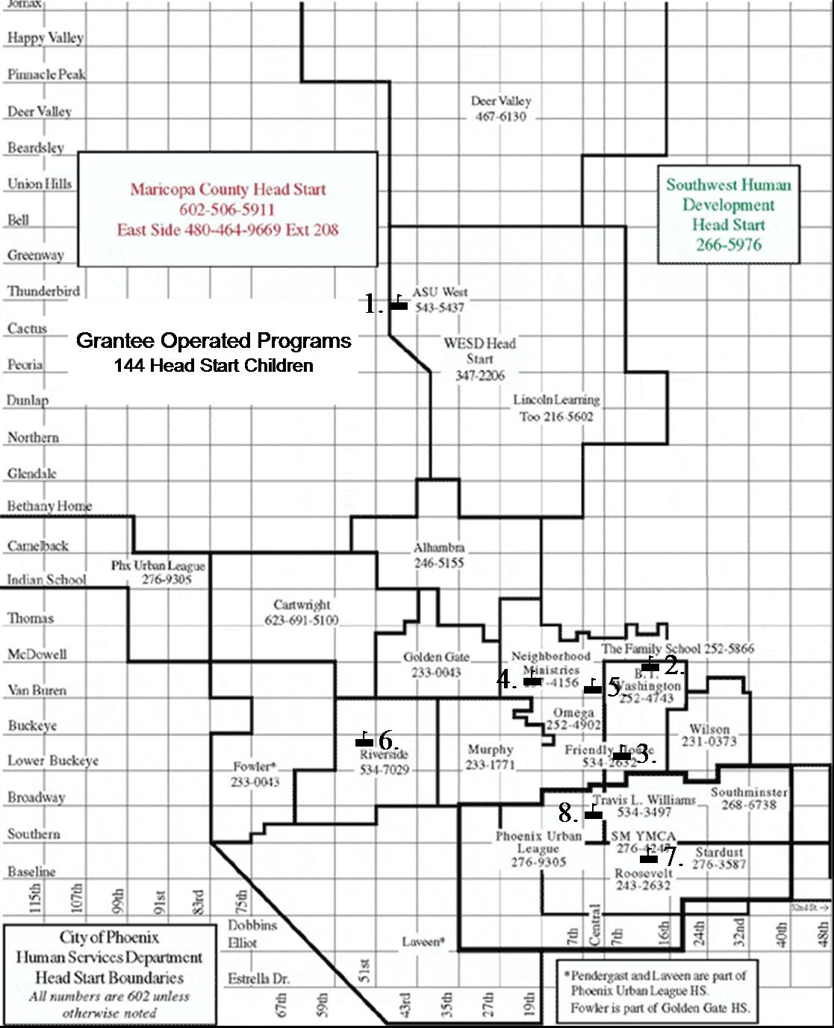
Grantee Operated Programs

Refunding Application

Program Year 39 (2004-2005)

Background

The City of Phoenix responded to the Welfare Reform Act by increasing efforts to make full-day, full-year childcare available to all low-income families who need it. Head Start is a comprehensive early childhood program for three- and four-year-olds from low-income families. The City of Phoenix is one of seven regional grantees that receive federal funding to deliver Head Start services in Arizona. In addition to early childhood education, Head Start provides medical, dental and nutritional care, social services and many involvement opportunities for families. The City of Phoenix has delivered Head Start services to low-income children and families since 1965. The Grantee Operated Head Start program is administered by the Human Services Department’s Education Division.

Today the City of Phoenix directly operates eight Head Start classrooms throughout the city, providing convenient access to extended day care. By providing stable and consistent environments for children, with convenience for parents and access to Head Start’s comprehensive services, the City fully supports the social and emotional well-being of children.

Mission

The mission of the City of Phoenix Head Start program is: “To promote self-sufficiency and well-being by providing quality comprehensive child & family development services.”

Philosophy Statement

It is the practice of City of Phoenix Head Start to enhance the early childhood development of all our children. In order to effectively enhance each child’s growth and development, we:

- Respect and celebrate diversity.
- Engage in a respectful partnership with each child’s family.
- View each child as a capable and competent learner.
- Believe in fostering the development of the whole child.
- Provide children with meaningful active learning experiences, and provide for interaction with other children, adults and open-ended materials in a safe, healthy, and joyful learning environment.
- Ensure all learning experiences are developmentally appropriate and focused on the needs, strengths, interests and abilities of the children.
- Teach skills and concepts while exploring content-rich subjects such as the arts, the sciences, literature and the social sciences.
- Provide a carefully arranged learning environment that has the potential to engage children in learning and is cared for and valued by the children and adults.
- View all adults as life learners and researchers.

Programs Operated

Following is a profile of each of the City of Phoenix Grantee Operated programs. Numbers reference the corresponding locations on the map.

1. ASU West CDC

One of the first partnerships, beginning in 1998, still provides Head Start and childcare services to college students. Arizona State University West Child Development Center fully integrates 20 Head Start students into four exemplary child development classrooms. Full-day services are provided to parents enrolled in school, training programs or working, from 7:00 a.m. to 6:00 p.m.

2. The Family School

With an increase in the number of mental health referrals for Head Start children, the Grantee Operated Program partnered with The Family School, a nonprofit center providing education, prevention, intervention and support programs to a diverse population ages 18 months to 7 years of age and their families. About 30% of the students have a diagnosis or history designating them at-risk for future school and mental health problems. The Family School, with a high adult-to-child ratio, is able to offer a flexible program that integrates mental health and special education interventions into the daily activities. Many of the young children enrolled have already “failed” in other group settings. The provision of Head Start in this integrated setting allows comprehensive services to be available for the children and families.

3. Friendly House CDC at Academia del Pueblo Charter School

Another partnership offering Head Start in a childcare setting is Friendly House Child Development Center at Academia del Pueblo Charter School. The Head Start classroom moved into the new center in 2000. The families at Friendly House Head Start have the opportunity of childcare services from infancy through eighth grade. Friendly House Head Start is a four-hour program with childcare services provided before and after Head Start, from 6:00 a.m. to 6:00 p.m. This partnership offers convenient access to childcare and Head Start for all siblings.

4. Neighborhood Ministries

The Grantee Operated Program embarked on its first faith-based partnership meeting the early childhood needs of an open door fellowship church for urban poor families called Neighborhood Ministries. The Head Start classroom is located at the neighborhood center, which offers Head Start families and others a food bank, clothing bank, summer camp, mentoring program for teen mothers, bicycle shop, volunteer tutoring for school-age children, and an incentive-based stay-in-school program for students in 5th-through-12th grades. One night a week over 350 kids look for the bus that brings them to the neighborhood center where they spend time in creative activities, sports, bible stories, and small group sharing. Many of the families at the Neighborhood Ministries site are considered homeless and very transient. Neighborhood Ministries recently opened its doors to The Neighborhood Christian Clinic; the Head Start children were the first to receive services. Each child was given a physical and dental check-up.

5. Thomas J. Pappas School

The newest partnership is with the Thomas J. Pappas School, serving children of homeless families. Pappas Head Start provides a nurturing environment for preschool age siblings of children already enrolled in the School. Head Start and Pappas together stepped up to the challenge of providing services to families as they transition from shelters to homes throughout the city. Pappas is providing transportation to and from Head Start. Located on campus, Head Start children have access to medical and dental services, clothing room, food, once a month birthday activities, and a wealth of donated items such as shoes and book bags.

6. Riverside

Riverside Head Start continues to provide opportunities to families living in the Riverside School District. Children attend a four-hour Head Start program and then ride the bus home where a family member cares for them.

7. Stardust Foundation

Another unique Grantee Operated Head Start site is Stardust Head Start. This site is located in the Habitat for Humanity’s South Ranch Community. Stardust Foundation is a non-profit organization which supports this Head Start classroom as one of their many community philanthropic endeavors. Families in this neighborhood have access to after school programs for school-age children, adult education programs including budgeting, GED, ESL, and computer time in the lab. The majority of families enrolled in this Head Start classroom come from within the neighborhood. Because the parents live in the neighborhood, this classroom usually has 90% parent participation. Stardust Head Start is a four-hour program with the option of extended-day Head Start until 4:30 p.m. for working parents.

8. Travis L. Williams

The Travis L. Williams Head Start classroom is located in one of the City-owned Family Services Center. TLW Head Start is a full-day program 7:00 a.m. to 5:00 p.m. for families who work or are in school or training. The multipurpose social services center provides the public with social services, education, health, advocacy, and any other social or human services needs.

Profile

Because the Grantee Operated Head Start Program encompasses so many different areas and neighborhoods of Phoenix, statistics reflect many different aspects of the City itself. Arizona is one of the fastest growing states in the country, with Maricopa County increasing by approximately 45% in the past ten years.

- 37.5% of single moms with children under age of 5 are below the poverty level
- 16% of two-parent families with children under age 5 are below the poverty level

In a report entitled Working but still Poor (Children’s Action Alliance, 1997) data reveal that most poor Arizona families with children are not relying primarily on welfare, but are working full or part-time, minimum wage jobs. Three out of four families in Arizona include parents who work. For almost one-third of all families with children, wages are so low that their family income remains below the federal poverty levels. Moreover, this percentage of families classified as “working poor” increased 54% during the past two decades. Among Arizona families identified as poor under the federal poverty standard, only 22% depend on welfare as their major source of income, while 63% rely primarily on wages.

Three years ago, community assessments showed that the critical need was quality affordable childcare. The City of Phoenix Head Start program has responded to this need by providing full-day, full-year Head Start or Head Start with childcare services wrapped around it to make a full-day of services for families. These full-day classrooms are reserved for parents who are employed, in school or in a job training program. The results of the more recent community assessment showed that childcare is no longer one of the top critical needs of families. Among the survey reports from the Grantee Operated sites this year families feel we need more services for dental care, utility assistance, and housing.

Alhambra School District

City of Phoenix Head Start Map Showing Individual Delegate Agencies

Alhambra School District

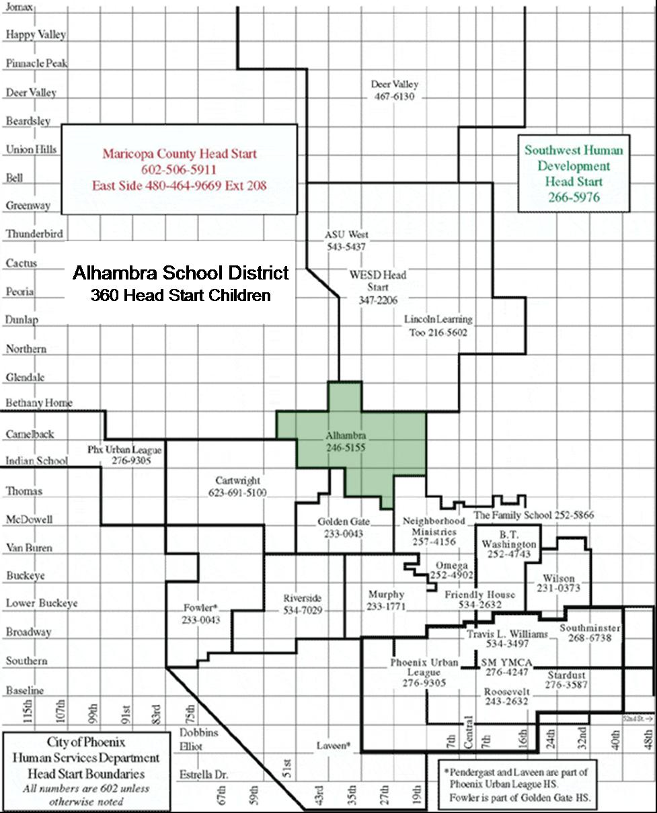
City of Phoenix Head Start

Program Approvals

Program Year 39 (2004-2005)

Community Assessments, Goals, Objectives, and Action Plan

Delegate Agency Name: Alhambra School District
Address: 3802 West Maryland
Phoenix, AZ 85019

APPROVED: Date:
Board Chairperson/Executive Director

APPROVED: Date:
Delegate Agency Director

APPROVED: Date:
Policy Committee Chairperson

Alhambra School District

Refunding Application

Program Year 39 (2004-2005)

Profile of the District

Alhambra Elementary School District No. 68 is a Pre-K-8 school district in Phoenix, Arizona with a student enrollment of 14,444 as of June, 2003. Located in west-central Phoenix and south-east Glendale, Alhambra neighborhoods are characterized by a mixture of older low to moderate income housing, multi-family apartments and older mobile home parks.

According to an Arizona Republic analysis four of the top five apartment slums in Phoenix are in the Alhambra School District area, with the worst of the worst living conditions. Many poor Head Start families are forced to live “in slum-like housing in a state with weak laws and powerful landlord lobbies.” (Hermann, Kossan & Konig, 1998). For “The Best Run City in America” these third world shanty towns are a disgrace to which most people turn a blind eye.

Once a stable family community, Alhambra District has undergone a major transformation in recent years. Many neighborhoods have shifted from older, established families to lower-income, multi-family households. This population shift has created some dramatic changes in the socio-economic levels of families living in the district. Several factors contribute to the changing demographics. Phoenix’s aggressive building cycle, downtown expansion, and the continued freeway construction have displaced many inner-city families. The Alhambra District has affordable housing and government subsidized properties which have attracted these displaced inner city families, refugees and immigrants, and contributed to the drastic change in the ethnicity, socioeconomic level and cultural makeup of the District.

Poverty

In the last 12 years, the proportion of Alhambra students qualifying for free or reduced lunches has risen dramatically. In the 1990-91 27% of District children received free or reduced cost lunches. In March 2003, the qualification rate more than trebled to 86%. Individual schools have even higher proportions, as shown in the accompanying table.
School | % Qualifying for  Free or Reduced  School Lunch 2003
Westwood | 96.8%
Andalucia Primary | 95.6%
Montebello | 94.5%

Statistics show that family poverty for kindergarten students is even higher than the school average, confirming that younger, poorer families are moving into the Alhambra School District. An estimated 1,808 four-year-olds reside in the district. Based on past statistics, a minimum of 75% of these preschoolers live at or below the poverty level. For the estimated 1,356 four-year-olds who are at or below the poverty level the City of Phoenix Head Start funds services for just 610 District children or 45%, of those in poverty. Alhambra Head Start serves 360 of these children.

Public Health Care Eligibility

Another indicator of poverty is eligibility for the Arizona Health Care Cost Containment System (AHCCCS). Families that are AHCCCS-eligible must be significantly below the poverty level as defined by the federal Head Start program. As of May 1997, 73% of Alhambra Head Start students had qualified for AHCCCS, placing them significantly at-risk. Other data show that 99% of the enrolled population in the Alhambra Head Start program require social services.

Student Mobility

Low family stability is also a byproduct of changing demographics. In 1990-91, the student mobility rate for Alhambra School District was 8.5%. The 1998-99 rate of student mobility in the district has fallen from 37% to 29% due to an upturn in the national economy at that time. For the 29% who do move, poor economic conditions, family problems, substance abuse, poor health, crime or delinquency, non-existent or inadequate coping skills, failure to bond with the local community, or dissatisfaction with local schools are still reasons for a high mobility rate.

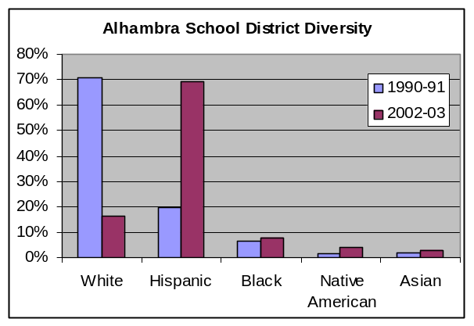
Race and Ethnicity

Alhambra School District has become more ethnically diverse as well as more economically depressed. The accompanying graph shows changes in the district’s racial and ethnic composition from 1990-91 to 2002-03. White residents dropped from 71% to 16%; Hispanic residents increased from 19% to 69%; other racial and ethnic groups grew somewhat.

Children in neighborhood schools speak 61 different languages, reflecting the cultural diversity of the area. Of children in grades K-8, 52% are non-English speaking or have limited English proficiency. In preschool the numbers are significantly higher. In 2002-03, the district identified 257 refugee and 1,905 immigrant families among the school population.

Alhambra Head Start Three-Year Plan

The top three concerns established through the comprehensive community needs assessment of Fall 2003 in the Alhambra School District Community are:

- Affordable medical services
- Affordable dental services
- Increased English as a Second Language classes for adults

Alhambra Head Start and Alhambra School District have taken on the challenge of meeting these top three priority community needs.

Alhambra School District’s Assistant to the Superintendent of Schools is collaborating with the local hospitals to provide medical services to all the uninsured and underinsured Head Start children. Right now, preschool siblings of elementary school children without medical insurance have access to the free medical clinics in their home school area.

Alhambra Head Start was fortunate to have secured a program improvement grant to purchase portable buildings, of which one has been designed to house a dental clinic. Alhambra Head Start, Alhambra School District and Restorative Justice Resources Coalition are working to secure free dental services for all uninsured children in the Alhambra School District.

Although ESL classes were expanded to 11 classes, the community needs assessment indicated additional adult ESL classes as a continued top priority. The classes are offered throughout the day and evening to accommodate different schedules. Alhambra School District will apply for other grant funding available to expand the ESL program.

Booker T. Washington
Child Development Center, Inc.

City of Phoenix Head Start Map Showing Individual Delegate Agencies

Booker T. Washington Child Development Center, Inc.

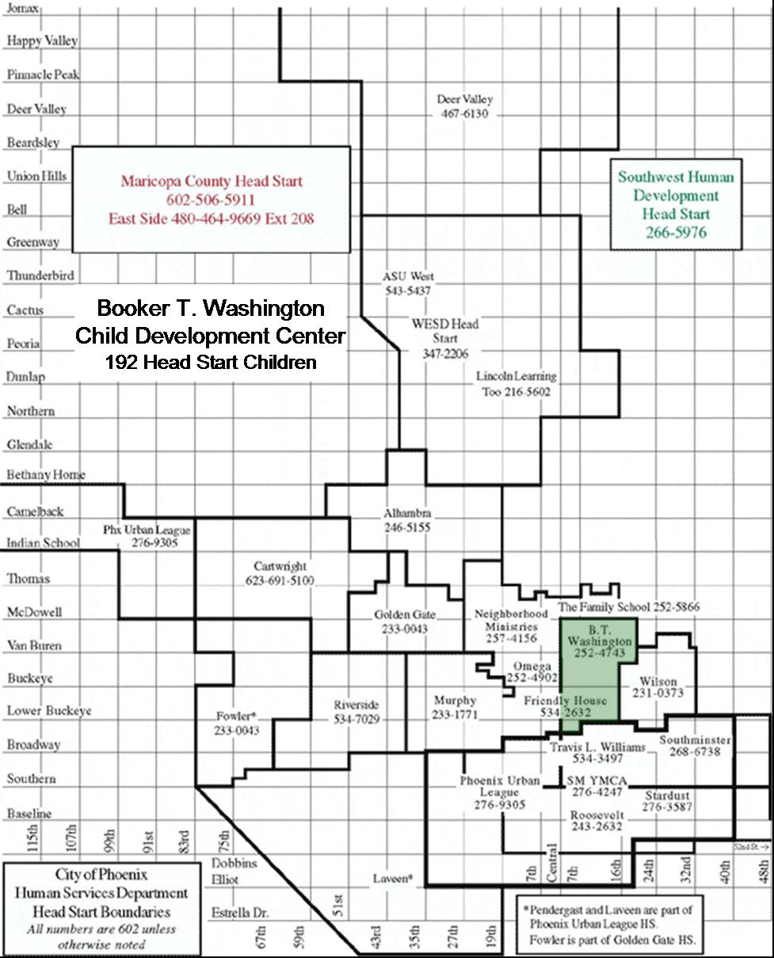
City of Phoenix Head Start

Program Approvals

Program Year 39 (2004-2005)

Community Assessments, Goals, Objectives, and Action Plan

Delegate Agency Name: Booker T. Washington
Child Development Center, Inc.
Address: 1519 East Adams St.
Phoenix, AZ 85034

APPROVED: Date:
Board Chairperson/Executive Director

APPROVED: Date:
Delegate Agency Director

APPROVED: Date:
Policy Committee Chairperson

Booker T. Washington Child Development Center, Inc.

Refunding Application

Program Year 39 (2004-2005)

Profile of the District

Booker T. Washington Child Development Center is one of the City of .Phoenix's original Head Start programs. Now in Its 37th year, Booker T. Washington services 192 low income children and their families who live within the boundaries of the Phoenix Elementary School District I, primarily in the Eastlake Park and Garfield neighborhoods. The program consists of 12 classrooms:

- 1 four year old classroom located at Shaw Elementary School. This classroom includes 5 severely disability children referred by Phoenix Elementary School District;
- 2 four year old classrooms at Ann Ott Elementary School - 1 AM class and 1 PM class;
- 1 three year old classroom located in the Sydney P. Osborn Housing Projects;
- 2 four year old classrooms at 1525 East Adams;
- 1 three year old classroom and 3 four year old classrooms located at 1522 East Adams;
- 2 morning and afternoon Extended Day classrooms at 1522 East Adams.

Area Served

Booker T. Washington program serves the east-central portion of the Phoenix inner city, between Interstate 17 and Thomas Road, and between 7th and 32nd Streets. The program is in a 20-square mile section of the central city designated by HUD as the Phoenix Enterprise Community where a large percentage of families live below the poverty level. Although many of the traditional poor have moved from unemployment to work, and from welfare to work, their minimum wage earnings still position them below the poverty level.
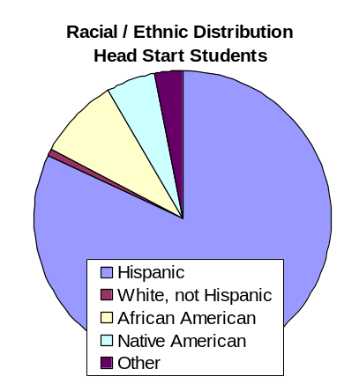

Race and Ethnicity

Booker T. Washington Head Start students are primarily Hispanic (82%). Just 1% are White; 9% are African-American, and 5% are Native American. The 3% who classify themselves as Other are of mixed race

Housing

The Booker T. Washington community is a transitional community with several public housing sites and a large percentage of Section 8 housing. Families are moving on to better living environments by purchasing homes, renting single housing homes and improving their living conditions.

This transitional status leads to high turnover among students. During the last program year, Booker T. Washington had 41 students (21%) drop from the program. During September and October 2003, a total of 18 students (9%) dropped out of the Head Start program

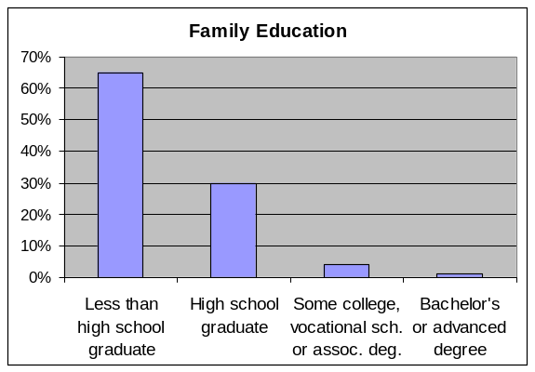
Education

Of the families served by Booker T. Washington Head Start, 65% have less than a high school education. Just 30% completed high school, 4% attended some college, and only 1% earned a bachelor’s degree or higher level of education.

Poverty

City of Phoenix Poverty & Population:
- 13% of children under 5 live in poverty
- 16% of the population live below 100% of the federal poverty level
- 37% of the population live below 200% of the federal poverty level
- 4% of the population are impoverished single mothers with related children under 18
- 9 % of the population is under 5, and 29% under 18.
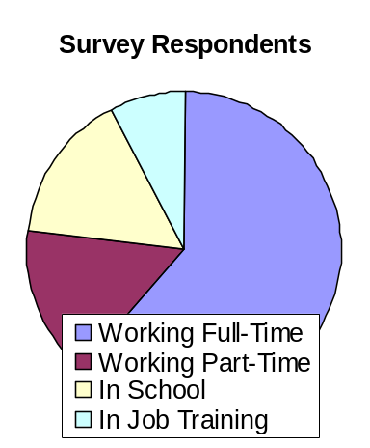

Employment

Of the people who responded to the community needs survey, less than one-third (32%) were working full-time. An additional 8% work part-time, 8% are in school, and 4% are in job training, but 52% are either unemployed or not in the workforce.

Parental Involvement

Parents are interested in learning more about how to work with their children and how to interact with their children during class time and at home. More books are being read at school and at home, and parents are sharing more with other parents and the community. Attendance and a growing number of participants at Booker T, Washington’s quarterly Literacy Days (200+) and Weekly PACT meetings (50+) justify the interest, concern and involvement of parents in the education of their children.

Booker T. Washington has a number of returning families. Each year we see the number grow, showing parent's confidence in BTW, and the concern and interest of parents in their child's continued educational growth and development.

Community Needs

As reflected in community survey, the top six needs of the community are:

ESL/Citizenship

The Booker T. Washington community includes a large number of monolingual Spanish speakers. At least 150 Head Start parents are undocumented, representing 78% of the student body, and 95% of the Hispanic population. Responding to this need, Booker T. Washington's weekly PACT sessions include a 15 minute ESL class. Parents are also referred and provided information about various other community ESL classes and resources.

Housing

The Booker T. Washington community has several housing projects and slum properties Tenants are charged excessive rates for rentals that have no running water, or that have other health and safety problems such as plumbing or heating issues.

Child Abuse/Domestic Abuse:
Need | Percent Responding
ESL – English as a Second Language | 50%
Housing | 47%
Domestic Violence | 34%
Child Abuse | 25%
Citizenship | 34%
After School Care | 30%

Booker T Washington families face a variety of issues that are closely associated with domestic abuse and child abuse, including: frustration, low self-esteem, poverty, stress, low education attainment, alcohol and drug abuse and a survival focus.

After School Care:

Because of the many housing projects in the area, parents that reside in the housing projects are required to seek work or volunteer community hours as part of their rental agreement, they therefore have a greater need for child care. They face higher stakes, as work provides not only a regular income, but is a precondition for housing as well.
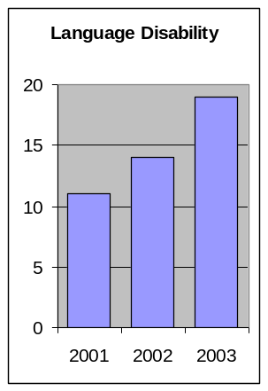

Language Disability

Booker T. Washington’s Head Start students are experiencing growing frequency of student language disability over the past two years. In 2003, nearly 10% of the Head Start students (19) suffered from a language disability.

To help these children, Booker T. Washington provides:
- Screenings to identify disabilities
- Speech therapist, through an outside service provider, for students identified needing services. Services include therapy sessions, monthly meetings with parents and yearly reviews.

Community/BTW Program/Staff Comparison:

Results from community survey revealed that Booker T. Washington Head Start has effective coverage, and that nearly half the respondents were Head Start families.

Children currently enrolled 46%
Don't know about the program 2%
Interested, not age eligible/unable to contact 33%
Not interested 5%
Another child care provider 8%
No Head Start in their area 5%

BTW Community Assessment Process

Executive Director met with staff to discuss the Community Assessment process. Teachers were instructed to inform parents of the process.

Parents, including Policy Council members, and teachers distributed community surveys door-to-door throughout many parts of the services area. Community surveys were also distributed to Eastlake Park Association members by BTW Board of Directors Vice President, Calvin C. Goode.

Completed community surveys were picked up by Grantee representative September 12, 2003

SOURCES:
U.S. Census Bureau
Chris Santiesteven, Phoenix Elementary School District 1
2002-2003 Booker T. Washington PIR
Booker T. Washington Student Data Base
Parent Surveys
Grantee - City of Phoenix

Cartwright School District

City of Phoenix Head Start Map Showing Individual Delegate Agencies

Cartwright School District

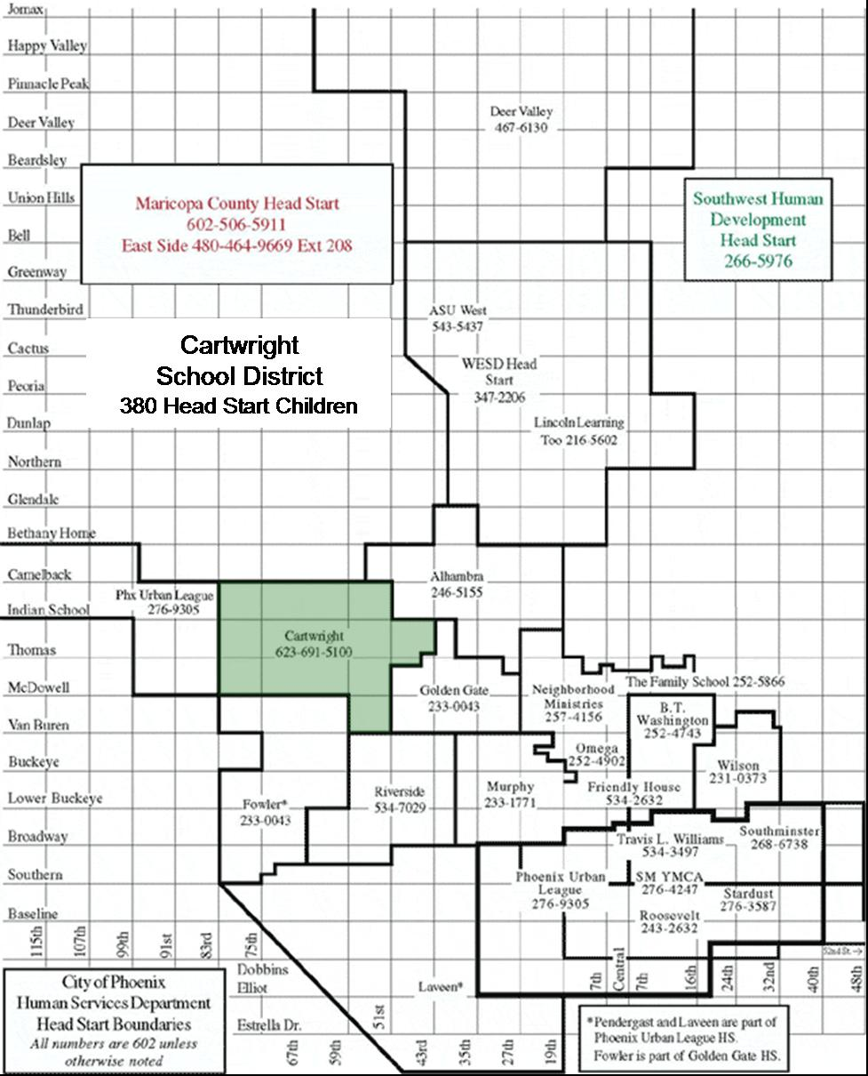
City of Phoenix Head Start

Program Approvals

Program Year 39 (2004-2005)

Community Assessments, Goals, Objectives, and Action Plan

Delegate Agency Name: Cartwright School District
Address: 5480 West Campbell
Phoenix, AZ 85031

APPROVED: Date:
Board Chairperson/Executive Director

APPROVED: Date:
Delegate Agency Director

APPROVED: Date:
Policy Committee Chairperson

Cartwright School District

Refunding Application

Program Year 39 (2004-2005)

Cartwright School District Profile

The Cartwright School District #83 is a PreK-8 district. Cartwright boundaries encompass the Maryvale area of the Phoenix city, generally bounded by Camelback and McDowell Roads, and 43rd and 83rd Avenues.

Cartwright currently serves over 19,000 children throughout the district. Enrollment is expected to continue growing incrementally in the coming years. Cartwright currently provides services to children and families on twenty-four campuses scattered throughout the district.

The population served by the Cartwright School District has seen steady increases over the past several years. In the last five years, the increases are marked not only because of their sheer size but because of the number of children coming to school speaking languages other than English. The District is designing strategies to ensure that all children attending district schools have an appropriate educational experience. The ethnic breakdown of children currently served by Cartwright is:

Approximately 66% of the children attending Cartwright schools identified Spanish as their Native language.
White | Hispanic | African  American | Native  American | Asian
134 | 1,093 | 16,599 | 220 | 1,886
0.7% | 5.5% | 83.3% | 1.1% | 9.5%

The impact of welfare reform, immigration reform and educational reform nationally and statewide—and all of their accompanying strategies—affect the District in several ways. Parents find themselves under significant amounts of new stress as they struggle to find employment. A significant number of jobs that parents of District children are able to find do not pay enough to provide the necessary level of support for the size of families they head. Many of the jobs are part-time or temporary. They lack quality affordable childcare and early childhood education programs available in the immediate community. Transportation to and from work and child care sites pose particular hardships on families who are making the effort to search for and maintain employment within the city.

An estimated 2,200 preschool age, eligible children live win the Cartwright School district boundaries. Cartwright currently provides services to approximately 650 preschool children, including 378 served with Head Start funds; 120 served with Child Development Block Grant Funds and 192 served in the Early Childhood Special Education program.

Head Start

The Cartwright School District is the Delegate Agency for the Cartwright Head Start program. The Cartwright Head Start program is housed in eleven classrooms at the Cartwright Early Childhood Center, containing 10 classes with a total of 179 children meet in the morning session (8:00 - 11:30 a.m.) Ten classes with a total of 179 children meet in the afternoon session (12:00 noon -3:30 p.m.). One class serves children in a full day setting (8:00 a.m. - 2:30 p.m.)

Cartwright Head Start has provided services in the Cartwright School District boundaries over the past 33 years. During that time almost 8,000 children and families have been served. At the time of this writing. the program is funded for 378 children.

The program is staffed as follows:
1 - 0.5 FTE CECC Coordinator
1 - 0.5 FTE Assistant Coordinator
1 - Education Coordinator
1 - Administrative Specialist
1 - Administrative Assistant
5 - Head Start Instructors (Single Session)
1 - Head Start Instructor (Double Session)
5 - Teachers
21 -Instructional Assistants
8 - Bus Monitors

The City of Phoenix provides Caseworkers and Program Assistants to assist in implementing the program, including:

2 - Program Assistants
1 - Caseworker II
5 - Caseworker I
1 - Mental Health Counselor

Cartwright School District Community Strengths

- The Cartwright School District serves 378 Head Start children in 11 classrooms on the Early Childhood Center Campus. This organizational placement of the Head Stan program ensures that Head Start families and children are served as registered district students and families. The Early Childhood Center Campus including all facilities and playground are maintained by the district and provided as In-Kind to the Head Start program.

- An Average of 14% of the Head Start enrollment are eligible preschoolers placed through Individual Education Plans in the least-restrictive environment.

- Head Start is the District model for all early childhood programming at the Cartwright Early Child Center. This programming model includes curriculum, parent involvement strategies. staff development, and program operations.

- The partnership with Epworth Child Care allows the District to provide space for up to twenty children from working families to be in care 6:00 a.m. - 5:30 p.m. daily, including days when classes are not in session and inter-session periods.

- The Cartwright District and its residents have welcomed and supported the Head Start program since 1967. Each year for the past 20 years, parents and community volunteers have donated over 10,000 hours of volunteer service per year. This volunteer services represents over $750,000 in In-Kind support to the Head Start program.

- Over the past ten years the Cartwright School District has provided a conservative estimate of $225,000 In-Kind service to the Head Start program each year. This means that over the past ten years, the district has donated over $2.5 million dollars worth of goods and services in support of the Head Start program.

- The district is currently working to align curriculum goals and objectives beginning in Preschool and through the eighth grade.

Surveys

Cartwright Head Start participated with other City of Phoenix Delegate Agencies in a Community Needs Assessment project during the fall of 2003. The purpose was to gather information about the current status of the community. Head Start Parents were provided with surveys and asked to return them to their immediate classroom.

The following data sources were used to compile this report:

- Cartwright School District data regarding enrollment by grade level were used to project the number of preschool aged children in the district.

- Cartwright School District Data was used to project the number of income eligible preschool aged children eligible to participate in the Head Start program.
- Based on Student Enrollment and Staff Assignments Summary (chart 1), approximately 2,200 children will be age-eligible for preschool services in the Cartwright School District.
- Based on the number of children in the Cartwright School District (chart 2) who are eligible for free lunches in November of 2003 (71%), about 1,564 age-eligible children will also be income-eligible for Head Start services.

- The 2002-2003 Program Information Report was used to report program demographic information.

- The data gathered during the survey portion of the Community Needs Assessment data was used to report respondent's information.

Community Survey Demographic Information
- 196 people responded to the survey.
- An average of 2.8 adults are in each household.
- Respondents have lived in the community an average of 5.3 years.
- An average of 2.9 children are in each household.
- The average age of children in each household is 5. 1 years.

Racial/Ethnic Composition
- 96% of the respondents were of Hispanic origin.
- 2% of the respondents were African American
- 1 % of the respondents were White/Caucasian
- 1 % of respondents were Native American or Asian
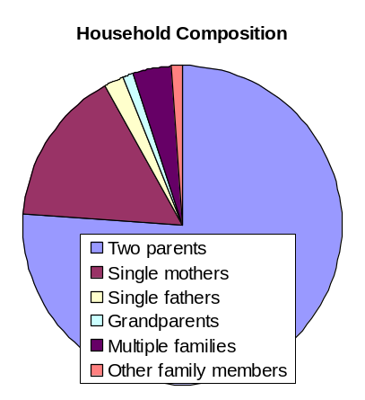

Household Composition
- 76% of the families are two parent families
- 16% of the families are headed by single mothers
- 2% of the families are headed by single fathers
- 1 % of the families are headed by grandparents
- 4% of the households have multiple families living together
- 1 % of the families are headed by other family members.

Employment Status
- 45% are working full time
- 9% are working part time
- 3% are seasonal workers
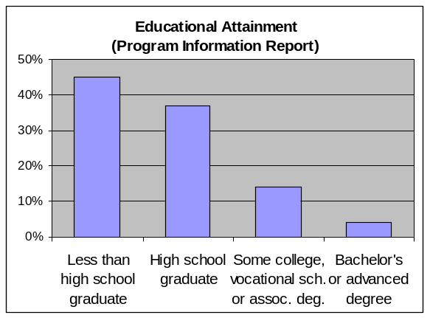

Educational level (PIR)
- 45% have less than a high school education
- 37% are high school graduates or have a GED
- 14% have some college, vocational school or AA degree
- 4% have a Bachelor's or advanced degree

Average Household Income Per Month
- $4,879

Need for and Accessibility of Community Services

As part of the Community Needs Assessment Survey, respondents were asked to assess community resources. The top five needs for more services, and the percentages of respondents who identified that service, include:

- ESL English as a second language 64%
- Neighborhood safety 60%
- Dental care 55%
- Job training 54%
- Medical care 51%

All other services were identified by fewer than half the respondents.

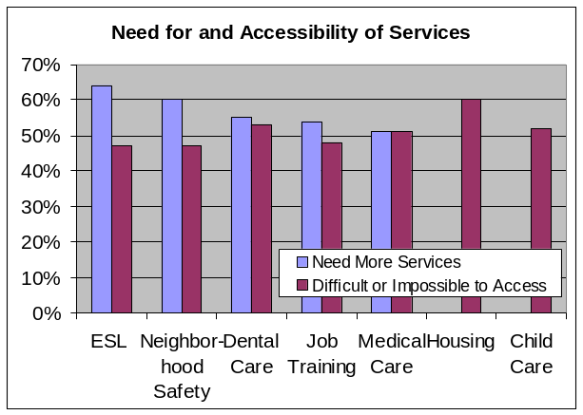
Respondents to the Community Needs Assessment Survey were also asked to rate the accessibility of community resources. The most-difficult-to-access services, and the percentage of respondents who rated the service as either “difficult” or “impossible” to access, include:

- Housing 60%
- Dental Care 53%
- Child care 52%
- Medical care 51%
- Job training 48%
- ESL English as a second language 47%
- Neighborhood safety 47%

All other items scored below 40%.

Prioritized Needs

Note that each of the most-needed services are also on the most-difficult-to-access list. Following are the items identified through the community needs assessment as the
highest priority needs in the Cartwright Head Start Service Area, listed by priority.

- The community needs adult education services including ESL, GED, citizenship and job training.

- The community needs general neighborhood safety programming that will address issues ranging from juvenile and adult crime prevention to domestic violence and child abuse.

- The community needs youth services programming, including school dropout prevention, job readiness training, gang prevention and substance abuse prevention.

Deer Valley Unified School District

City of Phoenix Head Start Map Showing Individual Delegate Agencies

Deer Valley Unified School District

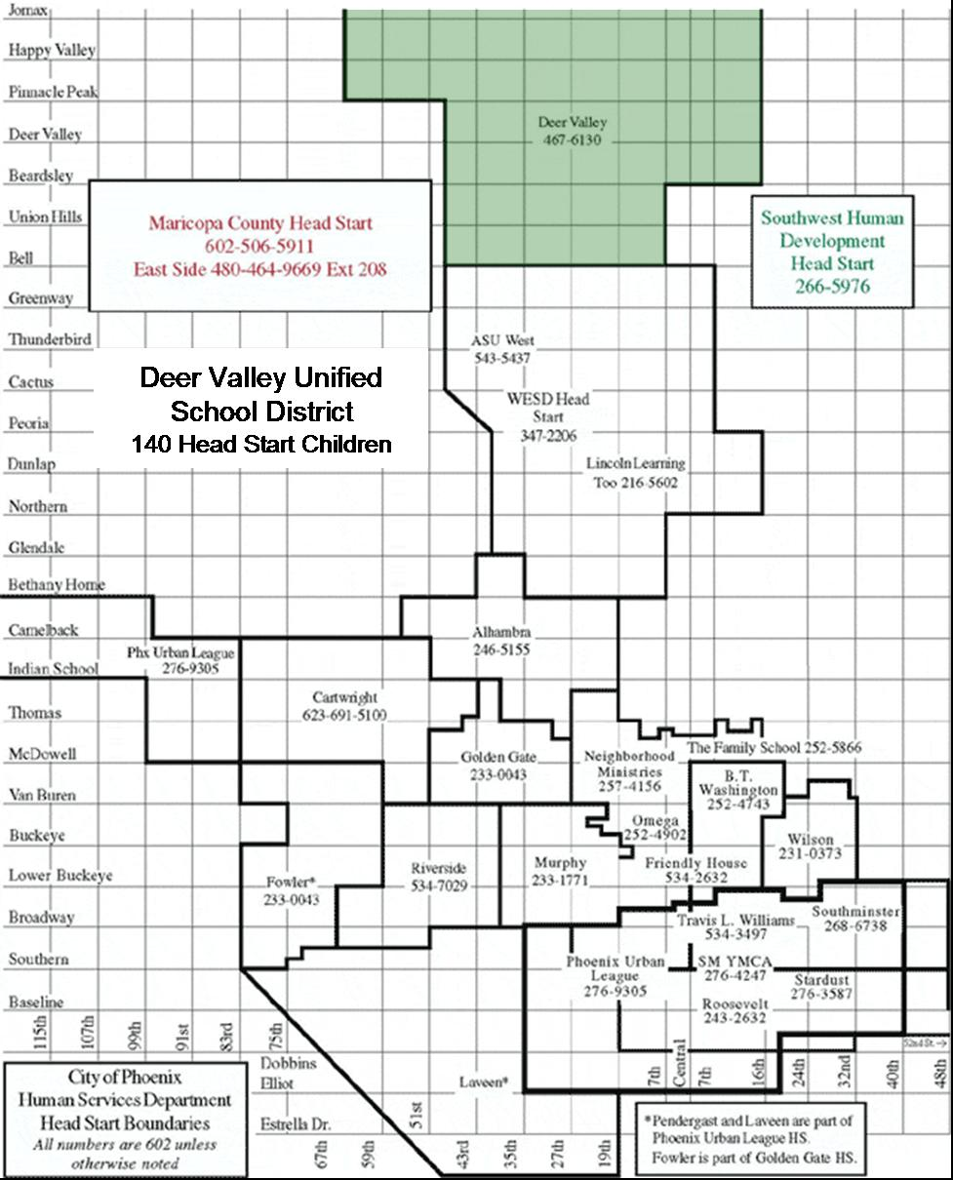
City of Phoenix Head Start

Program Approvals

Program Year 39 (2004-2005)

Community Assessments, Goals, Objectives, and Action Plan

Delegate Agency Name: Deer Valley Unified School District
Address: 18440 N. 15th Ave.
Phoenix, AZ 85023

APPROVED: Date:
Board Chairperson/Executive Director

APPROVED: Date:
Delegate Agency Director

APPROVED: Date:
Policy Committee Chairperson

Deer Valley Unified School District

Refunding Application

Program Year 39 (2004-2005)

Deer Valley Unified School District Profile:


Deer Valley Unified School District #97 (DVUSD) is a PreK-12 district. It encompasses the northern-most area of the City of Phoenix and adjoining cities and unincorporated areas of Maricopa County. Its 367 square miles make it one of the largest districts, in area, in the state, and the largest area district in Maricopa County. Enrollment of more than 30,140 students makes DVUSD one of the largest districts in the state. Deer Valley is also one of the most rapidly growing districts in Arizona, with a student population increase greater than 5 percent annually. By 2005-06 DVUSD is projected to experience an enrollment increase of 6,000 students, or 20%. By 2008-2009 projected enrollment will be 43,446, a 44% increase from today. The District has 31 campuses and anticipates constructing two campuses each year to keep pace with the growth.

An estimated 13,000 new students will enter DVUSD schools in the next few years. Several master planned developments will bring nearly 100,000 new residents into the community. The state School Facilities Board has already approved completing one new high school in 2004 and two elementary schools by 2005. Applications are pending for another high school for 2006 and five additional elementary schools by 2009.

The number of registered preschoolers is growing as well. Projections for the 2004-05 school year estimate that 500 students will be in self- contained preschool classrooms, in addition to the 140 funded Head Start preschoolers.

Demographic Profile

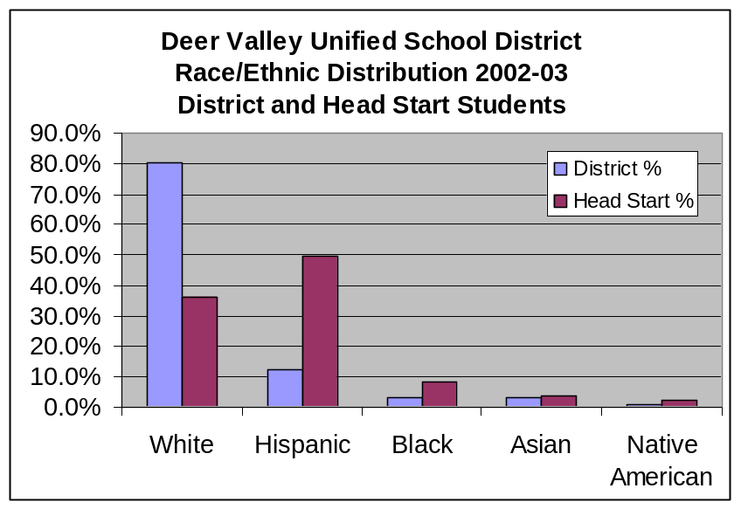
Deer Valley has become a district of great diversity. While portions of the western and the northern areas of the district house schools that serve primarily upper-income communities—including the much publicized Anthem Community in New River—the eastern area has substantial pockets of poverty. Large apartment complexes, trailer courts, and the desert provide low-cost housing for many families.
The 2002-03 student ethnic breakdown of DVUSD indicates a minority enrollment of 19% as compared to the district’s Head Start enrollment of 64% minority. The District’s minority population increased 3% this year.
Race/Ethnic  Group | District % | Head  Start %
White | 80.3% | 36.3%
Hispanic | 12.4% | 49.6%
African American | 3.1% | 8.1%
Asian | 3.3% | 3.7%
Native American | 0.9% | 2.2%

Head Start Job Status

Parents of Deer Valley Head Start students experience significant unemployment and under-employment, based on 2002-03 PIR survey data. Over 39% are unemployed, and only 7% have two working adults in the household. A different survey yielded similar results, but showed that nearly one-third of working adults works part-time, instead of full-time.
Employment  Status | Number | Percent
Full Time | 64 | 45.7%
Two-parent/  guardian employed | 10 | 7.1%
Training/School | 11 | 7.9%
Unemployed | 55 | 39.3%

Head Start Educational Level
Educational Level | Number | Percent
Less than high school graduate | 49 | 32.5%
High school graduate or GED | 79 | 52.3%
Some college, vocational, or  associate degree | 14 | 9.3%
Bachelors or advanced degree | 9 | 6.0%

Nearly one-third of the parents of Head Start students did not graduate from high school, and 85% have no education beyond high school. Just 6% have a college degree.

Head Start Annual Income Status

Deer Valley Head Start families are relatively poor, with only three in eight earning $15,000 or more. Over half make less than $1,000 per month. Deer Valley has only five over-income families (excluding SSI, TANF, SSDI, and Foster Families) using 2002 Poverty Guidelines, comprising less than 4 percent of Deer Valley Head Start families.
Income Range | Number | Percent
$0-2,999 | 16 | 12.5%
$3,000-5,999 | 16 | 12.5%
$6,000-8,999 | 12 | 9.4%
$9,000-11,999 | 21 | 16.4%
$12,000-14,999 | 15 | 11.7%
$15,000 and over | 48 | 37.5%

District Income Status

2003-04 District enrollment data reports that 6,147 District children (20%) are eligible for free and reduced meals.
Language Profile | Number | Percent
English | 114 | 69.1%
Spanish | 44 | 26.7%
Asian | 5 | 3.0%
Other | 2 | 1.2%

Language Profile

English is the predominant language at Deer Valley Head Start, spoken by 69% of students, but over a quarter speak only Spanish, and another 4% speak other languages.

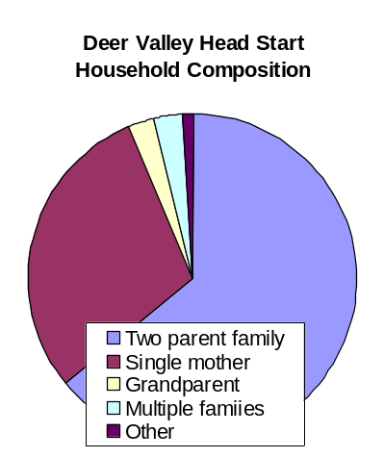
Household Composition

The household composition for the Deer Valley Head Start families are mostly two parent families (62%). Single mothers comprise a large number (28%) of the Head Start families. A small number of households include the grandparents as the primary caregivers (3%), multiple family situations (3%) or foster families (1%) as reflected in the chart below.

Mission Statement

The mission of Deer Valley Unified School District is to graduate students as contributing members of society, empowered to shape their futures using knowledge and skills gained through educational services developed in partnership with students, family, community, business and government and provided within a safe environment.

In support of the mission of DVUSD and the City of Phoenix Human Services Department Head Start Program, the Deer Valley Head Start Program’s mission is: To collaborate with parents, educators, and the community to provide quality child development services that promote family well-being and self-sufficiency and prepare children to make positive choices and experience success in school.

Deer Valley Community Strengths

Some strengths of the District community include:

- Head Start provides services to 140 families at 5 elementary sites within the Deer Valley District, under the Special Education Services Department. This organizational placement of the Head Start program assures that families and children are served as registered district students and families. The beautiful classrooms, state-of-the-art phone systems and convenient playgrounds are maintained by the District as in-kind contributions to the program.
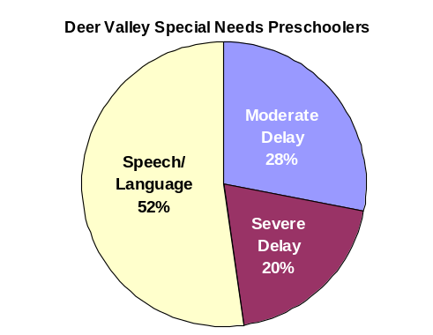
- DVUSD served 406 special needs preschoolers in 2002-03. Of these preschoolers 114 are certified Preschool Moderate Delay (PMD), 80 are Preschool Severe Delay (PSD) and 212 are Preschool Speech/ Language (PSL). Each child can receive speech as a related service as well as occupational, physical and adaptive physical education therapy. The District also provided vision (2 preschool children) and hearing impaired services (1 preschool child).

- An average of 26% of Head Start’s students are eligible preschoolers placed through Individual Education Plans (IEPs) in a least-restrictive environment.
- Head Start is the District’s model for the State Early Childhood Block Grant funded preschool classrooms. The established Head Start dollar per child campaign is funded annually to assure Head Start’s quality comprehensive service delivery. The program is integrated into the federal program by providing full day services to 40 children of parents/guardians who work or go to school at least half-time.

- The Parent Policy Committee and District recommended that the parent education program (for example: GED, ESL and basic computer classes) be maintained.

- Deer Valley Head Start’s full-day program is one outcome of the previous three-year plan for Head Start. To support this program further, DVUSD and Head Start collaborated with the Deer Valley YMCA in 1997; this three-way partnership provides full-day service to families. The YMCA provides daily early morning and late afternoon care and holiday and recess care (as needed) to Head Start children at no cost to the participating families.

- The Deer Valley community has welcomed and supported the Head Start program. From November 1992, through October 2003, Head Start has documented 42,239 volunteer hours donated by 2,525 parent and community volunteers. This translates into $358,861 in volunteer in-kind support to the Head Start program.

- The Governing Board of DVUSD is very supportive of prevention and early intervention services programs. The District is fortunate to have Dr. Susan Burke, a nationally-recognized early childhood expert and active child and family advocate, as Governing Board President.

Survey Results

A total of 140 survey forms were distributed to families, and when possible these forms were completed during home visits or in person while a family member was at a Head Start site. A total of 78 survey forms were returned, for a 55% response rate.

Deer Valley Community Needs:

Deer Valley Head Start conducted a community assessment to collect data that would influence the goals and objectives of the 2004-07 Three Year Plan for Head Start in Deer Valley. The Community Needs Survey was presented for approval to the Associate Superintendent of Education Services, (James Garver) on August 25, 2003. Upon approval, it was presented for approval to the Policy Committee. All surveys were completed and submitted for data analysis to the City of Phoenix on October 17, 2003. The survey data analysis was returned to Deer Valley Head Start on November 7, 2003.

In addition to this community needs survey, Deer Valley Unified School District has established a Strategic Planning Committee to develop goals and objectives based on the needs of the community. This committee’s plan will influence and support the goals for the Deer Valley Head Start program. Parents and staff of Deer Valley Head Start will continue to work collaboratively in this strategic planning process to develop long range goals and an action plan based on further analysis and discussion of the findings below.

Community Needs Assessment Findings

Based on the assessment data, the following areas were identified to be of highest concern:

- Housing
- Medical/Dental Care
- Job Training
- Quality/Affordable Child Care/After School Care
- Assistance for food, clothing and utilities
- Neighborhood Safety

- 40% to 46% of respondents felt housing was difficult to access and identified this as an area in need of more services. 29% indicated the quality of housing services fell below average.
- 36% of respondents found child care difficult to access, and 44% need more services for after school care.
- 28% of respondents found that existing job training services were difficult to access, and 42% indicated a need for more services.
- 52% of respondents indicated a need for more dental care services. Medical and dental care were identified areas of need with the greater need indicated for dental care.
- 47% of respondents indicated a need for more services in accessing assistance for food, clothing and utilities.
- 42% of respondents requested a need for more neighborhood safety services.

Future Focus

The long range goals for 2004-07 include the following:

- To improve community partnerships and identify resources in order to assist families to locate necessary assistance which may include housing, job training, medical and/or dental care.
- To improve quality and availability of child care and neighborhood safety through community resources and development of partnerships between families, providers of child care and law enforcement.

The current focus for parents and staff of Deer Valley Head Start is to use this report and data analysis, with results of the District Strategic Plan, to develop more specific short range goals and objectives to meet the needs of the families served. The Policy Committee will review these goals and make any necessary revisions. Then, strategies and steps to attain the goals will be developed and implemented.

Golden Gate Community Center, Inc.

City of Phoenix Head Start Map Showing Individual Delegate Agencies

Golden Gate Community Center, Inc.

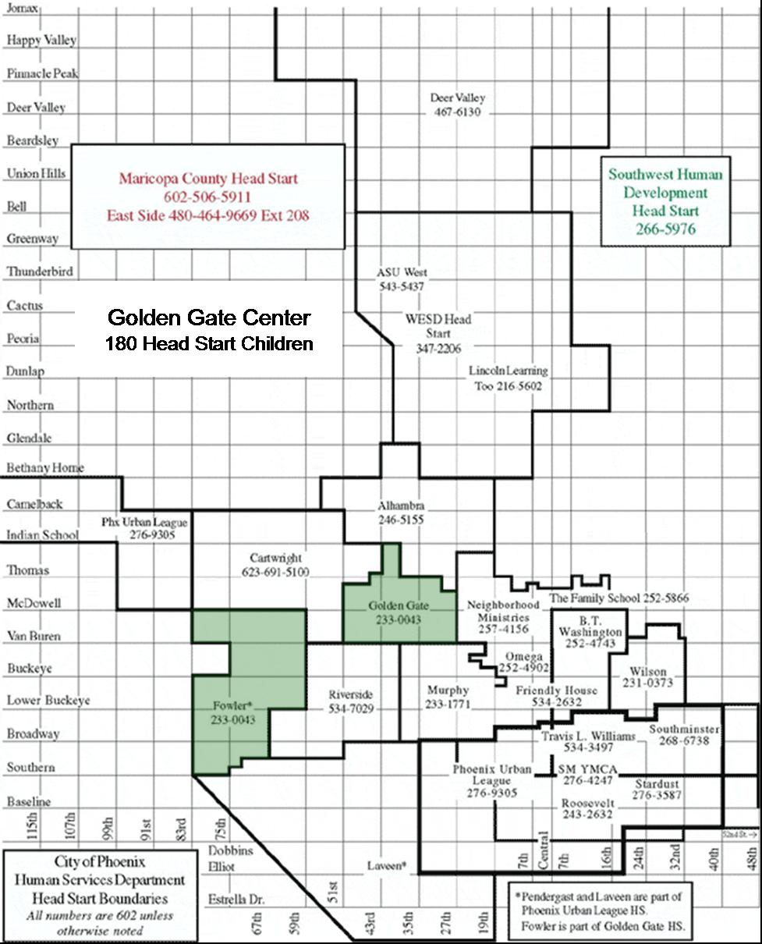
City of Phoenix Head Start

Program Approvals

Program Year 39 (2004-2005)

Community Assessments, Goals, Objectives, and Action Plan

Delegate Agency Name: Golden Gate Community Center, Inc.
Address: 1625 N. 39th Ave.
Phoenix, AZ 85009

APPROVED: Date:
Board Chairperson/Executive Director

APPROVED: Date:
Delegate Agency Director

APPROVED: Date:
Policy Committee Chairperson

Golden Gate Community Center, Inc.

Refunding Application

Program Year 39 (2004-2005)

Mission Statement

Three mission statements guide Golden Gate Head Start programs. The mission statements of the Community Center and the Grantee are similar in their focus on empowerment of the individual and of family units, and of assisting in the development of both. The mission statement of Arizona’s Children Association blends both of these statements with a slightly different perspective:

Based on a strong commitment to the welfare of children and families, the highest priority is to provide each child with a health family environment on a permanent basis. Toward that end, the Arizona’s Children Association will provide a broad spectrum of services that foster healing and promote the emotional well being of children and families. The Arizona’s Children Association will advocate for child welfare in every venue, if necessary, to accomplish this mission.

All three mission statements are compatible and leave no doubt that the total family is the focus of the work that is being done at Golden Gate Community Center/ Head Start.

Golden Gate Head Start Profile

Golden Gate Head Start serves two school districts in the southwestern section of Phoenix:

Isaac Elementary School District has one preschool, six elementary schools (K-8), two middle schools (6-8), one alternative middle school, and a magnet school for fine arts. Students from this district move on to the Phoenix Union High School District. Its 6.8 square mile attendance area is in west-central Phoenix.

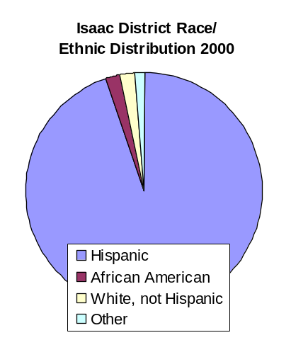
The District’s new superintendent, Dr. Kent Scribner, recently presented the School Board with his 100-day report, where he focused on many challenges and areas of concern to the District. According to the 2000 census, of the adults aged 25 and older currently residing in the District, only 20.9 % have their high school diploma or GED, and 62% have limited English proficiency. Of the 8,791 students enrolled in Isaac District, 95% are Hispanic, 2% are African American, 2% are White, not Hispanic, and very small remaining percentages are divided among Native American and Asian families. (A group of families from Iraq and Pakistan recently moved into apartments across the street from the Community Center). 93% of students qualify for free lunch, up from 65% in 1990-91.

After many years of enrollment increases, the student population is now beginning to decline. The numbers of preschoolers, however, is increasing less quickly than in the past. The number of students with disabilities has also stabilized.

Two schools underperformed under the testing done for Arizona Learning; five schools underperformed under the No Child Left behind testing.

The District currently has 440 teachers. At least 60 must be replaced on a yearly basis, a relatively high turnover rate.

Key challenges for the District include:

- A safe living environment for the residents of the community
- Friendly customer service
- Revamping the organization chart
- Restoring trust between administration and individual schools

Very little new housing development is occurring within the Isaac District; some small pockets of new commercial development are emerging south of McDowell Rd. The corner of McDowell and 35th Ave. is still a focus of discussion related to what will replace a market that burned down several years ago.

A revitalization project between 31st and 35th Aves., McDowell and Palm Lane within the Isaac District is nearing completion. The area had been targeted by the City Council as a tract of manageable size that will help increase market values in the area. City actions in this program include: upkeep codes are enforced; housing is rehabilitated; multiple rental renovations take place; capital improvements occur (such as creating a loop street to cut down traffic); blight areas are eliminated. The private sector has responded with more than 20 new homes and another group of homes renovated.

Fowler Elementary School District No. 45 was established in 1895, and is located nine miles west of downtown Phoenix. The District encompasses approximately 12 square miles.

The District currently has four elementary schools and two middle schools. At least two more schools are on the drawing boards as new construction in this district continues to have a major impact. Over 4,000 homes have been built recently, and at least 5,000 new homes will be built within the next five years. Most of these home are affordable, from $90,000; however, one developer is considering starting a 40 acre with 4,000 sq.-ft. homes. By 2020, a total of 20,000 homes may be built, each with an average of 3.5 persons per unit. A new section of freeway—South Mountain Loop—is currently under consideration; while it may be 10 years to completion, it is already stimulating commercial development and new home construction. Current plans for commercial development in this area include a new Target Center and a Wal-Mart center. A new Sunrise Preschool recently opened. These facilities are primarily in the southern part of the district. Resources—such as medical and dental health facilities, libraries and supermarkets—are still not available for families in the northern portion of the District, and new resource development is not anticipated. The majority of families qualifying for Head Start services are primarily in the northern part of the district, a separation foreseen by the previous superintendent as the building was started in the mid 1990’s.

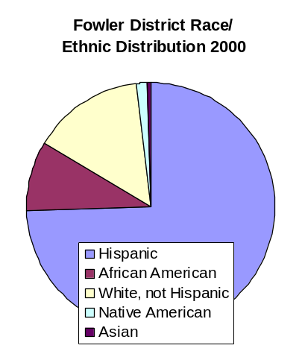
The influx of new families has increased the concentration of Spanish-speaking children, particularly in the Sunridge and Fowler elementary school areas, which have trailer courts, apartment complexes and other low-rent housing. In addition, a small area in the southern portion of the district—Santa Maria—is demographically similar to the areas surrounding the Fowler and Sunridge campuses. The children most likely to attend Head Start will be those who live in the area surrounding Sunridge, and other eligible children whose parents are able to provide transportation.

Fowler District demographics reflect the changes brought about by construction: 35% of the students in the district are Limited English Proficiency. Of the total enrollment of 3,232 students, 74% are Hispanic, 14% are White not Hispanic, 9% are African American, fewer than 1% are Asian and just over 1% are Native American. The mobility rate is currently very high, at 47%. The highest percentage of Hispanic students is at Sunridge and Fowler elementary schools.

Strengths and Needs of Head Start Children and Families

Survey respondents included Head Start families, and other Community Center clientele, including members of the ESL and GED classes, aerobics and recreational classes. Respondents’ average monthly salary was $1,672 per month. A two-parent family was reported by 70% of respondents. Ethnically, 96% of respondents reported Hispanic. Only 56% reported working full-time, and 10% reported part-time work; 16% indicated a need to find -time work.

According to Census data, the U.S. poverty rate in 2002 was 12.1%, up noticeably from 11.7% in 2001. For children, the poverty rate was 16.7%, unchanged from 2001, but significantly higher that for adults 18 to 64 and seniors 65 and over. The number of children in poverty increased to 12.1 million in 2002, from 11.7 million in 2001. In 2002, 7.2 million families were in poverty, up from 6.8 million in 2001.

Kids Count data provides information by state for. In Arizona, 36% of the population is Hispanic. For children under five, 20% live in poverty; 14% have no parents in the labor force; only 53% have both parents in the labor force. In addition, 31% of 18 to 24 year olds are not high school graduates. Ethnically, 36% of children under 18 are Hispanic. Linguistically, 11% of children 5 to 17 speak a language other that English at home and do not speak English very well.

Not surprisingly, two of the primary concerns of respondents in the Golden Gate service areas indicated a need for ESL resources and job training as two of their top concerns. A total of 77 % of adult respondents were either working, in training or in school. Almost 30 % indicated the need for work or training. The strengths of the families in the Golden Gate programs are their tenacity and desire to work and to gain advancement for their children and other family members. Lack of English skills, a high school diploma or GED often stands in the way for families trying to provide for their children. The Community Center has resources to assist families through the ESL, GED computer and citizenship classes. Individuals are also assisted to find other such resources throughout the community such as through the Isaac District programs, Chicanos por la Causa and community colleges.

Transportation is available through the City bus system which runs throughout the District. With Fowler District, in a more rural/suburban setting than the largely urban Isaac District, plans could be made to bring resources to the families by working with that District to carve out space and time to help parents in that area. Transportation is often the key obstacle for families in the Fowler District so local site-based resources would be most helpful for families.

Children With Disabilities

According to Kids Count data, Arizona has 40% of its children ages 3 and 4 enrolled in school, and 5.4% percent of children ages 5 to 17 have one or more disability.

Golden Gate Head Start has always worked closely with the two school districts it serves. Traditionally, Golden Gate has always had more than the mandated 10% of certified children. This is due in large part to agreements with both school districts as well as the development screening process itself. Within the Isaac District, the number of certified preschoolers was 87 ( as of 11/21/03) with 40 still pending. This number is lower than the usual 140 to 155 average number of certified preschoolers, due in large part to the fact that summer screenings did not take place this year and schedules were off-kilter. The majority of children at Golden Gate who are placed by either District are typically categorized as speech and language developmental delays. Both Districts have classrooms of their own for placement of more challenging children. Both Districts prefer to keep the more challenging children in their own classrooms with access to multiple therapists in one classroom. Fowler District currently has 330 children certified, 80 of whom are in the preschool. Speech and language therapy is available in both English and Spanish; occupational and physical therapy and special education are also available. Specialists are regularly brought in for support. Support staff in the past have been from the Arizona School for the Blind and also for hearing impaired children enrolled in the Head Start Program. Golden Gate has not found it necessary to initiate special recruitment efforts in the area of disabilities.

Racial and Ethnic Composition/Culture and Language

The two districts are different in terms racial and ethnic composition, but the children in the Head Start programs are primarily Hispanic and most speak Spanish. A slight influx of Middle Eastern children has recently come to the program in the Isaac District. If this trend continues, it will definitely affect the program; for example, language has proved to be a challenge already, necessitating recruitment of Arabic speakers for the purpose of testing, conferences, conversations about classroom routines and issues such as food differences and the FPA process. Typically, one Asian child, either Chinese or Vietnamese, has enrolled each year. The language issues have not been as challenging because the parents speak English. Active recruitment of African American children has been undertaken, with fliers concentrated in certain apartment complexes. As families of non-Hispanic ethnicities and races enter the program, an effort to place multiple children and families in one classroom has been the goal. The objective has been to assist families in networking and provide them with support as well as assist the children with the transition process. This approach is crucial, as the majority of children at Golden Gate speak Spanish. While the goal is to help all children become comfortable speaking some English prior to entering English-only kindergarten, Golden Gate does try to provide language assistance in the primary language of all children as much as possible. The other challenge is to integrate the classroom with cultural items so as to make each child feel welcome in the program.

Unmet Need for Head Start

Kids Count data indicated 40% of children ages 3 and 4 were enrolled in schools as of the year 2000. Barring changes since then, it can be assumed that over 50% of children ages 3 and 4 are not enrolled in school.

Within the Fowler District, 401 children are currently in kindergarten. The Head Start program is serving 60. American child care, Swift Day Care and Sunrise Preschool and other school-based sites also provide child care services.

The waiting list for 3 and 4 year olds is at 20% with full registrations; many more are pre-registrations and parents who were turned away because of lack of transportation services.

Within the Isaac School District, the child care facilities in the area ( including Isaac Preschool Campus, Maranatha, American Child Care, Kiddies Kingdom and others are providing services for preschoolers as well. The waiting list at the Isaac District program is sizeable because of the need for transportation and the fact that the preschool campus is able to provide this service. Golden Gate continues to receive calls at a 2 to 1 ratio for services for three-year-olds. The District program serves primarily four-year-olds as does Golden Gate. Classrooms for three-year-olds are being requested at both programs. Transportation is again a critical issue at this program. Families at the outermost boundaries of the Isaac District, both to the west and to the north, are often unable to access the program.

After-school care does not present a large issue at this time. Most of the parents who responded to child care surveys indicated that friends or relatives—rather than day care programs—were caring for their children. Space at the Community Center is not available at this time; more efficient would be to seek child care partners to provide extended day care for families who need it.

The five-days-a-week/co-located program option was selected by parents within the Golden Gate program. Home-based care has been used within Golden Gate for special circumstances quite successfully. The new administration favors looking into applying for a home-based infant and toddler program with a special emphasis on serving families for several years with the menu of services that will be available at Golden Gate.

Special recruitment plans for the Isaac District will include a mass mailing to the zip code area as well as advertising on the Spanish radio and through the Spanish newspapers. Fowler recruitment has been successful through the standard methods utilizing fliers and school newsletters.

Future Focus for 2004-2007

The results of the survey indicated that the goals for the next three years are:

- To provide opportunities for families to learn English
- To provide medical and dental resources for Head Start families
- To provide opportunities for families to learn how to make themselves and their neighborhoods safer
- To provide opportunities for job readiness training for families

The first three goals continue to be the areas of most concern and have been for the past six years. Job readiness training was a close fourth area of concern and the Parent Policy Committee felt it should be included as well.

Other areas include: need for transportation; inclusion of all cultural groups into the program; need to assist families with the concerns within their own neighborhoods regarding the condition of homes, streets and yards; and need to address mental health issues and parenting issues that can escalate into domestic violence situations. A new agency, with vast experience in behavioral health; will make a difference for the families in this community. Immigration and citizenship also continue to be areas of concern for families.

The Community Needs Assessment Process

The Community Assessment process included several different information sources and methodologies, including:

- Surveys were distributed and results tallied
- Interviews with variety of district personnel by Executive Director and Head Start Director
- Discussion with Parent Policy Committee to the results of the surveys and the objectives
- Survey of senior citizen group
- Interviews with Maryvale Precinct officers, City agencies, and Child Care providers
- Group discussions in forum groups
- Internet information sites (crime grids, health related date, demographic date on various topics)

Greater Phoenix Urban League

City of Phoenix Head Start Map Showing Individual Delegate Agencies

Greater Phoenix Urban League

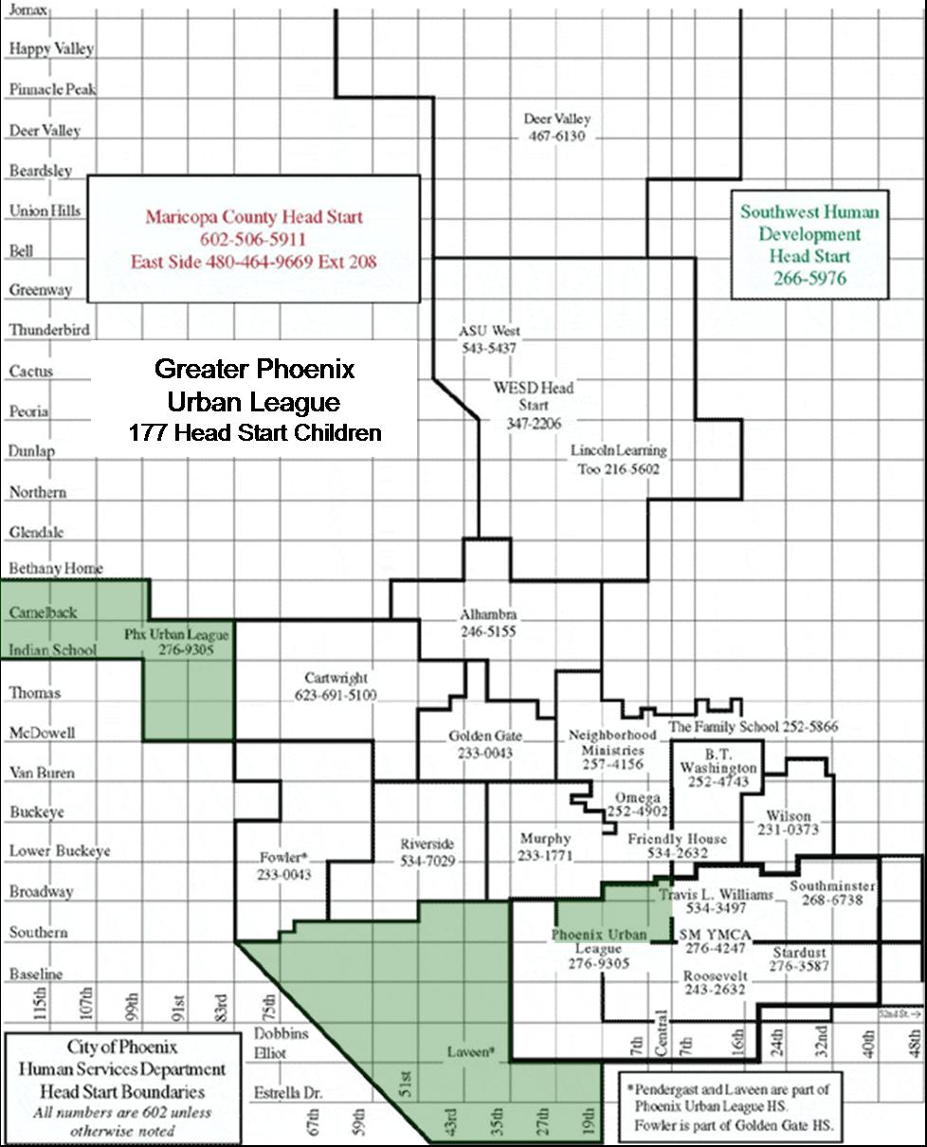
City of Phoenix Head Start

Program Approvals

Program Year 39 (2004-2005)

Community Assessments, Goals, Objectives, and Action Plan

Delegate Agency Name: Greater Phoenix Urban League
Address: 3851 W. Wier Ave.
Phoenix, AZ 85041

APPROVED: Date:
Board Chairperson/Executive Director

APPROVED: Date:
Delegate Agency Director

APPROVED: Date:
Policy Committee Chairperson

Greater Phoenix Urban League

Refunding Application

Program Year 39 (2004-2005)

Background Information

The National Urban League was founded in 1910. Its objective was to fight the intolerable living and working conditions experienced by the nation's Blacks in urban cities. Today, it has 114 affiliates in 34 states and provides assistance to anyone in need, regardless of race, age or gender. With this necessary expansion, the depth and scope of the challenges the agency now faces has also grown considerably.

Greater Phoenix Urban League, Inc. was proudly established as an affiliate in 1945. GPUL is a private, not-for-profit organization serving the Greater Phoenix area. The League provides services in employment, housing, education, youth and community education, advocacy and equal opportunity/affirmative action.

GPUL Head Start

The Greater Phoenix Urban League has operated the Head Start program since 1972. The first program was in Okemah Park, located at 32nd and Anne Streets, one of the poorest communities in Phoenix. Eventually, families were driven out of the Okemah area because of commercial and industrial development. In 1986, GPUL Head Start moved to the First New Life site. The first of many expansions occurred in 1991 with one classroom. In 1994 and 1995, expansion took on new territory, as GPUL moved into both the Pendergast and Laveen School Districts.

Roosevelt School District

GPUL serves 20 children and families that reside in the Roosevelt School District at one site. During the past couple of years, several charter schools have opened in the Roosevelt School District. The charter schools are enrolling children into their Kindergarten program who will be 5 years old by December 1st. These children could have been enrolled into a Head Start program; however, some parents can now enroll their preschool-age child in the same school as their elementary school-age child, very convenient for working parents with two or more children.

South Phoenix is growing rapidly. New jobs have emerged with the opening of two major grocery store facilities and the new Arizona Mills Mall. In central Phoenix, the new Bank One Ball Park has created hundreds of jobs. As more parents enter the work force, the need for full day care increases. In the immediate area of the Head Start program, one center-based and three home-based child care facilities have recently opened. The community is diverse and has several stable pockets as well as several negative elements that suggest a need for intervention.

In terms of educational attainment, almost 20 percent of the residents have less than a high school diploma. The lack of educational resources in the community to assist individual certainly contributes to the poor achievement level that has proven to contribute to literacy problems with young children.

GPUL provides computer-training classes for Head Start parents and extended family members. After completing the 9-week class, participants receive a computer and job referral and counseling. Enrollment of children has been challenging for this area. Many families have grown to over-income status as they join the workforce. Just recently this South Phoenix Community has been going through renovation. Families are being bought out and the land is being used for industrial parks, new housing and apartment complexes. Another potential barrier for enrolling children in this area is affordable housing. Many of the new homes start at around $120,000, out of reach for many poorer residents.

Pendergast School District

GPUL provides Head Start services at three sites in five classrooms to 100 children in the Pendergast School District. Parents in this district have opted for a year-round schedule for the Desert Horizon, Westwind and Pendergast elementary schools. A collaborative effort between the Pendergast District, Southwest Leadership Foundation and the Head Start program resulted in opening the Cummings Community Center. The center has been in the Desert Horizon School over nine years. The first year an after-school program was developed. Since then the center has added GED/ESL classes, conducted parent training, opened a clothing bank and a food bank, conducted health fairs and hired a Family Services Case Worker. The Case Worker can provide direct or referral services for families in crisis situations, and works with families to develop short and long term goals toward becoming self-sufficient.

The Pendergast Elementary School District covers a nineteen square-mile area. It continues to grow. Where the district had a lot of open spaces, new housing developments are going up. Major grocery stores, strip malls and shopping centers are also going up, creating more jobs and accessible shopping places. The bus services have also extended their boundaries, making shopping, doctor visits and other needs more convenient.

This area is growing in population. Residents are economically poor, average and above average; 36% qualify for free or reduced-cost lunches. The ethnic break down is 40% Hispanic, 33% White, 10% African American, 15% Native American and 2% Asian/Pacific Islander.

Laveen School District

GPUL provides services to 57 children at two sites in three classrooms in the Laveen School District. At the San Martin site the modular unit is large enough to house the Administrative Office and one classroom serving 20 children in the morning and 20 children in the afternoon. At New Jerusalem another classroom serves 17 three-year-olds.

Of the three districts, Laveen is the neediest. Community resources are extremely limited. Transportation is an issue for most families and the buses don't run all the way through the community. Public facilities such as laundries, drug stores, grocery stores, medical facilities, banks and clothing stores are scarce. Construction of new homes on the perimeter of the community is happening rapidly.

The MOM mobile is on site at San Martin De Porres Church once a week, providing prenatal care and immunizations to children and adults. Families in this area that have no heals insurance can access health services like physical exams, immunizations and some health screenings.

While the overall population of Laveen grew over the past decade, median income rose 50%. But the number of families living below the poverty level also grew. About 30% of the Laveen residents live below the 100% poverty level.

The Laveen area is a diverse community. Clearly this population presents a myriad of social services, education, housing and medical needs. Approximately 25% of the population is monolingual Spanish-speaking, 20% of adults over 25 years of age have less education than a high school diploma, 28% of people older than 16 are not in the labor force.

The community provides services to families in need through referrals into the larger Phoenix area for financial and counseling services.

Recruitment and Selection Procedure (All Sites)

The recruitment process is designed to inform all eligible families about Head Start services so that the greatest numbers of families have an opportunity to apply for enrollment.

A formal process is followed for selecting children and families, with criteria that consider age, income, employment status, disabilities and the extent to which the family meets Head Start requirements.

Survey Results

A total of 300 survey forms were distributed, by delivery to families, filled out during home visits, parent meetings or in person while a family member was at a Head Start site. Survey forms were given to all teachers living and working in the community. A total of 150 survey forms were turned in for a response rate of 50%. One parent and community leaders focus group was also conducted.

The survey sought to collect information in four areas:

- Concerns and needs of the adults in your family
- Concerns and needs about the children in your family
- Concerns and needs about the Head Start Program
- Concerns and needs about your community

The responses from families across our recruitment areas were similar. Of the 150 responses:

- 75% (113) felt the need for medical and dental facilities for both adults and children.
- 80% (120) were concerned and had the need for safe, livable and affordable housing.
- 65% (98) wanted English classes provided so that the adults could learn English

John C. Lincoln Health Network
Lincoln Learning Center

City of Phoenix Head Start Map Showing Individual Delegate Agencies

Lincoln Learning Center

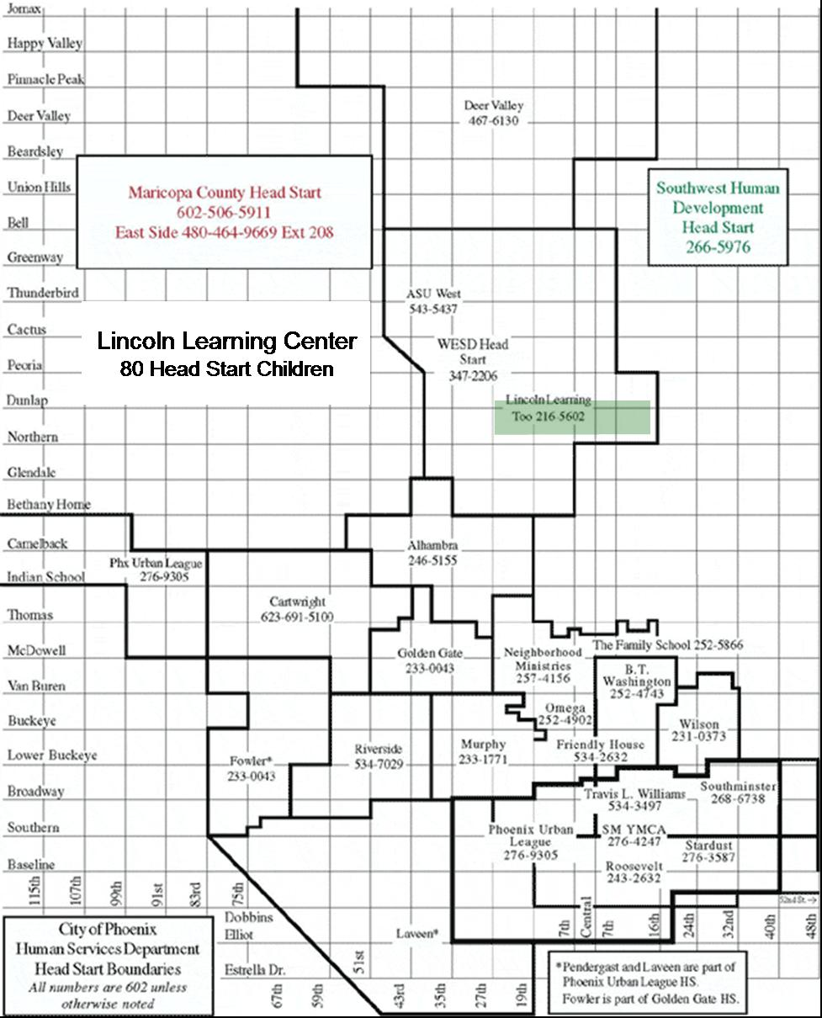
City of Phoenix Head Start

Program Approvals

Program Year 39 (2004-2005)

Community Assessments, Goals, Objectives, and Action Plan

Delegate Agency Name: Lincoln Learning Center
Address: 34 E. Sunnyslope Lane
Phoenix, AZ 85020

APPROVED: Date:
Board Chairperson/Executive Director

APPROVED: Date:
Delegate Agency Director

APPROVED: Date:
Policy Committee Chairperson

Lincoln Learning Center

Refunding Application

Program Year 39 (2004-2005)

Introduction

The Lincoln Learning Center, Head Start Program, is an affiliate of John C. Lincoln Hospital at North Mountain. The community assessment information is used to assist in the planning for the Head Start Programs at the Lincoln Learning Center, the Sunnyslope community and the greater Phoenix area.

Delegate Agency Mission

The mission of the Lincoln Learning Center is:

- To be a leader in providing quality child development services to the community in a nurturing, safe and healthy environment through the team effort of a well-trained, competent staff.

- To work collaboratively with other departments at Lincoln and other community human service organizations to meet the health care and social needs of identified children while promoting family well-being and self-sufficiency.

John C. Lincoln Hospital and Lincoln Learning Center

The Lincoln Learning Center is located at 303 E. Eva and the Head Start Program is located at 34 E. Sunnyslope Lane in Sunnyslope, both are located on the campus of John C. Lincoln Hospital at North Mountain, a 230 bed, nonprofit community hospital located in Sunnyslope providing health care and community services to north Phoenix residents, including hospital and long-term care, wellness programs, rehabilitation and sports medicine, a food bank, child care, adult day health care, retirement living and home health services.

Community Profile

The target population served by the John C. Lincoln Learning Center Head Start Program is families and children residing in the Sunny slope Community within the attendance boundaries established by the Washington Elementary School District (WESD) for Mountain View, Sunnyslope, and Desert View schools.

School district and community resource agency information was used as an indicator of community demographics.

- The district enrollment has varied year-to-year since 1993-94 with small decreases from the previous years in 1997-98, 1999-2000 and 2001-02. Enrollment dropped from 2000-01 and 2001-02 due to decreases in enrollment at Desert View, Sunnyslope and Shaw Butte. Children in the Sunnyslope area attend one of five public elementary schools, one charter school (Dragon Flye) and one parochial school (Most Holy Trinity). The following table shows the percentage growth in enrollment from 1999 through 2003 in the target schools:

Growth (Reduction) in Enrollment, 1999-2000 to 2002-03
School | 2002-03 PY | Compared to  1999-2000 PY | % Growth  (Decrease)
Desert View | 674 | 605 | 11.4%
Mountain View | 1127 | 1170 | (3.7%)-
Sunnyslope | 845 | 940 | (10.1%)-
Total | 2,646 | 2,715 | (2.5%)

- District-wide, the Community preschool, Building Bridges and Special Needs preschool programs have shown growth. In 1995-96 the school had 13 classrooms (not including Head Start). By 1999-2000 the program had expanded by two classrooms. In 2002-03 the District has 20 such sites.

- In 2000, WESD students’ eligibility for free or reduced-cost lunch for school-age children illustrates poverty levels in the community. The schools in the Sunnyslope area reflect rates of eligibility significantly higher than the District average of 55%, as shown in the accompanying table.

Eligibility for Free/Reduced-Cost Lunch
School | 2003 PY | Compared  to 2000 PY
Desert View | 81% | 90%
Mountain View | 88% | 94%
Sunnyslope | 78% | 95%

Child Abuse and Neglect

Underlying correlates of child abuse and neglect are poverty and economic deprivation. Child abuse and neglect in Sunnyslope can be examined by looking at activity in Zip codes 85020 and 85021.

In 1999, Sunnyslope accounted for 777 reports of child abuse and neglect made to Child Protective Services. In a 2001, the Arizona Department of Economic Security received 295 reports of child abuse and neglect from these Zip codes. The number of total reports in Sunnyslope declined overall by 62% from 1999-2001, despite an overall 10% increases in reports for Maricopa County as a whole, from 17,809 in 1999 to 19,623 in 2001.

One reason for this remarkable turnaround is the Sunnyslope Prevention Plan, which began in August 1994 with a small team of community members. They attended four days of training provided by the Governor's Office for Children and Developmental Research Programs, focused on the Hawkins and Catalano Communities that Care model for developing a comprehensive prevention plan. Team members included a school social worker from Sunnyslope Elementary School, Program Directors from John C. Lincoln Hospital’s Learning and Birthing Centers and Food Bank, supervisor from Child Protective Services and a Phoenix Police Department PALS Officer. The workgroup’s goal was to develop a broad-based prevention plan, including strategies for addressing priority risk factors based on needs assessment information, identification of the community's priorities, and proposed strategies for community mobilization efforts to address the root causes of juvenile delinquency, child abuse and adolescent problem behaviors.

Juvenile Crime

Juvenile crime serves as an indicator of many underlying social problems, including poor school performance, lack of parental supervision, abuse, economic difficulties and psychological problems. Crime is measured by arrests and referrals to the juvenile court for children in Sunnyslope.

In 1995, 3% of Sunnyslope youth were referred to the Maricopa County Juvenile Court. IN 1998, referrals grew to 4%. More recent data, 2001, shows that 1% of youths from the Sunnyslope area were referred, a significant decrease in recent years.

Health Care

Uninsured births in the Sunnyslope area decreased from 5.6% in 1995 to 3.5% in 2000, the most recent data available from the Arizona Department of Health Services.

Children’s Community Health Services has been successful in increasing immunization rates for children served by the program from 19% in 1997 to 86% in 2002. Immunizations rates among infants and children remain an area of concern.

Current insurance statistics, 2003, for the Children’s Community Health Services are as follows: 42% Tobacco Tax; 27% Self-pay (no insurance); 26% Insurance/PHP; and 5% have other insurance.

Healthy Families

1996 Data:

- The Healthy Families Program in Sunnyslope at birth related to potential child abuse, 29 families, with a total of 60 children, were enrolled in the program in 1996.
- Participant data from the first two years of operation in Sunnyslope indicates that the one out of six mothers enrolled in Healthy Families are teen parents, with the average age being 25.
- One out of four mothers were married, with 62% of the fathers living in the home. Fewer than one in five (17%) of the mothers were employed.
- For 31% of the families substance abuse was a concern; 10% had a history of domestic violence with an additional 3% expressing concern about a current domestic violence problem.
- Almost half (45%) of the families receive services in Spanish. The ethnicity of the participants includes 55% Hispanic, 41% Anglo and 3% Asian.

1999-00 Data:

The past four years has shown little significant changes in demographic information:

- The ethnicity of the participants includes 50% Hispanic, 41% Anglo, 6% other, and 3% African American.
- The number of families served from July 1999 to April 2000 is 32.
- The average age of the mother is 24.5.
- 61% of the mothers were not married, but 66% of the fathers reside in the home.
- Of the clients served, 22% are teen mothers (under age 20 years).
- Only 9% of the mothers listed substance abuse as a concern, a significant drop (22%) from those expressing concern four years ago.
- 16% of the families in the Healthy Families program use Head Start services.

Language/Ethnicity

The number of limited English proficient students is an indicator of the number of community members with languages other than English. In the target schools the numbers are significant.

Limited English Proficiency
School | Limited  English | Total  Enrollment | Percentage
Desert View | 325 | 674 | 48.2%
Mountain View | 791 | 1,127 | 70.2%
Sunnyslope | 501 | 845 | 59.3%

Ethnicity and Race:

Ethnic/Racial Distribution of School Enrollments
Target Schools | Hispanic | White, not Hispanic | African American | Native American | Asian
Desert View, Sunnyslope & Mountain View | 58.5% | 28.9% | 5.2% | 4.1% | 3.3%

Disabilities

The school district’s Special Services Department has reported the need for more special needs services, but space and the constant need for staff has been a challenge. Some new programs that have been implemented over the past 3 years are the addition of another preschool program and an autistic program. The autistic program will start with preschool and will add one grade every year up through second grade.

District-wide, the Special Services Department serves 3,250 students out of 25,000, or 13%.

Medical, Dental and Social Services

Marley House

From 2000 through 2002, referral requests have increased 59%, from 1,832 to 2,913. Participation in services beyond information and referral increased 13% from 400 in 2000 to 452 in 2002. From 2000 through 2002 a total of 1,132 families has participated in program services such as counseling, case management, parenting classes, in-home support and parent support groups.

In 2000, Marley House records show that 6 families were referred to Children’s Health and Children’s Dental for services. In 2002, 64 families were referred for medical and dental services. Since changes in data collection in 1999-2000, it is unclear if the number of referrals is a true representation of referrals made during that period; however, with the addition of a case assistant position shared between Children’s Health and Marley House, the expected increase in referrals is reflected.

Dessert Mission Children’s Dental Clinic

In 1999 total visits increased from 1998 by 17%, and a total of $263,232 subsidized care was provided. In 2002 a total of 2,526 visits were provided by the clinic, with 811 children served. Of the 811 served, 671 were new patients to the program. Through the school program, 6,243 children were screened for dental problems and were provided prevention education. 472 of these were urgent care cases.

Tooth decay continues to be the most common problem diagnosed, resulting in a high number of extractions and root canals. The Clinic will be implementing a sealant program at schools in order to minimize the need of urgent care and increase prevention among services.

The total value for services provided to the schools was $153,655. The overall value of dental services was estimated at $500,530 at a cost of $476,000. Through a special grant, 9 children received pedodontic specialty services, which valued $17,170. The Clinic paid 75% of the cost and the other 25% came from in-kind donations.

In 2003 the Clinic is running at a 5% increase over 2002, for a total of 2,219 visits just through October with a services value worth $424,066.

Children’s Community Health Center

In 2002 the Children’s Health Services provided 5,766 visits for sick children.
- 1,860 of all visits provided were for immunizations.
- 5,766 doses were administered to children
- 1,743 of all visits provided were for Well Child Checks
- 1,155 or 20% of the total visits of the clinic were provided through the School Based Clinics.

In 2003, the Health Center provided a total of 5,689 visits through October this year. 7% increase over last year’s average with $477,602 worth of services provided to-date.

Desert Mission Food Bank

In 2002, the total of individuals served throughout all programs was 95,051 compared to 68,305 in 1999, an increase of 28%. Also in 2002, the Holiday Adoption Program adopted 1,904 individuals and 16,862 emergency food boxes were distributed.

Approach to Community Assessment

An array of strategies was used to gather information for the Head Start Community Needs Assessment for the Lincoln Learning Center Head Start program, including:

- Input from community leaders and service providers in Sunnyslope.
- Head Start parents completing community assessment surveys.
- Information gathered for the Sunnyslope Youth and Family Partnership Risk Assessment Update for 2002

Limitations

The small sample size of the interviews and surveys, limits the findings and caution should be used when drawing conclusions solely relying on a single source of data.

Input from Community Leaders and Service Providers

Input was solicited from various agencies in the Sunnyslope community as well as on-line resources. Community leaders and on-line resources that provided input include:

- Web site for the Washington Elementary School District (WESD).
- Director of the Desert Mission Food Bank
- Director of the Children’s Community Health Center
- Caseworker I for Lincoln Learning Center, Head Start
- Director of the John C. Lincoln Children’s Dental Clinic
- Director of Marley House Family Support Center
- Sunnyslope Youth and Family Partnership Risk Assessment for 2002

Because school district information is a strong reflection on the community, the information gathered from the WESD web site was valuable to this assessment. The following information demonstrates some of the changes that the district has experienced in the last three-to-five years.

- The district experienced a significant increase in English Language Learners over the past ten years. Currently approximately 4,700 Limited English Proficient students are in WESD, an increase of 87% from five years ago and 538% from ten years ago.
- Thirty-five different languages are represented in district schools. After English, the second largest group is Spanish, and the third is Serbo-Croatian.
- Schools are running out of space.
- The schools must deal with refugee issues.
- Title I services are provided to 20 schools, 10 with school-wide designation and 10 schools with target assistance programs.
- Special Education services are available to approximately 13% of the student population.

Head Start Community Assessment Surveys

Head Start community assessment surveys were distributed throughout the Sunnyslope community working in cooperation with schools, and community agencies such as the Marley House, Desert Mission Food Bank, Women Infants & Children (WIC), Community Health Services, Sunnyslope Community Center as well as the Lincoln Learning Center Head Start parents.

Profile of Respondents

Of the respondents,

- 79% were Hispanic, 17 % were Anglo, and 1% was African American.
- 76% were two parent families, 11% were single mothers, 2% were single fathers, 1% were grandparents and 4% were in multiple family households.
- Average length of time in the community was 6.8 years.
- 4% indicated having a child with a disability, 5% of the children were receiving TANF, 26% of children were receiving Food Stamps, and 19% of the children were on AHCCCS.
- 18% of adults reported needing full time work, 7% needed part time and none reported needing training.
- The average reported monthly household income was $978.
- 22% of the adults were seeking health insurance, 8% need medical care, 7% need dental care, 4% needed mental health services and 13% need immigration services.

Head Start and Child Care Needs

The survey results showed that 57% of respondents are currently enrolled in Head Start. 15% of are interested in Head Start and 38% are interested in volunteering their time to Head Start. None of the respondents indicated child care as a need or a reason for not enrolling their child in Head Start. In a community of many working parents, the availability of childcare is an important resource to insure family functioning. Child care program capacity in Sunnyslope has increased 52% between 1994 and 2002 (Sunnyslope Youth and Family Partnership).

Results of the Community Needs Assessment

Community Strengths

The Washington Elementary School district has begun to implement a variety of educational and social service programs that are an asset to the community, such as three after school programs in the Sunnyslope community.

More Spanish speaking personnel have been added to community resource agencies, including the Lincoln Learning Center Head Start program, in response to community need.

The Lincoln Learning Center and Head Start program have strong linkages with a continuum of services for families in the Sunnyslope community, and have demonstrated a history of successful collaboration. For example:

The Children’s Health Center is a short walk from the Lincoln Learning Center and the Marley House Family Support Center. The Children’s Community Health Services program, Lincoln Learning Center and Marley House work together to provide a full range of services to the families of our community.

Most Critical Needs and Concerns in Community

Information from the community surveys, the Sunnyslope Youth and Family Partnership Risk Assessment and input from community agencies was reviewed and analyzed to identify the most critical needs and concerns in the Sunnyslope community.

Top six community problems or issues identified as difficult to access: | Top six community problems or issues identified as a need for more services:
1. Housing | 1. Dental Care
2. Utility Assistance | 2. ESL
3. Child Care | 3. Medical Care
4. Job Training | 4. Housing
5. Medical Care | 5. Transportation
6. Dental Care | 6. Food and Clothing

Similarities and Differences

- Problems and issues identified as both difficult to access and a need for more services include: housing, medical care and dental care.
- Problems and issues identified only as difficult to access include: utility assistance, childcare and job training.
- Problems and issues identified only as needing more services include: ESL, transportation and food/clothing.

Viable Resources Available in Community

John C. Lincoln Health Network, Lincoln Learning Center

Lincoln Learning Center is a not-for-profit child care program serving working families from the Hospital and the community with children ages six weeks to twelve years.

Families with low incomes are served through a scholarship program and a contract with the Arizona Department of Economic Security. Head Start services are available to children whose parents are income-eligible.

Children’s Community Health Services Center

The Children’s Community Health Services Center is a community centered, community driven medical home for a population who would otherwise go without, including children who have no means of obtaining essential health care. Services include: 1) diagnosis and treatment of minor or chronic illness, including medication if needed, 2) health screening, 3) health promotion and counseling and 4) immunizations.

Children’s Dental Clinic

The John C. Lincoln Children’s Dental Clinic began providing dental services to children in the 1930’s. Using volunteer dentists, the JCL Children’s Dental Clinic provides cleanings, sealant, fillings, extractions and root canals to children who have no dental insurance, AHCCCS or financial resources for dental care. The Director of the Dental Clinic maintains an ongoing recruitment program for additional dentists who donate their time. A voucher program for participating dentists helped the clinic provide dental care to children enrolled in the Tobacco Tax Primary Care Program.

Desert Mission Food and Clothing Bank

Desert Mission, a division of John C. Lincoln Health Network, operates a food and clothing bank that distributes 700-800 emergency food boxes each month. Desert Mission also acts as a distribution center for government food programs to low-income families.

Sunnyslope Youth and Family Partnership

Established by John C. Lincoln Hospital in January, 1995, the Sunnyslope Youth and Family Partnership represents a collaborative effort on the part of businesses, schools and community agencies in Sunnyslope to prevent juvenile delinquency and enhance opportunities for the positive physical, social and emotional development of youth in the community. The Youth and Family Partnership provides structure for ongoing development and implementation of the Sunnyslope Prevention Plan and includes over 90 representatives from 40 member organizations.

Marley House, Family Support Center

In March 1996 Marley House (formerly Lincoln House) was opened to facilitate delivery of educational, health, social and recreational services to children and families in the Sunnyslope community. John C. Lincoln Hospital, in conjunction with the Sunnyslope Youth and Family Partnership, established the Marley House Family Support Center as the first school-linked and neighborhood-based center in east Sunnyslope designed to improve access to services. The purpose of the Marley House Family Support Center is to assist families identified through JCL Community Health Center Children’s and Women’s Services, the Student Health Program, Children’s Dental Clinic, hospital or referred form partner agencies, by providing case management and support in obtaining community services.

The JCL Community Health Center and Marley House work together to provide a full range of services to the families of the community. As families are determined eligible for children’s health services, in addition to receiving health services, social needs are addressed and eligible families with medical care needs are referred to the JCL Community Health Center for eligibility determination and enrollment into the Tobacco Tax Primary Care Program or Kids Care.

The Elementary Student Health Program

The Elementary Student Health program represents a commitment among Washington Elementary School District, John C. Lincoln Hospital and a number of area physicians to care for the whole child by making much-needed health services available to children attending nine schools in the Sunnyslope community. The services include diagnosis and treatment of minor illnesses, education on nutrition and exercise, immunizations, referrals to appropriate medical and dental services and health education for family members.

Barriers

Awareness of community resources.

John C. Lincoln Health Network and its affiliates in the Sunnyslope area provide an abundance of community resources. As listed above, these agencies cover an array of services to meet challenges of individuals and families living in the surrounding areas.

The barrier is not that services aren’t available, but that the community is not fully aware of the services. A campaign was launched six years ago to promote public awareness. This campaign consisted of community newsletters, flyers, and community presentations. This campaign has been very effective in the community, but it must be an on-going effort because of the high mobility rate.

Transportation to resources.

Many families are unable to get to appointments for resources because of the distance. Many families have none or only one vehicle, which is used by working family member as transportation to work. Many individuals are walking to appointments, but for the hottest times of the year walking is impossible, especially if they must bring small children with them to appointments.

Murphy School District

City of Phoenix Head Start Map Showing Individual Delegate Agencies

Murphy School District

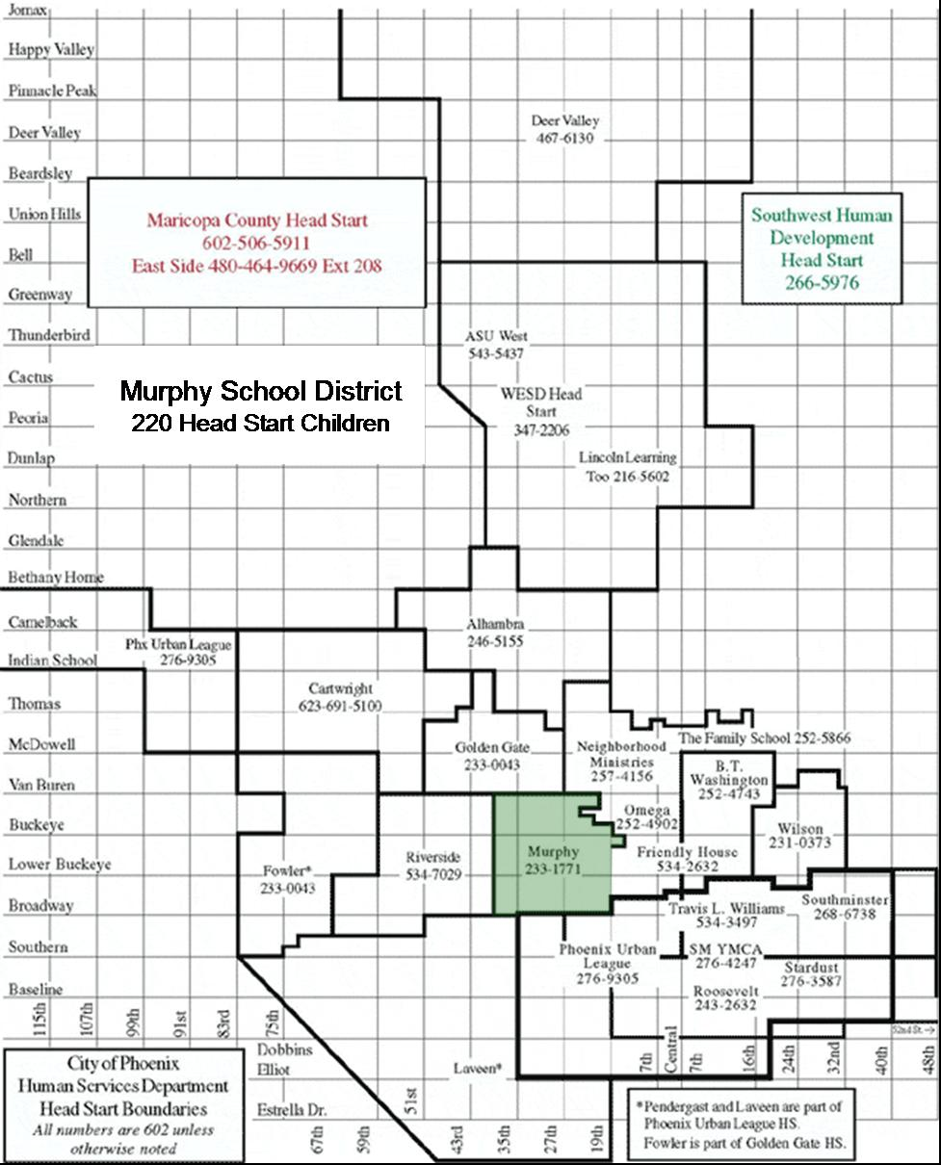
City of Phoenix Head Start

Program Approvals

Program Year 39 (2004-2005)

Community Assessments, Goals, Objectives, and Action Plan

Delegate Agency Name: Murphy School District
Address: 2615 West Buckeye Rd.
Phoenix, AZ 85009

APPROVED: Date:
Board Chairperson/Executive Director

APPROVED: Date:
Delegate Agency Director

APPROVED: Date:
Policy Committee Chairperson

Murphy School District

Refunding Application

Program Year 39 (2004-2005)

Background

Murphy Head Start initially received funding in 1978 for one classroom and a home base class. The Home Base option was discontinued in 1979, allowing for two site-based classrooms. Head Start expanded in 1984, increasing enrollment to six classrooms. The 1990 Head Start expansion increased enrollment to ten classrooms. With the advent of welfare reform, Murphy Head Start collaborated with the Arizona Department of Economic Security to provide the first wrap-around program in Arizona. Murphy Head Start has been accredited by the National Association for the Education of Young Children since May 1999. Murphy Head Start operates the state funded preschool, serving 20 children. In August 2002 funding was provided to implement a classroom using a four-day option, as a seed classroom for A Stepping Stone Foundation, serving 20 children. The total number of preschool children receiving services in Murphy School District is 220.

Profile of the District

Murphy School District No. 21 evolved from a rural farming community in the late 1800's-early 1900's to an urban industrial and commercial area that it is today. The district is zoned 68% industrial and 6% commercial. Single-family residential zoning is reported at 5%, multiple family units at 18% and public assistance housing includes 320 units.

Murphy is a PreK-8 district. The district is located approximately five miles from downtown Phoenix. It is considered an inner-city school district and encompasses an approximately 12-square-mile area in southwest Phoenix, bordered by the Salt River and Van Buren St., and 19th and 39th Avenues. Total 2003-04 enrollment is 2,600. The Murphy community is characterized by a mixture of older, low-income housing and apartments populated by multiple families.

Few amenities are in the area: one park, no play grounds outside of the schools, no day-care centers, no community centers, no programs for the elderly and few small businesses.

Three of the district’s four schools provide classroom space for Head Start Classes. The W.R. Sullivan School does not provide space as the school age population count is large, and this school has no additional space for Head Start classrooms. Head Start eligible children residing in the W.R. Sullivan attendance area are transported to one of the other district schools that has Head Start classes. The bus used for transporting children is in-kind support from the district. To accommodate the need for transportation, two start times and bus runs minimize the time children spend riding the bus.

Jack L. Kuban School is the only school that does not have transportation for Head Start children because most of the families reside within the attendance area.

Arthur M. Hamilton School serves a portion of the Phoenix inner-city where the population is 95% Hispanic; 94% of families have incomes below the federal poverty level; and 40% of households are headed by a single parent, mostly female. Many area residents are recent immigrants who lack English language skills. Gangs, drugs, criminal activity and violence plague the community.

Hamilton School enrolls 600 PreK-8th grade students, who are 95% Hispanic, 1 % African American and 1 % Native American. Almost all students are “at risk of educational failure” as defined by the Arizona Department of Education. Hamilton students are 100% eligible for free/reduced meals and Title I services. English language limited students comprise 69% of enrollment. A total of 140 preschool students are on this campus, including 100 Head Start students, 20 State funded and 20 preschool students funded by A Stepping Stone Foundation.

Hamilton school is in located in the area that has the Maricopa County Housing Projects. Due to the heightened interrogation of undocumented residents after the September 11 tragedy, many apartments in the Coffelt Housing Project are vacant, due to fear of deportation of undocumented residents. This situation has afforded the Head Start program the opportunity to use two adjoined apartments that previously housed a childcare center. Murphy Head Start is currently using the facility for parent training, staff meetings and Policy Committee meetings. Murphy intends to obtain a license for the facility in the event expansion funds become available to have a classroom on the site. A Coffelt Housing Project site would be accessible to more than 50 eligible Head Start families in the area.

Jack L. Kuban School is the newest school in the district, and serves a portion of the Phoenix inner-city where the population is 95% Hispanic; 94% of families have incomes below the federal poverty level; and 40% of households are headed by a single parent, mostly female. Many area residents are recent immigrants who lack English language skills. Gangs, drugs, criminal activity and violence plague this community as well

Kuban School enrolls 518 PreK-8th grade students, who are 91 % Hispanic, 7% White, 1 % Asian, and 1 % Native American. Kuban students are 90% eligible for free/reduced meals and Title I services. English language limited students comprise 56% of students. Forty Head Start children are enrolled at this site in morning and afternoon classes.

Alfred F. Garcia School serves a portion of the Phoenix inner-city where the population is 97% Hispanic; 95% of the families have incomes below the federal poverty level; a single parent, mostly female, heads 30% of households. Many area residents are recent immigrants who lack English language skills. Gangs, drugs, criminal activity and violence also plague this community.

Garcia School enrolls 816 PreK-8 grade students, who are 97% Hispanic, 1 % Black, 1 % White and 1 % Native American. Garcia students are 90% eligible for free/reduced meals and Title I services. Eighty Head Start children are enrolled at the Garcia campus. The Garcia campus provides Wrap-Around Child care for children of parents that are employed, attending school or in job training.

Garcia Campus has a newly-constructed building that has been donated to the Head Start program and will be in close proximity to the modular building that was built with federal funds. This building will house the Head Start office and two classrooms.

Poverty

Murphy School District is a free lunch district. The median income is $10,097. At the present time Murphy Head Start is serving 260 of the estimated 400 four year olds who are at or below the poverty level. Another indicator of poverty is AHCCCS (Arizona Health Care Cost Containment Services, the Arizona Medicaid program) eligibility. In order for a family to be eligible for AHCCCS, they must be significantly below the poverty level. As of June 2003, 73% of the children in the Murphy School District qualified for AHCCCS.
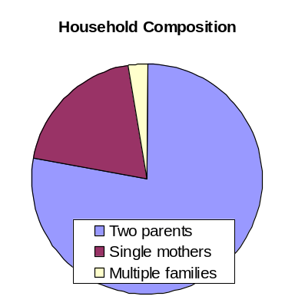

Murphy School District Demographics

A profile of current Murphy School District Demographics show the level of need to be extremely high. These factors include:

- 69% of the students come from single parent homes
- 50% of the parents have less than an 8th grade education
- 65% of the parents are not employed full-time
- 50% of the families earn less than $6,000 annually

The significance of the community drug and alcohol problems and the need for Head Start is reflected by the demographic profile comparing Murphy District and the State of Arizona.

Indicator | State of Arizona | Murphy School District
Families who live in poverty | 16% | 94%
Minority students | 37% | 94%
High school graduation rate | 63% | 38%
Languages other than English | 16% | 51%
Latchkey children | 20-30% | 39%
Average family size | 2.6 | 5
Median family income | $27,540 | $10,097

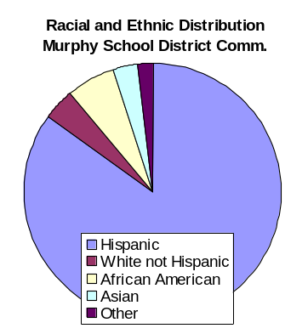
Ethnic Origins

The Murphy School District Community remains predominately Mexican American. The ethnic composition is as follows: 85% Hispanic; 6% African American; 4% White; 3% Native American; 2% Other

Family Mobility

Low family stability is also a characteristic of the Murphy School District. While student mobility in Phoenix as a whole averages 11% per year, in the Murphy District one of every five students either moved into or left the district in the 2002-03 school year. High mobility is another indicator of the number of at-risk students in the Murphy School District.

Survey Results

Murphy Head Start conducted a comprehensive Community Needs Assessment in September and October 2003. Surveys and focus groups measured the needs and trends that are evident in the community. Of the 340 surveys that were distributed, 85% were returned.
Method | Forms Distributed
Head Start Families | 220
State Preschool Families | 20
Hamilton Resource Center | 50
Community Agencies | 50

In addition to the surveys, Murphy School District conducted in-depth interviews with:

- District Family Resource Specialist
- Assistant Superintendent
- Hamilton School Resource Specialist

A total of 28 concerns were ranked in terms of their importance in the Murphy community. The top five concerns established through the comprehensive community needs assessment and surveys in the Murphy School District Community are:

- Job Training
- Neighborhood Safety
- Medical Care/Dental Care
- ESL/GED
- Domestic Violence

Results of Annual Self- Assessment

In addition to the surveys and interviews, Murphy School District conducts an annual self assessment. Results of the self-assessment conducted in March 2003 indicated:

(a) Educational Services:

Instructional staff has a need for additional training on individualizing for children. Teachers have had the opportunity to list classroom learning materials that may be needed in each of their classrooms; the self-assessment revealed that manipulative, multicultural materials and books are needed in the classrooms. The Lead Teacher and Director will inventory classroom materials and place orders to insure adequate learning materials.

(b) Community Partnerships

Community Partnerships include, Kith and Kin, Women Together for Health, Maricopa County Housing, Maricopa County Flood Control, Valle del Sol, A Stepping Stone Foundation, Friendly House, etc. The donation of the apartment space in the Coffelt Housing Project serves as a community meeting and training facility for parents and staff.

(c) Administrative/Human Resources

A system must be developed that will provide up to date information regarding staff immunization and TB skin test results. A form has been developed that will document new staff orientation that covers Head Start philosophy and other required topics.

(d) Governance

The Policy Committee did not have direct communication with the School Board, the governing body for Murphy School District. A Board member has been invited to be a Community Member on the Policy Committee and share information with both parties.

Phi Iota’s Omega Foundation, Inc.

City of Phoenix Head Start Map Showing Individual Delegate Agencies

Phi Iota’s Omega Foundation, Inc.

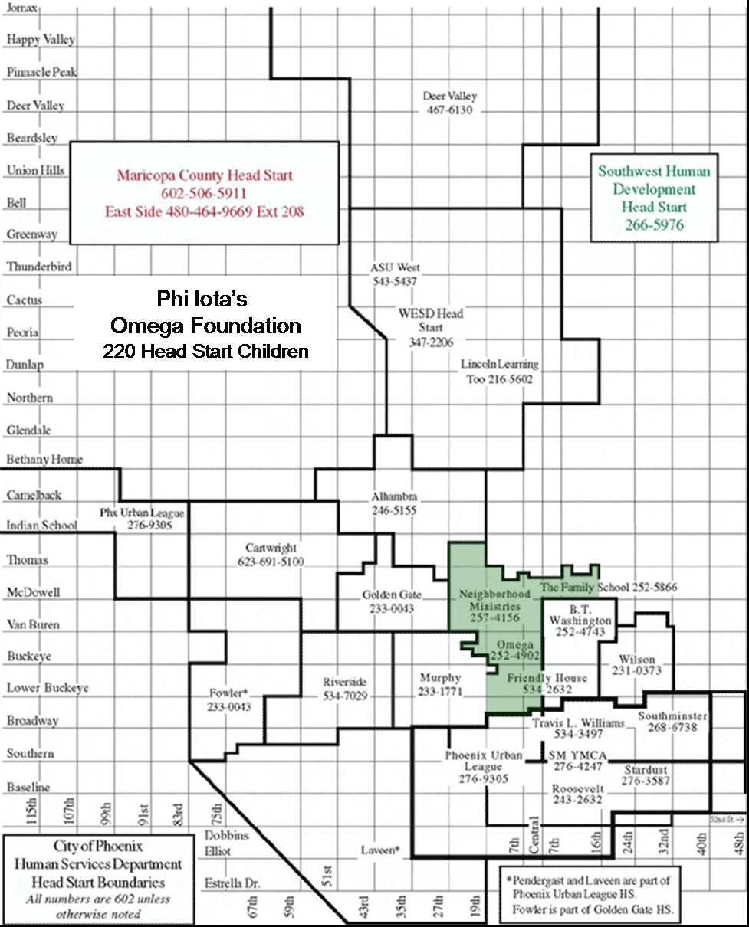
City of Phoenix Head Start

Program Approvals

Program Year 39 (2004-2005)

Community Assessments, Goals, Objectives, and Action Plan

Delegate Agency Name: Phi Iota’s Omega Foundation, Inc.
Address: 707 W. Grant St., Rm. 119
Phoenix, AZ 85007

APPROVED: Date:
Board Chairperson/Executive Director

APPROVED: Date:
Delegate Agency Director

APPROVED: Date:
Policy Committee Chairperson

Phi Iota’s Omega Foundation, Inc.

Refunding Application

Program Year 39 (2004-2005)

Profile

Omega Head Start program is located within the-inner city of Phoenix Arizona, a large metropolitan area that exhibits all the good and bad features related to big city living.

Each classroom is housed on campuses in the Phoenix Elementary School District #1 attendance area. This school district has 14 schools; Omega Head Start classes are located at eight of these campuses. A partnership with the school district allows Omega to be a community service that helps to benefit the preschool population and the larger community. Because the schools are a center of their community, the program webs out to include and benefit from all of the programs offered by a large inner-city school district.

The Omega attendance areas are diverse and unique. The eastern area is made up of manufacturing companies, community based businesses, mom & pop thrift stores. old established neighborhoods and newly-built condominium gated communities. This new construction changed the face of this area and displaced some of the older homes within the last few years.

The northern area has remained constant physically, while “new immigrants” move into the old established apartment and condominium complexes. This new migration has helped add to the ethnic diversity of the Omega Head Start program.

The western area finds new houses, trailer parks, and project houses. This area has a highly-transient population.

The center of Omega’s attendance area is the downtown Phoenix business district, the hub of the business, government and courts communities and a social gathering place. America West Arena houses the Phoenix Suns basketball team, recently remodeled to accommodate cultural events. Next door is Bank One Ballpark, home of the Arizona Diamondbacks baseball team. The area houses several theaters, restaurants and taverns. The Phoenix Civic Plaza and Convention Center is scheduled to doubled in size to accommodate more, bigger and more diverse meetings. An additional new major hotel is anticipated to be built in response to the larger Convention Center

This area is a major service employment district and a significant percentage of Omega Head Start families work in this community’s service industry.

Bethune Site

The southern boundary site is the Bethune community. This area exhibits older homes that were built about in the immediate post-war era. The original owners have moved out and most homes are rented. A number of houses are abandoned and boarded up. Within the last 3 years, some small efficiency apartments have been built. This older community has changed from a once stable area, to a highly-transient younger population.

Capitol Site
Site | Head  Start  Classrooms | Head  Start  Enrollment | Types of  Programs | Total  School  Enrollment
Bethune | 2 | 40 | Morning &  afternoon | 582
Capitol | 1 | 20 | Morning | 428
Emerson | 1 | 20 | Morning | 516
Heard | 2 | 40 | Morning &  extended | 776
Kenilworth | 1 | 20 | Morning | 557
Lowell | 2 | 40 | Morning | 619
Monterey Park | 1 | 20 | Morning
Whittier | 1 | 20 | Morning &  Extended | 467
Totals | 10 | 220

This attendance area is located two blocks from the Arizona State Capitol, which has been renovated within the last three years. This school site was also renovated to upgrade the facility and to help with removing blight in this community. Several new affordable sliding scale apartments have been built in this area. Several homeless shelters within this community add another standard of living.

Emerson Site

This catchment area has undergone a major renovation and community beautification, effort within the last few years. Many homes have been refurbished and are for sale. These homes have become less affordable for the Head Start families, and are being purchased by others able to afford the homes. This fact has had an effect on our program enrollment also. This school’s total enrollment has increased; however the number of eligible preschool children has decreased.

Heard Site

This school site has found an increase in refugee families with the last few years. Apartment complexes have been designated to handle the new immigrants that are coming to the Phoenix area. This fact has changed the ethnic composition of the area and the family cultural dynamics that lead to a more diverse community. This school has established programs to meet the diverse needs of this changing community. The Head Start classroom recently moved into a new facility at this campus as a partnership between our program, the Principal and the School Board.

Kenilworth Site

The Kenilworth school site is on the National Historic Register. This community has many older single dwelling homes that are being renovated and refurbished to create a community of beauty and purpose. A very active community organization strongly advocates for change in this community. New business are being opened and may create local area jobs.

This school community has experienced a change in recent years in the economic and ethnic groups that live in this area. This school site has proven to be more stable and constant enrollment site in recent years.

Lowell Site

This school attendance area continues to maintain a constant enrollment. Families in this area tend to stay in this area and make full use of the resources that are familiar and near. A close-knit community, most local businesses modify their services to accommodate the culture, language and other needs of the people in the community. Projects house many of Omega Head Start’s children, who are able to walk to school. The classroom that continues to be fully enrolled and calls are constant for this site. This area is labeled “The Barrio” because of the high percentage of low-income Hispanic groups in this area.

Monterey Park Site

This is a very unique site that we have occupied a classroom for only 2 years. On this site is located in the gifted students program, special education speech therapy offices and testing services and Omega Head Start program. The school district is committed to providing services to a special population to help in the development of intellectual, emotional, social and developmentally appropriate activities.

The children were historically offered transportation to this area and as soon as funds permit Omega will partner with the school district as a part of program improvement funds to provide transportation for Head Start families.

Whittier Site

This site was established from the last three-year community needs assessment. Families in the community advocated to ensure that Omega Head Start was able to provide services in this area. Because of an identified need, the Principal at this site agreed to allow Omega to offer extended day service for working families.

The community has older single dwelling homes that have been renovated, remodeled, and are selling at a higher price than Head Start families are able to afford. This area has many businesses and provides employment opportunities for Head Start families.

Challenges

Omega Head Start has been in this community for over 37 years and is now seeing third generation children through the program. Research has shown that early learning years play a crucial role in the development of the intellect, self-esteem and self confidence in children. Omega’s goal is to provide the most comprehensive learning environment and to meet the needs of the children and families and extend these vital services to the community. This goal has proven to be a strength of the program.

The program has managed to keep abreast of many nuances that have occurred in Head Start over the last few years.

Enrollment

Other Child Care Facilities By Zip Code
Omega Head Start Site | Zip Code | Licensed Child Care Facilities
Bethune | 85007 | 4
Capitol | 85007 | 4
Emerson | 85006 | 7
Heard | 85015 | 19
Kenilworth | 85003 | 5
Lowell | 85003 | 5
Monterey Park | 85004 | 10
Whittier | 85006 | 7

Omega Head Start faces a challenge of enrollment because of the many other pre-school opportunities that are becoming available within the community. Competition comes from charter schools, district sponsored pre-school, day care homes, and other grantee operated programs in our area.

Housing Projects Transition

Omega faces another challenge in its catchment area. The school site where the administrative offices are housed is experiencing a dilemma within the next three to four years. An aggressive City of Phoenix partnership plan called Hope VI Project is planning to demolish the Mathew Henson housing projects to build another public housing facility. The completed project is stated to house more families than the original community. This school year the majority of the families had to relocate during the pre-construction phase in December. The school district had to restructure its school plan to accommodate the transient school population. The children that once lived in the Mathew Henson project housing attend Head Start at the Monterey Park site. Last school year the district bused children to Monterey Park; this year those logistics could not be provided. Consequently, enrollment at Monterey Park has been low because the parents are responsible for transporting the children. Omega will continue to work with the Hope VI project, the PESD #1 District and Dunbar School to help to provide an alternative to serve the children that still live near this community.

Health

Another challenge for Omega Head Start is the continually growing population of undocumented and uninsured persons. Children are coming to the program without means to comply with the program’s health requirements. Arizona has a Kid Care program benefiting children that meet the criteria for this program. The School District has also established school-based health clinics at four of the Omega schools. These programs are funded by Tobacco Tax funds and private foundations. Services are offered to children not eligible for government or private insurance programs.

Special Needs

Omega Head Start has a long standing partnership with PESD #1 to provide a quality learning environment, inclusive services and a sound strengths-based educational program for children with disabilities. Omega program typically serves a high number of children with disabilities and has provided a classroom in collaboration with the School District and Southwest Human Development, an agency specializing in services with children with disabilities at all levels, including: Pre-School Moderate Delay; Pre-School Severe Delay; Pre-School Speech/Language and Children/Family Receiving Mental Health Services.

Projected/Anticipated number of Pre-School Children with Disabilities.

Maricopa County has the largest concentration of Head Start programs. The inner city of Phoenix has the most diverse, ethnic, and culturally diverse population. The ethnicity of Omega’s students reflects the total population in regards to the percentage of culture represented.

Overall Summary

Assessment of Need

The Omega Head Start Program is one of two Head Start programs located in the Phoenix Elementary School District #1. Omega is located in the inner City of Phoenix where the population is highly concentrated. Omega services three housing projects, which provide the highest number of Head Start children.

Projections

- Next Year incoming student population: Total 9,530
- Incoming Pre School Children: Total 568
- Anticipated Pre School Special Needs Children: Total 29

Community Strengths

- Many old established residences and neighborhoods.
- Schools are located in local neighborhoods.
- City of Phoenix Housing Projects are well maintained.
- Head Start Program in close proximity to local residents.
- Omega and Booker T. Washington Head Start have been located in community for more than thirty combined years.

Community Resources:
Many identified resources are in the community, but some essential services are located outside the community, posing a problem for local transportation services.

Key Community Needs:

- Affordable housing
- Affordable, quality day care
- Adequate transportation
- Crime prevention strategies
- Affordable, adequate and accessible health care
- Summer recreational activities for children (all ages).

Roosevelt School District

City of Phoenix Head Start Map Showing Individual Delegate Agencies

Roosevelt School District

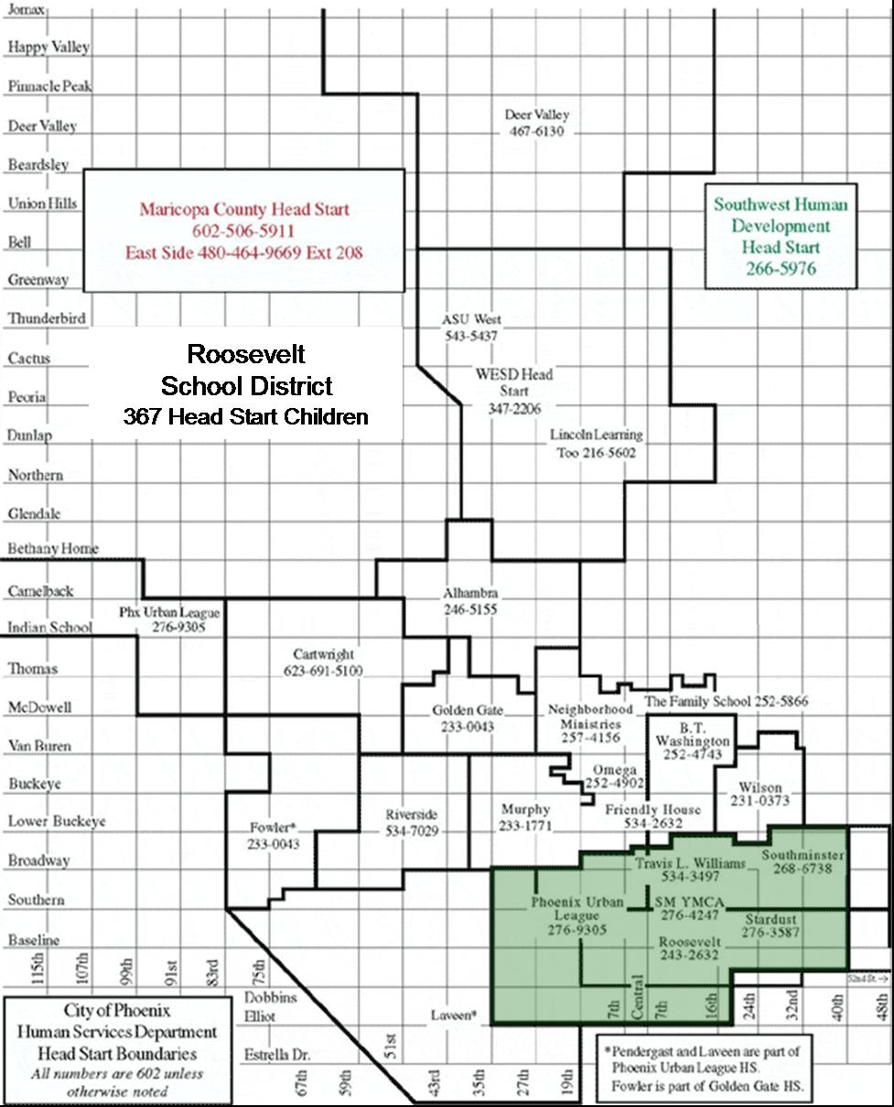
City of Phoenix Head Start

Program Approvals

Program Year 39 (2004-2005)

Community Assessments, Goals, Objectives, and Action Plan

Delegate Agency Name: Roosevelt School District
Address: 6000 S. 7th St.
Phoenix, AZ 85040

APPROVED: Date:
Board Chairperson/Executive Director

APPROVED: Date:
Delegate Agency Director

APPROVED: Date:
Policy Committee Chairperson

Roosevelt School District

Refunding Application

Program Year 39 (2004-2005)

Basic Geographic Description

The Phoenix area is the fifth largest city in the U.S. Geographically the area is classified as tropical desert with an elevation of 1,058 feet and a year-round mild climate. For several years the Phoenix area has been one of the fastest growing cities in the U.S.; this rapid growth is just now taking place within the boundaries of the Roosevelt School District

Demographic and Economic Features

The Roosevelt School District serves the preschool and elementary students residing in the Phoenix South Mountain Village, south of the Rio Salado, between 48th St. and 27th Ave.. The Roosevelt School District is approximately 40 square miles in size and serves 11,689 children in grades PreK-8. During the 2002-03 school year 81% of the students qualified for the federal free and reduced lunch program. The district is over 80% Hispanic, and 15% African American.

Trends of the service area

The Roosevelt District is experiencing a housing boom; single-family homes are being built on what was once farmland, citrus orchards or open desert. These new homes range in price from the low $100,000 and up; creating an increasingly economically diverse community. A corresponding expansion of grocery stores and other retail outlets is occurring, but little expansion in the way of employment for skilled workers or vocational training. The table below shows the present and projected socio-economic profile of the South Mountain Village:

Present & Projected Socio-Economic Profile
Population |  | Households |  | Employment
2000 | 2020 | 2000 | 2020 | 2000 | 2020
91,907 | 113,513 | 25,939 | 35,700 | 55,091 | 66,890

Strengths and Needs of Children and Families

While South Mountain Village experiences dramatic growth, the number of young children living in severely distressed neighborhoods is also growing. According to William O'Hare and Mark Mather (2003), Arizona saw an increase of children living in distressed neighborhoods from 4.8% in 1990 to 6.0% reported in the 2000 Census.

Providing another statistical snapshot of the State's children is the following information from “Kids Count 2003 Data Book Online:”

 | Arizona | U.S.

Economic Condition of Families
- Children in extreme poverty (income below 50% of poverty level) | 9% | 7%

Child Health
- Children without health insurance | 18% | 12%

Neighborhood Characteristics
- Children in neighborhoods with a high poverty rate (above 18.6%) | 33% | 23%
- Children in neighborhoods with a high rate of female-headed families (above 35.2%) | 10% | 17%
- Children in neighborhoods with a high rate of high school dropouts (above 14.7%) | 42% | 25%

Information from inside the Head Start program

Responses were received from the Roosevelt Head Start parent survey that was conducted in March 2003. Roosevelt Head Start participants identified the following significant needs with more than 50% of the respondents having identified the items, as “need more services for.”

Resources to address needs

Items with response rate of 50% or greater
Item | Need for more services | Item response rate
Neighborhood safety | 62% | 77%
Job training | 55% | 75%
Housing | 53% | 80%
City services | 53% | 77%
Dental care | 52% | 80%
ESL | 52% | 80%
School dropout | 51% | 74%
Food | 50% | 76%
Public schools | 50% | 76%

Identified needs fall into 3 broad areas:

City Services
- Neighborhood Safety
- Housing
- City services

Health
- Dental care
- Food

Education
- Job training
- School dropout
- ESL
- Public schools

Problems in Resources Availability or Accessibility

Arizona, like many other states, is experiencing a budget crisis and so a potential expansion of state services or state funding to address the above needs has little likelihood.

Preschool Children with Disabilities
Type of Disability | Number of  Students
Preschool moderate delay | 39
Preschool severe delay | 37
Preschool speech/language delay | 43
Preschool hearing handicapped | 2
Preschool visually impaired | 5

The table shows the number of preschool children receiving services through Roosevelt School District's Special Needs Department; the Head Start program serves 26 of these children. Other youngsters in the service area may not be identified or may receive services through an outside agency. These students may receive any of the following therapies depending on their individual needs: physical, occupational, speech, language or special education services. The service provider depends on where the child is attending preschool. According to the Special Needs Department both the incidence and prevalence rate seem to be stable over time.

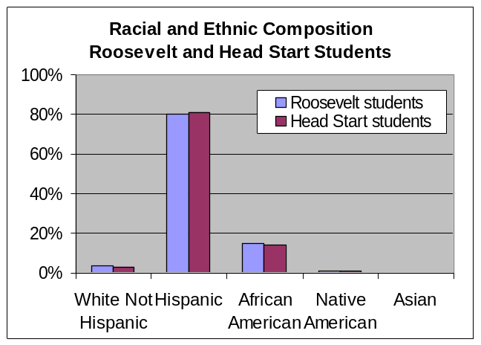
Racial and Ethnic Composition,
Culture and Languages

The graph at right compares the racial and ethnic composition of students enrolled in the Roosevelt School District and the Head Start program. No disparity exists between these two populations.

Languages Spoken

For several years, over half of the children who enter Roosevelt's schools are English learners. To meet the needs of this culturally and linguistically diverse group, each Roosevelt Head Start classroom has one Spanish-speaking adult, with eight Spanish-speaking teachers and 12 Spanish-speaking instructional assistants

Needs and Characteristics of Specific Racial, Ethnic and Cultural Groups

In addition to the staffing needs, Roosevelt Head Start classrooms are filled with culturally and linguistically diverse media, toys, music and books for its diverse group of young learners. Culturally appropriate instructional lessons and hands on activities are part of the daily instruction.

All of the printed materials sent home to Head Start parents are in both English and Spanish. All parent classes and events have translation services available. The City of Phoenix Head Start caseworkers are bilingual as well. Should a family need to be referred for outside services every attempt is made to find an agency that has bilingual staff.

Estimated Number of Eligible Head Start Children

The Roosevelt Head Start has 16 classrooms and serves 310 children.

Number not served by any programs

Roosevelt Head Start currently has 10 income-eligible students and 20 students over income on a waiting list. The City of Phoenix estimates as many as 150 unserved eligible youngsters may be in the Roosevelt area. This estimate appears to be in line with the information from “Kids Count 2003 Data Book Online,” which estimates that only 40% of the State's 3 and 4 year olds are enrolled in nursery school, preschool or kindergarten, leaving 60% of Arizona's preschool population unserved.

Implications

According to Department of Health Services licensed child care facilities within the 85040 and 85042 zip codes have a capacity for 1,553 children; however, the capacity includes older, school-aged children as well as preschoolers. The number also includes for-profit child care businesses.

However it may be wise to conduct intensive recruitment in the Phoenix Enterprise Zone since this has been identified as an area with high poverty.

Conclusions

Based on an extrapolation of the data, it would appear that a significant number of children with the Roosevelt School District are income-eligible for Head Start but are not currently receiving services. Recruitment of eligible children then becomes a key issue.

As previously stated the areas of need that were identified by the parent survey fell into 3 broad categories: city services, education and health. It becomes important that each Head Start youngster and his or her family is made aware of and assisted in finding the appropriate agency to meet their needs.

Assessment Process

The community assessment was conducted in March 2003. Parents, guardians and staff were given a “hard copy” which was in both English and Spanish. Results were then turned into the City of Phoenix Head Start office for aggregation into usable results.

Several focus groups were held during October 2003. Roosevelt Head Start personnel participated in the City of Phoenix meeting on October 1 and the district's parent policy interviews were conducted in on October 14. All of Roosevelt's interviews were held during October.

Southminster Presbyterian Church

City of Phoenix Head Start Map Showing Individual Delegate Agencies

Southminster Presbyterian Church

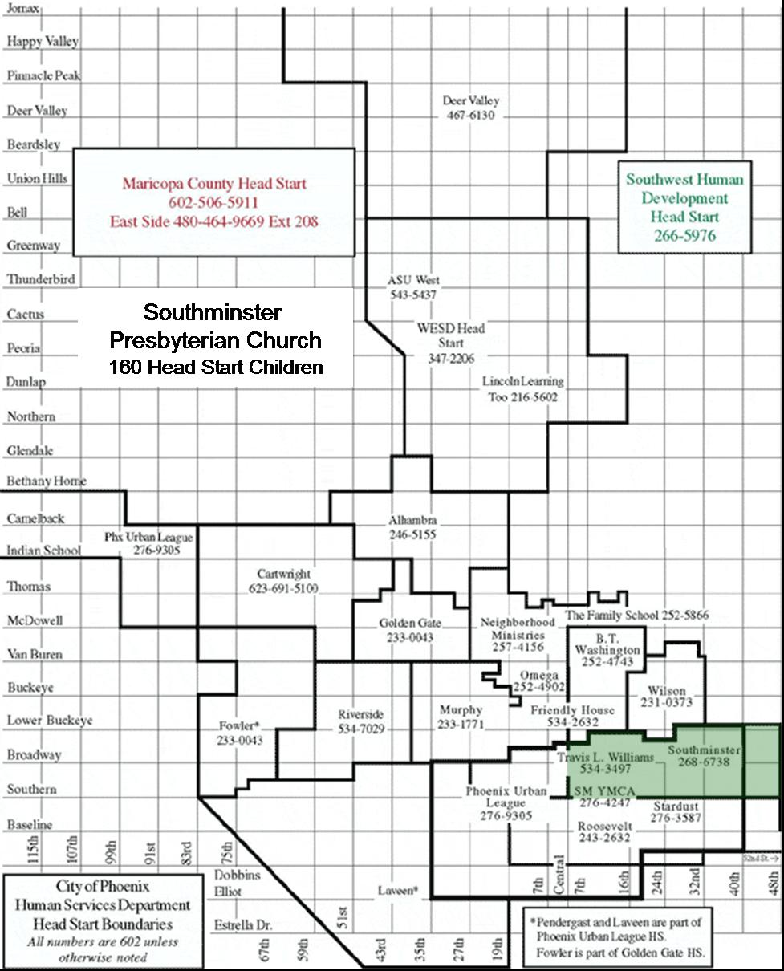
City of Phoenix Head Start

Program Approvals

Program Year 39 (2004-2005)

Community Assessments, Goals, Objectives, and Action Plan

Delegate Agency Name: Southminster Presbyterian Church
Address: 1923 E. Broadway
Phoenix, AZ 85040

APPROVED: Date:
Board Chairperson/Executive Director

APPROVED: Date:
Delegate Agency Director

APPROVED: Date:
Policy Committee Chairperson

Southminster Presbyterian Church

Refunding Application

Program Year 39 (2004-2005)

Community Assessment Process

Southminster Head Start is located in South Phoenix, also known as the South Mountain Village Community. The boundaries of Southminster Head Start program are Southern Ave. to University St., and Central Ave. to 48th St.

Community surveys were distributed to all Southminster Head Start families and to families residing in the surrounding areas of the Head Start center. Community surveys were also distributed to area grocery stores, barber and beauty shops, local businesses, the Post Office and Southminster Presbyterian Church staff. The response rate was 92%.

Families in this urban area reside in the City of Phoenix and in Council District 8. Based on the 81 surveys returned, minority residents are 91% of the population: African Americans make up 47%, Hispanics are 44 %, Whites are 4% and 5% are Other. Based on Arizona Statistics for Reported Crimes, the Phoenix Police Department categorizes this area as one of the highest crime rate areas in the City. The South Mountain area had a total of 1 ,059 violent crimes from January through August, 2003, including 32 homicides, 79 sexual assaults, 383 robberies and 565 aggravated assaults.
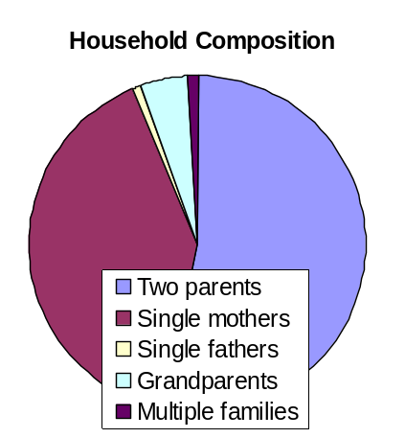

Household Composition

Average number of adults in household 2.3
Average length of time in community 13.0 years
Average number of children in household 2.7
Average age of children in household 5.9 years

Based on the surveys 49% of families have two parents, 37% are headed by single mothers 1% have single fathers, 4% are headed by grandparents and 1 % are multiple families living together. Average monthly household income is $1,738.

Social Services and Disabilities

In the area of social services and disabilities, the survey showed that 59% of adults receive AHCCCS (Medicaid), TANF or SSI 59 services. Five percent of adults and children have some type of disability.

Employment & Training

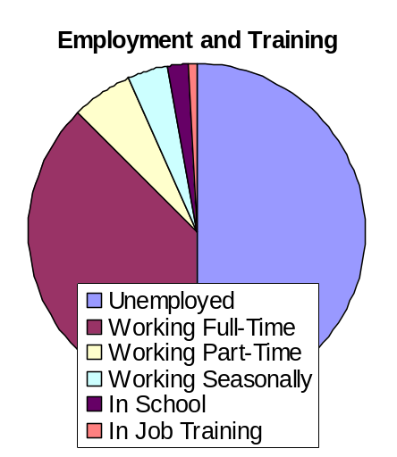
Of those responding to the survey 39% are working full time, 6% are working part time, 4% have seasonal positions, 2% are in school and 1% receive job training. The remaining 52% are underemployed/unemployed. The need for employment varies: 17% are seeking full time work, 7% need part time work, 2% need training and 1% are looking for seasonal work. The remaining 73% is unknown.

Community Assessment Results

Southminster Head Start families, as well as the families in the surrounding communities, need a great deal of services and resources. Question 12 of the survey asked respondents to describe the community's needs for services. The most critical needs in the Southminster community, and the percentage of respondents citing the issues, are:

- Medical Care 60%
- Job training 55%
- Housing 52%

Washington Elementary School District

City of Phoenix Head Start Map Showing Individual Delegate Agencies

Washington Elementary School District

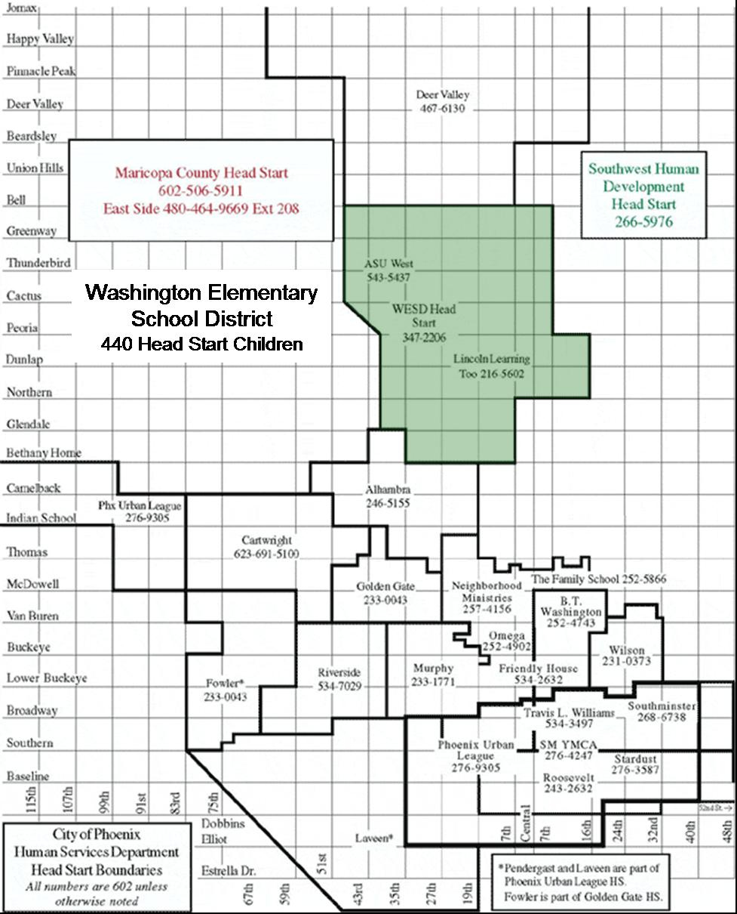
City of Phoenix Head Start

Program Approvals

Program Year 39 (2004-2005)

Community Assessments, Goals, Objectives, and Action Plan

Delegate Agency Name: Washington Elementary School District
Address: 8430 N. 39th Ave.
Phoenix, AZ 85051

APPROVED: Date:
Board Chairperson/Executive Director

APPROVED: Date:
Delegate Agency Director

APPROVED: Date:
Policy Committee Chairperson

Washington Elementary School District

Refunding Application

Program Year 39 (2004-2005)

WESD Mission Statement:

The mission of the Washington Elementary School District is to educate and challenge all students to dream and achieve through outstanding educational programs.

Washington Elementary School District Profile:

The Washington Elementary School District (WESD), the largest elementary school district in Arizona, is proud of its 112-year record of providing a quality educational experience for its children and community.

The district's 24,600 students attend 32 schools in a 44-square-mile area of Phoenix and parts of Glendale. Outstanding educational programs are provided in each of the 25 K-6 elementary schools, the traditional school, the K-8 school and the five middle schools that comprise the district.

WESD passed a $64 million bond in 2001. Renovation projects are in progress at various schools and the District's 33rd school is scheduled to open in August 2004. Three elementary schools were reconstructed in 1996 as part of an earlier $114.7 million bond initiative.

WESD employs approximately 3,000 people, with 1,500 teachers, 1,400 support staff, and 100 administrators.

Approximately 68% of district students are enrolled in the free and reduced lunch program, with eligibility ranging from 9 percent to 100 percent in the various schools. The number of lunches served each day is approximately 17,000.

Title I services are provided to 20 schools, 14 with school-wide designation and 6 schools with targeted assistance programs.

Special education services are provided to approximately 15% of the student population. Head Start provides services to 440 families at 14 elementary school sites within the Washington Elementary School District community, as part of the Preschool/Head Start Department. The district also provides optional preschool services to an additional 140 preschool families funded through the state Early Childhood Block Grant. Four additional school sites offer tuition-funded preschool.

Demographic Profile:

Approximately 52% of district students are White, not Hispanic; 36% Hispanic; 7% African American, 4% American Indian, 3% Asian.
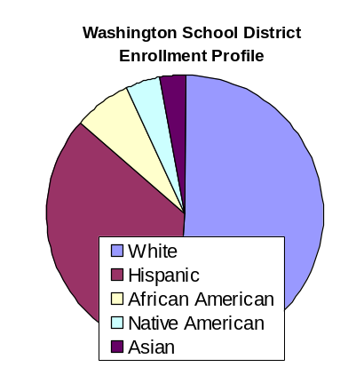
Head Start survey respondents have a slightly different profile, with 19% White, 84% Hispanic, 6% African American, 4% Native American, and 1% Other. (some overlap between White and Hispanic).

Head Start Employment Status:
(based on 2002-03 PIR)

Two-parent families (based on 345 families):
- Both are employed 22
- One is employed 278
- Both are not working 45
- Both in job training/school 1
- One in job training/school 19
- Neither in job training 325

Single-parent families (based on 203 families):
- Parent is employed 87
- Parent is not working 116
- Parent in job training/school 11
- Not in job training/school 192

Head Start Employment Status:
(based on 333 returned survey results)

Percent of Adults who are:
- Working full time 36%
- Working part time 10%
- Working temporarily/seasonally 2%
- In job training 1%
- In school 5%
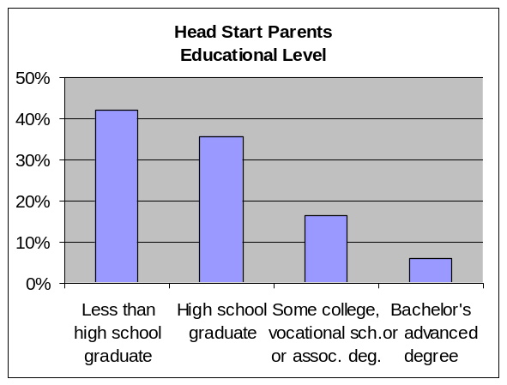

Head Start Educational Level:
(based on 2002-03 PIR – 548 families)

Less than high school graduate 230
High school graduate or GED 196
Some college, voc. school or assoc. degree 90
Bachelor’s or advanced degree 32

Head Start Annual Income Status:

Average household income per month, based on survey results, is $1,277.

Primary Language of the Family at Home:
(based on 2002-03 PIR)

English 274
Spanish 280
Middle Eastern & South Asian Languages 3
East Asian Languages 2
European and Slavic Languages 1
African Languages 2

Thirty-five different languages are represented in district schools. The primary language group is English speaking, second largest is Spanish, and third is Serbo-Croatian.

The district has experienced a significant increase in English Language Learners over the past ten years. Currently approximately 4,700 Limited English Proficient students are in WESD, an increase of 87% from five years ago and 538% from ten years ago.
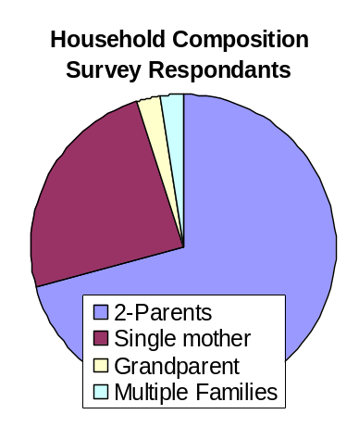

Household Composition:

The household composition for the Washington Elementary School District families is mostly two parent families. In addition, single mothers head up a large number of the Head Start families. A smaller number of families are comprised of grandparents as the primary caregivers, along with the same number of multiple families sharing households.

This chart illustrates the household composition of the Head Start survey respondents.

Children with Disabilities Status:

Washington Elementary School District provides special needs services for approximately 575 preschool children (December 2003). Of the 575 children, approximately forty children with disabilities are receiving services in the Head Start classroom (December 2003).
 | Number of Students
Type of Disability | WESD | Head Start
Preschool moderate delay | 231
Preschool severe delay | 142
Preschool speech/language delay | 162 | 50
Other (occupational therapy,  physical therapy, etc.) | 40
Non categorical development delay |  | 27
Totals | 575 | 77

Head Start Disability Status:
(based on 2002-2003 PIR)

Services for seventy-seven preschool children with disabilities were provided in the WESD Head Start program (2002-03 school year). An average of 17.5% of Head Start’s enrollment consisted of preschooler’s with Individual Education Plans (IEP’s) placed in the Head Start’s least-restrictive environment.

WESD Head Start Community Needs Assessment:

WESD Head Start conducted a community assessment to collect data that would influence the goals and objectives of the 2004-07 Three Year Plan for Head Start. The Community Needs Survey was presented to the WESD Associate Superintendent, Dr. Susie Cook, on August 14, 2003 for distribution approval. Survey information was also given to the 2002-03 Parent Policy Committee. All surveys were completed and submitted for data analysis to the City of Phoenix on October 1, 2003. The survey data analysis was completed and returned to WESD Head Start on November 21, 2003. In addition to the Head Start Community Needs survey, WESD has district and site Strategic Planning Committees, which are involved in developing goals and objectives based on the needs of the community. The resulting plan of these committees will influence and support the goals for the WESD Head Start program. The parents and staff of the WESD Head Start program will be encouraged to work collaboratively on these strategic planning processes to develop long-range goals and objectives not only for the WESD Head Start program, but the entire school district.

Survey Results:

A total of 425 surveys were distributed to families, and when possible, they were completed during home visits, parent meetings or when a family member was at a Head Start classroom. A total of 333 survey forms were returned, for a 78% response rate.

Community Needs Assessment Findings:

After collecting and recapping the assessment data, the following areas were determined to be of most concern:

- Housing
- Medical/Dental Care
- Child Care/After School Care
- Job Training
- Utility Assistance
- Neighborhood Safety

- Data from survey results indicates that 33% to 47% of the respondents believe housing is difficult to access. 45% indicated the need for more services for quality housing.
- Medical and dental care were identified areas of need with the greater need indicated for dental care. 48% of those responding indicated a need for more dental care services.
- Neighborhood safety was recognized as an area of need with 50% of those responding requesting a need for more services.
- 33% to 38% of the responses indicated child care and after-school care are difficult to access.
- Need for more services for job training was indicated by 45% of the responses, and 29% of the respondents found job training to be difficult to access.
- Utility assistance was found to be difficult to access by 32% of the respondents, and 25% believe the quality of services for utility assistance is below average.

Future Focus:

The long-range goals for 2004-07 include the following:

- To improve community partnerships and identify resources in order to assist families to locate necessary assistance, which will include housing, job training, dental and/or medical care.
- To improve quality and availability of childcare and neighborhood safety through community resources and development of partnerships between families, providers of child care and law enforcement organizations.

The current focus for parents and staff of WESD Head Start program is to use this report and data, along with District Strategic Plans, to develop more specific short-range goals and objectives to meet the needs of the families being served in the Washington Elementary School District. The WESD Head Start program Parent Policy Committee will assist and review goals and, when considered necessary, make revisions. Subsequently, plans and tactics to attain the goals will be developed and put into action.

Wilson School District

City of Phoenix Head Start Map Showing Individual Delegate Agencies

Wilson School District

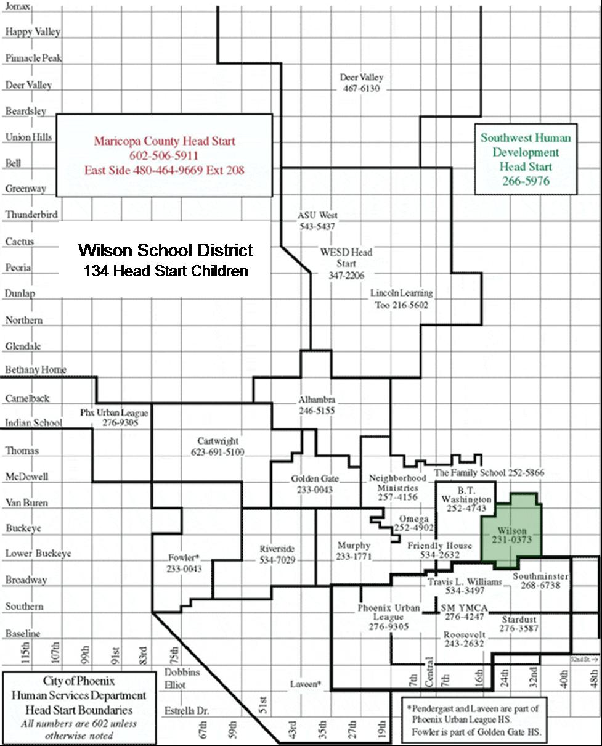
City of Phoenix Head Start

Program Approvals

Program Year 39 (2004-2005)

Community Assessments, Goals, Objectives, and Action Plan

Delegate Agency Name: Wilson School District
Address: 430 N. 30th Place
Phoenix, AZ 85008

APPROVED: Date:
Board Chairperson/Executive Director

APPROVED: Date:
Delegate Agency Director

APPROVED: Date:
Policy Committee Chairperson

Wilson School District

Refunding Application

Program Year 39 (2004-2005)

School District Description

The Wilson Elementary School District is located in Maricopa County, Arizona, within the downtown Phoenix metropolitan area and a designated Enterprise Zone. The district spans approximately 35 square miles and consists of two adjoining school campuses with a nearby charter high school. The district serves approximately 1,400 students in Head Start through eighth grade.

For years the Wilson Elementary School District has been considered one of Maricopa County’s most “at risk” school districts, with a high number of children and families in poverty. A brief windshield survey of the Wilson neighborhoods demonstrates why it has earned the reputation as a difficult place to grow up. The main thoroughfare through the District, Van Buren St., is well-known for prostitution, drug dealing and gang activity, all of which can be visible at any time. The area has no city parks, no library, no YMCA or other recreational facilities, no banks, no movie theatres and no grocery stores (except the corner liquor market). Within the District boundaries are two shelters for homeless families and domestic abuse victims, a defunct women’s prison facility, the State Hospital for mental illness, a number of topless bars and fantasy motels, as well as substandard housing, rent-by-the-week motels, dilapidated trailer parks and apartment units. The only neighborhood church shares the same city block as the District Schools.
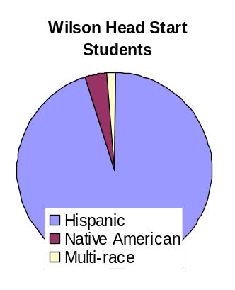

Ethnic composition of the Wilson Community

The community is made up largely of Hispanics, at 69% compared to 34% for the rest of the city. Many of those residents are recent arrivals to the United States. The vast majority of Head Start children are also Hispanic at 95%, the remaining students are 3.5% Native American and 1.5% multi-racial. The Wilson Head Start staff is also largely Hispanic at 74%, 11% white, 4% Native American and 11% African American. Levels of English proficiency reflect the ethnic distribution: 68% of district students and 80% of Head Start students speak Spanish as their primary language.

 | City of Phoenix |  | Wilson District
 | Number | Percent | Number | Percent
Total population | 1,321,045 | 100% | 5,081 | 100%
Population under 5 years | 114,516 | 8.7% | 478 | 9.4%
Population 5-19 years | 308,263 | 23.3% | 1,185 | 23.3%
Median age | 30.7 |  | 28
Hispanic Origin | 449,972 | 34.1% | 3,508 | 69.0%
Single mother households  (with own children under 18) | 37,656 | 8.1% | 97 | 10.6%
Wilson’s family income level is much lower than in the rest of the City. Median family income in Wilson was $22,252 at the time of the 2000 census, less than half the median income for the City of Phoenix, $46,467. In the Wilson School District 464 family households have children 18 and younger. More than half of those families (294) live below the federal poverty line. Of families living in poverty, 158 have children that are Head Start age and younger. All of Wilson’s schools are designated Title I, and 97% of the elementary through high school students are eligible for free and reduced lunches.

Disparities Between Wilson School District and Other Areas of the City:
 | City of Phoenix |  | Wilson School District
 | Number | Percent | Number | Percent
Families in poverty status with related children under 18 | 30,777 | 87% | 294 | 94%
Median family income | $46,467 |  | $22,252

These challenges, combined with family mobility and limited English proficiency levels, all impact the ability of the District’s students to succeed academically. About 20% current enrollment are first-year enrollees in the District. Moreover, many of the Wilson students do not come from backgrounds where it is the norm to complete high school and go on to college. Frequently they are born to teenage mothers who decide to work rather than complete school. According to the Arizona Department of Health Services, the Wilson area has about twice the number of babies born to teenage mothers than Maricopa County.

Educational Attainment for Wilson School District Residents
 | City of Phoenix |  | Wilson School District
 | Number | Percent | Number | Percent
Less than 9th grade education | 86,881 | 10.9% | 877 | 32.25%
High school graduate or higher |  | 76.6% |  | 43.8%
Bachelor’s degree or higher |  | 22.7% |  | 7.6%

Housing and Transportation

The Wilson community is also plagued by a shortage of adequate housing and transportation. Families commonly remain for years in the weekly rental motels along Van Buren St. Families who do own their homes take great pride in them; however, few homeowners are in the district. The total number of occupied housing units for Phoenix is 465,834, of which just 917 units are in the Wilson community. Relative to other neighborhoods in the City, Wilson’s households house far more people in typically older homes. Most of Wilson’s houses were built between 1940 and 1970; fewer than 1/3 of the homes have been built in the last 25 years. Inadequate housing is a top concern for community members in the Wilson area.

Community activists and leaders have joined together to form the Wilson Renaissance Project, which will someday provide quality housing and recreational opportunities for the families in the community.

Many people rely on the Phoenix bus system to get to and from work and for grocery shopping. Unfortunately, residents must take more than one bus to get to the nearest stores. The lengthy time between busses can present challenges for grocery shopping, especially in the summer months when the heat threatens to spoil food quickly. An anticipated light-rail system will run south of the Wilson District, but its funding is uncertain and construction is several years away.

Housing and Transportation Issues for the Community:
 |  | City of Phoenix |  | Wilson District
 |  | Number | Percent | Number | Percent
Housing  Characteristics | Owner occupied units | 282,670 | 60.7% | 289 | 31.6%
Housing  Characteristics | Households with 1.5+  more persons per room | 30,749 | 6.6% | 322 | 35.1%
Housing  Characteristics | Lacking complete  plumbing facilities | 2,749 | 0.6% | 36 | 3.9%
Housing  Characteristics | Lacking complete  kitchen facilities | 2,850 | 0.6% | 15 | 1.6%
Housing  Characteristics | No telephone service | 13,855 | 3.0% | 108 | 11.8%
Transportation | Households with no  vehicle available | 41,607 | 8.9% | 248 | 27.0%
Transportation | Workers rely on public  transp., walking or  other than a private  vehicle for work | 45,701 | 7.7% | 323 | 22.4%

Estimated Number of Children to be Served

Based on the 2000 Census 478 children under 5 years of age live in the district. Approximately 192 of those are of Head Start age. The Wilson Head Start program currently serves 134 or 70% of that total. Some children are served by the Salvation Army’s Herberger Child Care Center for homeless children, New Creations, and Faces of Crisis Nursery. The remaining children are cared for at home by relatives or friends. Increasing numbers of residents who care for children at home are being trained through Kith and Kin to improve their home care techniques. In the past two years 52 people have been trained and, on average, they care for 3 children between the ages of 0-5.

Services for Special Needs Preschoolers

Wilson Head Start is the only provider of services for school district special needs preschoolers. To date, 19 children (14% of funded enrollment) have been certified for disability services. Of that group 10% are certified for Speech and Language Services and 4% are certified for Special Education. Typically, the number of students certified with disabilities by the end of the first semester averages between 25-30 (19-22%). Services are currently provided through Easter Seals of Arizona. The district also provides a Special Needs Aide shared by the seven Head Start classrooms, seven hours per day. If ever a case is so severe that Head Start cannot accommodate a preschool child, the district will pay tuition for another program.

Strengths and Needs

In spite of their many needs, families in the Wilson area are quite resilient and resourceful. Most are employed and work very hard for low wages. Many do not speak English well or read in either Spanish or English, but they manage to live here successfully and find assistance when they need it. They are working to improve their educational level by participating in English classes when possible and convenient. The families in the community are close, and help each other in a crisis. They will move in with one another to share expenses to prevent homelessness, if necessary. Most cannot afford to pay for child care, so they baby sit for each other, often free of charge.

The Wilson Community Center has become a valuable resource for English training and many other personal development courses for parents. These programs fill up quickly, leaving many others without convenient, affordable classes.

Community members are very concerned about accessible and affordable medical care. Very few are eligible for the state health care system, but more and more are taking advantage of Kids Care for their children. Families are concerned about emergencies, especially for themselves as they lack insurance coverage. Community members would like to see more education about medical services in the community, particularly prenatal care. A new sliding-fee clinic scheduled to open in the vicinity early next year will fill many of the gaps in health care that exist in the Wilson community.

Dental care is also a significant problem. The children tend to have very bad teeth and parents need education in this area. They are hesitant to seek dental care and feel that it is unimportant to protect baby teeth that will fall out anyway. Resources for low cost or free dental care in the area is currently extremely limited.

The Wilson area has a high incidence of anemia. This issue is met through referrals to WIC and the free breakfast and lunch programs. Head lice is also a recurring problem for many families.

The families are also very concerned about neighborhood safety, but are hesitant to report problems to the police. They worry about children witnessing the indecencies of Van Buren St.—drugs, prostitution and gang activity—as they are leaving school. Additionally, among this community’s most devastating health issues is also an issue of public safety: in 2002 the highest cause of death for persons aged 20-34 was homicide. Families would like to see more community members actively involved in reporting crime and want more block watches formed. One neighborhood re-formed its block watch and has seen moderate progress in the past few years. The community would like to see more resources for people involved in domestic violence and more safe recreational spaces for the children that are free of charge.

Summary and Conclusions

The City of Phoenix and other agencies have increased their attention to the Wilson community over the past few years, improving the quality of life for residents in the Wilson School District and surrounding communities. We believe that this means positive change is on the way. The Wilson 21st Century Community Center has been instrumental in making necessary accommodations to meet some of the identified needs. As the data show, a lot of immediate need remains in the community. Inadequate housing, public safety, and health care are still the top three critical concerns for many families with young children in this community, and will require a long-term commitment for gradual change. For the near-term, increased accessibility to English classes for parents would be a tremendous help and would enable parents to work more comfortably with other entities to address some of these other issues.

Appendix A. Survey Questionnaires

Community Survey

_________________________________
(Delegate Agency Name)

Dear Community Members:

Head Start is in the process of planning its program for the next three years and is interested in knowing your concerns about the community in which you live, work and where your children attend school. Please take a few minutes to fill out this survey. Return it to your Head Start Center or __________________________________. Thanks very much for your help.

******************************************************************************
SAMPLE:
Please mark the box that best reflects the availability of transportation in your community: | Not  Available | Sometimes  Available | Always  Available
Trains | 
Buses |  | 

- Length of time in community: _____years _____months

- Number of adults in household: _____

- Number of children in household: ______

- Age(s) of children in household: ________________
5. Race or Ethnicity, please mark one:
Hispanic
African American
Native American
White/Caucasian
Asian/ Pacific Islander
Other, please specify:

6. Please mark the box that best describes your household:
Two parent family
Single mother
Single father
Grandparent
Multiple families
Adult (s) without minor children
Other, please specify:

7. Please list the number of adults or children in the household who: | Adults | Children
Have a disability
Receive TANF(Temporary Assistance for Needy Families)
Receive Food Stamps
In AHCCCS (Arizona Health Care Cost Containment System)

8. Please list the number of adults in your household that are :
Employed full time (35-40+ hours a week)
Employed part time
(20-35 hours per week)
Employed temporarily
(less than 20 hours, seasonal,)
In job training
In School/GED classes

9. Please list the number of adults (one choice per adult) in your household needing or seeking:
Full time employment
(35-40+ hours a week)
Part time Employment
(20-35 hours per week)
Temporary (less than 20 hours) / seasonal Employment
Job Training

10. Please list the number of adults or children in your household needing or seeking:
 | Adults | Children
Health insurance
Medical Care
Dental Care
Mental Health Services
Citizenship/ Immigration Services

11. Please estimate your household income per month:
$

12. Please mark ONE box (“don’t need”, “have enough”, “need more”, or “don’t know”) that best describes the community’s need for services in the following categories: | Don’t need services for | Have enough  services for | Need more services for | Don’t Know
Affordable Housing
Child care (infants, toddlers)
After school care
Job training
Transportation
Medical Care
Dental Care
Teenage pregnancy & parenting
Child abuse
Juvenile crime
Gang Prevention
Other crime
Substance abuse services/treatment
Quality of public schools
Neighborhood safety
Domestic violence
City services (street repair, graffiti removal, etc.)
Mental health services
English language classes
Citizenship classes
Job training
School dropout prevention
Food
Clothing
Utility assistance
Legal aid
Financial/debt counseling
Other (please specify)

14. Please mark ONE box (“below average”, “average”, “above average”, or “don’t know”) that best describes the quality of available services in your community for the following categories: | Below Average  Quality | Average  Quality | Above Average  Quality | Don’t Know
Affordable Housing
Child care (infants, toddlers)
After school care
Job training
Transportation
Medical Care
Dental Care
Teenage pregnancy & parenting
Child abuse
Juvenile crime
Gang Prevention
Other crime
Substance abuse services/treatment
Quality of public schools
Neighborhood safety
Domestic violence
City services (street repair, graffiti removal, etc)
Mental health services
English language classes
Citizenship classes
Job training
School dropout prevention
Food
Clothing
Utility Assistance
Legal aid
Financial/ debt counseling
Other (please specify)

For parents of children age 4 or younger: | Yes | No
15. Is your child currently enrolled in the Head Start Program?
16. If not, are you interested in Head Start for your Child?
17. Would you like to volunteer your time to the Head Start Program?

18. If your child is not enrolled in Head Start, please indicate why:
Not interested
Don’t know about the program
Have other child care provider/ arrangements
There is not a Head Start in my area
On waiting list
Do not Qualify
Other, please explain:

If you would like us to contact you about the Head Start Program, please fill out this section below:
Name:
Address:

Phone:
Child’s Name(s):
Child’s age(s):
Thank you for your time!

Cuestionario de la comunidad
________________________________
(Nombre de la agencia designada)

Estimados miembros de la comunidad:

Head Start está en el proceso de planificar un programa por los próximos tres años y está interesado en conocer cuales son sus preocupaciones en cuanto a la comunidad en la que vivimos, trabajamos y donde sus hijos van a la escuela. Por favor tome un momento para llenar este cuestionario. Devuélvalo a un centro de Head Start o ___________________________
Muchas gracias por su ayuda.

******************************************************************************
EJEMPLO:

Por favor indique cual es la forma de trasporte más común en su comunidad: | No  Disponibles | A veces  Disponibles | Siempre  Disponibles
Trenes | 
Autobuses |  | 

- Tiempo viviendo en la comunidad: _____años _____meses

- Numero de adultos en el hogar: _____

- Numero de niños en el hogar: ______

- Edades de los niños en el hogar: _______________
5. Raza u origen étnico, Por Favor marque una opción:
Hispana
Afro-Americano
Nativo Americano/ Originario de Alaska
Blanco/ Caucásico
Asiático/ Originario de otras islas del Pacifico
Otro, por favor especifique:

6.Por favor marque la opción que mejor describa su hogar:
Padre y madre
Madre soltera
Padre soltero
Abuelo (a) (s)
Varias familias
Adulto (s) sin un menor
Otro, por favor especifique:

7. Por favor liste el numero de adultos o niños que: | Adultos | Niños
Estén discapacitados
Que reciben TANF(Ayuda temporal para familias necesitadas)
Reciben cupones de comida
Reciben ayuda de AHCCCS (Arizona Health Care Cost Containment System)

8. Por favor liste el numero de adultos en su hogar que están:
Empleados tiempo completo (35-40+ horas a la semana)
Empleados medio tiempo (20-35 horas a la semana)
Empleados temporalmente (menos de 20 horas, por temporadas)
En entrenamiento de trabajo
En la escuela / clases de GED

9. Por favor liste el numero de adultos (una opción por adulto) en su hogar que necesita o busca:
Empleo de tiempo completo (35-40+ horas a la semana)
Empleo de medio tiempo (20-35 horas a la semana)
Empleo temporal (menos de 20 horas)
Entrenamiento de trabajo

10. Por favor liste el numero de adultos o niños en el hogar que necesiten o busquen:
 | Adultos | Niños
Seguro médico
Cuidado médico
Cuidado dental
Servicios de salud mental
Ciudadanía/ Servicios de inmigración

11.Por favor calcule el ingreso en su hogar:
$

12. Por favor marque una opción (“no necesita”, “tiene suficientes”, “necesita mas”, o “no sabe”) la que mejor describa la necesidad de servicios en la comunidad en las siguientes categorías: | No necesita servicios para | Tiene suficientes  servicios | Necesita mas servicios para | No sabe
Vivienda económica
Guardería (bebés, niños pequeños)
Cuidado de niños después de la escuela
Entrenamiento para trabajar
Trasporte
Cuidado médico
Cuidado dental
Embarazo y crianza de niños de adolescentes
Abuso infantil
Crimen juvenil
Pandillas
Otros crímenes
Servicio y tratamiento para el abuso de substancias
Calidad de escuelas públicas
Seguridad en el vecindario
Violencia doméstica
Servicios de la ciudad (reparación de calles, limpiar graffiti, etc.)
Servicios de salud mental
Clases de inglés
Clases de ciudadanía
Entrenamiento para trabajar
Evitar la deserción escolar
Comida
Ropa
Asistencia con las utilidades
Asistencia legal
Consejería financiera / deudas
Otro (por favor especifique)

13. Marque una opción (“Fácil de obtener”, Difícil de obtener, “Imposible de obtener”, o “No sabe”) lo que mejor describa cual fácil es obtener servicios en las siguientes categorías: | Fácil de obtener | Difícil de obtener | Imposible de obtener | No sabe
Vivienda económica
Guardería (bebés, niños pequeños)
Cuidado de niños después de la escuela
Entrenamiento para trabajar
Trasporte
Cuidado médico
Cuidado dental
Embarazo y crianza de niños de adolescentes
Abuso infantil
Crimen juvenil
Pandillas
Otros crímenes
Servicio y tratamiento para el abuso de substancias
Calidad de escuelas públicas
Seguridad en el vecindario
Violencia doméstica
Servicios de la ciudad (reparación de calles, limpiar graffiti, etc.)
Servicios de salud mental
Clases de inglés
Clases de ciudadanía
Entrenamiento para trabajar
Evitar la deserción escolar
Comida
Ropa
Asistencia con las utilidades
Asistencia legal
Consejería financiera / deudas
Otro (por favor especifique)

14. Por favor marque una opción (“Menos que lo normal”, “normal”, “mas que lo normal”, o “No sabe”) la que mejor describa la calidad de servicios disponibles en su comunidad en las siguientes categorías: | Menos que lo normal  Calidad | Normal  Calidad | Mas que lo normal  Calidad | No sabe
Vivienda económica
Guardería (bebés, niños pequeños)
Cuidado de niños después de la escuela
Entrenamiento para trabajar
Trasporte
Cuidado médico
Cuidado dental
Embarazo y crianza de niños en adolescentes
Abuso infantil
Crimen juvenil
Pandillas
Otros crímenes
Servicio y tratamiento para el abuso de substancias
Calidad de escuelas públicas
Seguridad en el vecindario
Violencia doméstica
Servicios de la ciudad (reparación de calles, limpiar graffiti, etc.)
Servicios de salud mental
Clases de inglés
Clases de ciudadanía
Entrenamiento para trabajar
Evitar la deserción escolar
Comida
Ropa
Asistencia con las utilidades
Asistencia legal
Consejería financiera / deudas
Otro (por favor especifique)

Para padres de niños de 4 anos o más jóvenes: | Sí | No
15. En este momento su hijo (a) ¿está inscrito en el programa de Head Start?
16.Si no, ¿está interesado (a) en el programa de Head Start para su hijo (a)?
17. ¿Le gustaría ser voluntario del programa Head Start?

18. Si su hijo (a) no está inscrito en Head Start, por favor explique por qué:
No estoy interesado (a)
No sé acerca del programa
Tiene otro servicio de guardería
No hay un programa de Head Start en mi área
Esta en una lista de espera
No califico
Otro, explique

Si usted quiere ser contactado con información acerca del programa de Head Start, por favor llene la sección de abajo:
Nombre:
Dirección:
Teléfono:
Nombre del menor:
Edad del menor:

¡Gracias por su tiempo!

Phoenix City, July 1, 2002 estimate, U.S. Census Bureau. For April 1, 2000 (Census 2000), Phoenix City had 1,321,000 residents and the Phoenix-Mesa MSA had 3,252,000 residents. The Census Bureau expects Phoenix to surpass Philadelphia as the fifth-most populous city in the first half of 2004.
All data in this section are for Phoenix City from Census 2000, except poverty data from Census Bureau for 1999.
Directory of Human Services and Self-Help Support Groups, Maricopa County, Community Information & Referral, Phoenix, Arizona, annual edition.
Crime data provided by Phoenix Police Department.
“Phoenix: 10 of the Worst Addresses.” Arizona Republic, May 24, 1998.
http://www.census.gov/prod/2003pubs/p60-222.pdf.
Annie E. Casey Foundation, http://www.aecf.org/kidscount/.
Sources: Village Area - Village GIS Coverage, Phoenix Planning Department, March 2002; Population and Households: Census 2000, U.S. Census ;Employment 2000: MAG Employer Database; Projections - Whole Traffic Analysis Zones, Maricopa Association of Governments
Kids Count Census 2000: “The Growing Number of Kids in Severely Distressed Neighborhoods: Evidence from the 2000 Census” Annie E Casey Foundation and the Population Reference Bureau.
http:www.aecf.org/cgi-bin/kc.cgi?action=profile&area=Arizona
Based on Maricopa County Public Health data for zip codes 85006, 85008 and 85034 used in “Community Health Assessment for the Wilson Community.”

